S.B.V.P.Samaj’s

**S.M.B.S.T.College, Sangamner**

**Department of Zoology**

|  |  |  |
| --- | --- | --- |
| 1 | Title of the Activity | “Participation of Students in Polio vaccination Drive” |
| 2 | Place | Campus Area  S.M.B.S.T. College, Sangamner |
| 3 | Objective of the Activity | To boost the involvement of students in public awareness initiatives.  To make students aware about significance of Polio immunization campaign. |
| 4 | Date & Time of Activity | Date: 3rd March 2024  Time: 10:30 to 11:30am |
| 5 | Number of students Participated | M.Sc.-10 students and 5 teachers |
| 6 | Guest Lecturer |  |
| 7 | Chief Guest | Hon.VicePrincipal Dr.Wagh |
| 8 | Beneficiary/Progamme Outcome | Through Participation in polio drive students learned about the significance of the polio campaign and how we can all contribute by increasing public awareness. |

Program Coordinator IQAC Coordinator Principal

“Participation of Students in Polio vaccination Drive”

Report

As we all know, Pulse Polio is an [immunization](https://en.wikipedia.org/wiki/Immunisation) campaign established by the [government of India](https://en.wikipedia.org/wiki/Government_of_India) to eliminate [poliomyelitis](https://en.wikipedia.org/wiki/Poliomyelitis) (polio) in [India](https://en.wikipedia.org/wiki/India) by vaccinating all children under the age of five years against the [polio virus](https://en.wikipedia.org/wiki/Poliomyelitis). The project fights polio through a large-scale [pulse vaccination](https://en.wikipedia.org/wiki/Pulse_vaccination) program and monitoring for poliomyelitis cases. S.M.B.S.T. College, Sangamner, was one of the polio booths arranged for nearby people. Dr. Lakshman Ghaywat, along with Asst.Prof. Sandip Kudner, Asst.Prof.Shaila Borase, Asst.Prof.RidaManiyar, and Dr. Anupama Kandalgaonkar from the department of zoology, along with 12 students, visited this polio booth on 3rd march 2024 at 10 am and Participated in pulse polio vaccination drive.

The booth worker stated that “a three-day nationwide pulse polio vaccination drive is being carried out across the country. The campaign was started on Sunday for all children between the ages of 0 and 5. The campaign involved mobile teams, transit teams, and dedicated vaccination centers in both rural and urban areas. On the first day, children aged up to 5 years were brought to booths, where they were administered two drops of the oral polio vaccine. The booths were open between 7 a.m. and 5 p.m. For the next two days (March 4 and 5), health teams will visit every household and vaccinate children.

As part of the campaign, the vaccination teams have already started administering polio vaccines to children in remote areas and shanties. In rural areas, home visits were conducted for three days, while in urban areas, they will continue for five days. Several intensified-pulse polio vaccination teams have been deployed for this purpose.

Dr. Anupama Kandalgaonkar gave detailed information about polio disease. She stated that “Polio has been around since time immemorial, as the disease has even been depicted in ancient tomb paintings. Polio is an illness caused by a virus that mainly affects nerves in the spinal cord or brain stem. It is transmitted through contaminated water or food or contact with an infected person and even causes paralysis. Most people infected with polio do not get any symptoms. For those who experience symptoms, polio begins with flu-like symptoms such as fever, headache, muscle ache, sore throat, loss of appetite, nausea, etc. One can be affected by paralytic or non-paralytic polio. Paralytic polio starts typically with the same kind of symptoms as non-paralytic polio but soon progresses to intense pain, extreme sensitivity to touch, muscle weakness, and spasm. It may lead to paralysis of the leg or arm.”

Through Participation in polio drive students learned about the significance of the polio campaign and how we can all contribute by increasing public awareness. Every one of us made a call to family members, acquaintances, and neighbours who have kids younger than five years old, requesting that they always give polio dose to kids.

HOD

Prof.Dhakne.K.R.

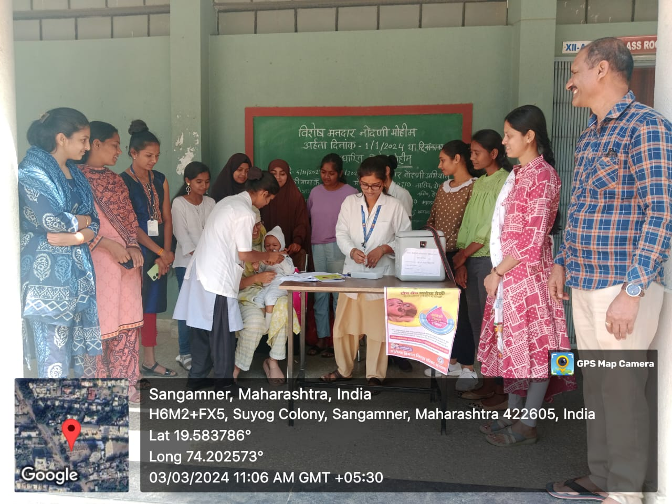

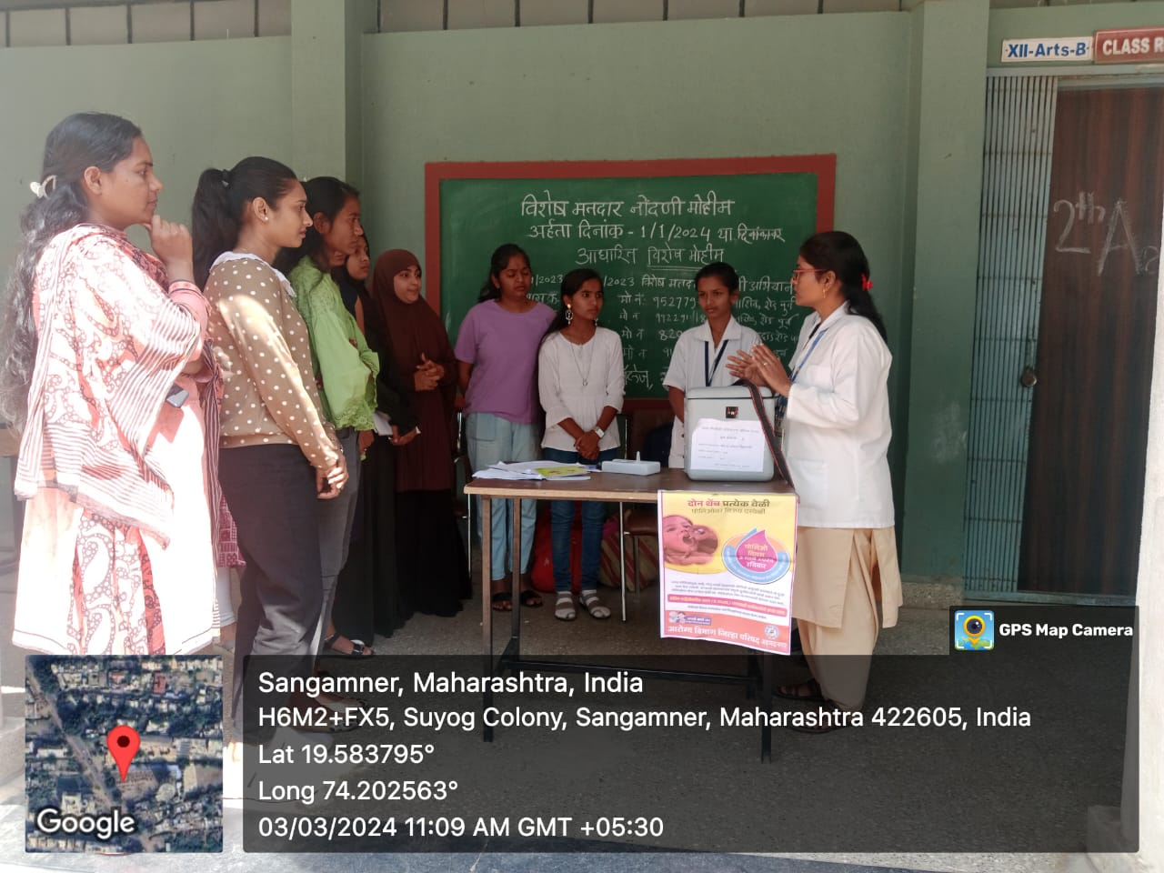

Photograph of Participation of Students in Polio vaccination Drive