सहकार महर्षी भाऊसाहेब संतुजी थोरात महाविद्यालय, संगमनेर
आय.क्यु.ए.सी. अंतर्गत
इतिहास विभाग आयोजित
राष्ट्रपिता महात्मा गांधी पुण्यतिथी
मंगळवार, दि. ३०/०१/२०२४

सहकार महर्षी भाऊसाहेब संतूजी थोरात महाविद्यालयातील इतिहास विभागाच्या वतीने मंगळवार दिनांक ३० जानेवारी २०२४ रोजी राष्ट्रपिता महात्मा गांधी यांची पुण्यतिथी साजरी करण्यात आली. महात्मा गांधी यांच्या प्रतिमेचे पूजन करुन कार्यक्रमाला सुरुवात झाली. या कार्यक्रम प्रसंगी महाविद्यालयाचे उपप्राचार्य आदरणीय डॉ.विलास कोल्हे, इतिहास विभाग प्रमुख प्रो.डॉ. राजदेव टी.बी., हिंदी विभाग प्रमुख प्रा. मिनेश सातपुते, प्रा. स्नेहल थिटमे, प्रा. डापसे श्रीकांत, प्रा. सागर गोसावी व इतिहास, भूगोल, इंग्रजी विभागातील विद्यार्थी या कार्यक्रमासाठी उपस्थित होते.
यावेळी महाविद्यालयाचे उपप्राचार्य डॉ. विलास कोल्हे यांनी आपल्या भाषणात सांगितले कि, इंग्रजांच्या गुलामगिरीतून देशाला मुक्त करणाऱ्या भारतातील एक शूर स्वातंत्र्यसैनिक म्हणजेच राष्ट्रपिता महात्मा गांधी. ज्यांनी आयुष्यभर सत्य आणि अहिंसेचे पालन केले. सत्य आणि अहिंसेचा मार्ग सर्वात सुंदर आणि खरा मार्ग आहे याची शिकवण महात्मा गांधी यांनी करून दिली. गांधीजींनी असहकार, अहिंसा आणि शांततामय विरोध यांना शस्त्र म्हणून इंग्रजांविरुद्ध वापरले. १५ ऑगस्ट १९४७ साली आपला भारत देश स्वतंत्र झाला आणि काही दिवसातच म्हणजेच ३० जानेवारी १९४८ रोजी महात्मा गांधी यांचे निधन झाले. सरांनी ग्रामोदय, स्वदेशी, स्वच्छतेतून समृद्धीचा मूलमंत्र जगाला देणारे राष्ट्रपिता महात्मा गांधी यांच्या जीवनातील विविध प्रसंग सांगून डॉ. बाबासाहेब आंबेडकर, पंडित नेहरू, गोपाळ कृष्ण गोखले, नेल्सन मंडेला, जॉन रस्किन यांची उदाहरणे देखील दिली.
इतिहास विभाग प्रमुख प्रो.डॉ. राजदेव टी.बी. यांनी देखील विद्यार्थ्यांना गांधीजी व त्यांचे जीवन कार्य याविषयी मार्गदर्शन केले. या कार्यक्रमाचे प्रास्ताविक प्रा. श्रीकांत डापसे, आभार हिंदी विभाग प्रमुख प्रा. मिनेश सातपुते व सूत्रसंचालन प्रा.स्नेहल थिटमे यांनी केले. इतिहास, भूगोल, इंग्रजी विभागातील एकूण २३ विद्यार्थी या कार्यक्रमासाठी उपस्थित होते.

Sahakar Maharshi Bhausaheb Santuji Thorat College, Sangamner
I.Q.A.C. &
Department of History Organized
Father of the Nation Mahatma Gandhi Punyatithi
Tuesday, 30/01/2024

The death anniversary of Father of the Nation Mahatma Gandhi was celebrated on Tuesday 30th January 2024 on behalf of the Department of History in Sahkar Maharshi Bhausaheb Santuji Thorat College. The program started by worshiping the image of Mahatma Gandhi. Honorable Dr. Vilas Kolhe, Vice Principal of the College, Head of History Department Prof.Dr. Rajdev TB, Head of Hindi Department Prof. Minesh Satpute, Prof. Snehal Thitme, Prof. Dapse Srikanth, Prof. Sagar Gosavi and students of History, Geography and English departments were present for this program.
On this occasion the Vice Principal of the college Dr. Vilas Kolhe said in his speech that the father of the nation is Mahatma Gandhi, a brave freedom fighter of India who freed the country from the slavery of the British. Those who followed truth and non-violence throughout their lives. Mahatma Gandhi taught that the path of truth and non-violence is the most beautiful and true path. Gandhi used non-cooperation, non-violence and peaceful protest as weapons against the British. India became independent on 15th August 1947 and Mahatma Gandhi died within a few days on 30th January 1948. Sir also gave examples of Dr.Babasaheb Ambedkar, Pandit Nehru, Gopal Krishna Gokhale, Nelson Mandela, John Ruskin by narrating various incidents in the life of Mahatma Gandhi, the father of the nation who gave the world the mantra of prosperity through village development, Swadeshi, cleanliness.
History Department Head Prof.Dr. Rajdev T.B. He also guided the students about Gandhiji and his life work. Introductory Prof. By Srikanth Dapse. Thanks to the program Head of Hindi Department Prof. Expressed by Minesh Satpute and anchoring by Prof. Snehal Thitme. A total of 23 students from History, Geography and English department were present for this program.
Sahakar Maharshi Bhausaheb Santuji Thorat College, Sangamner
I.Q.A.C. &
Department of History Organized
Father of the Nation Mahatma Gandhi Punyatithi
Tuesday, 30/01/2024
Photo
Image worship
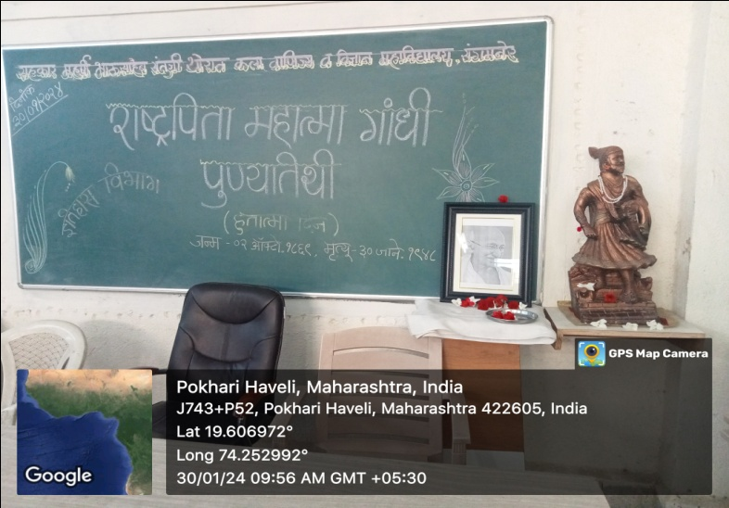
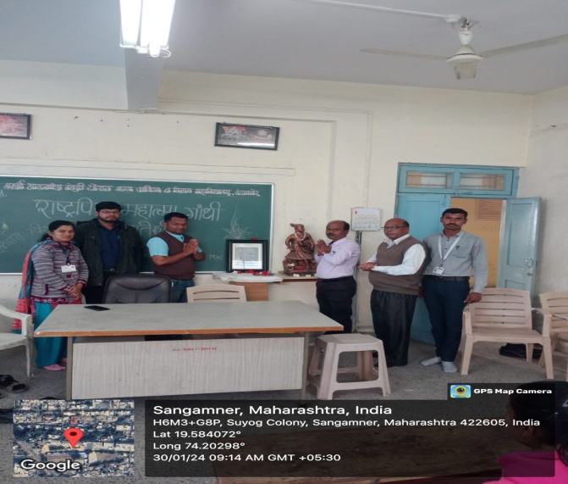

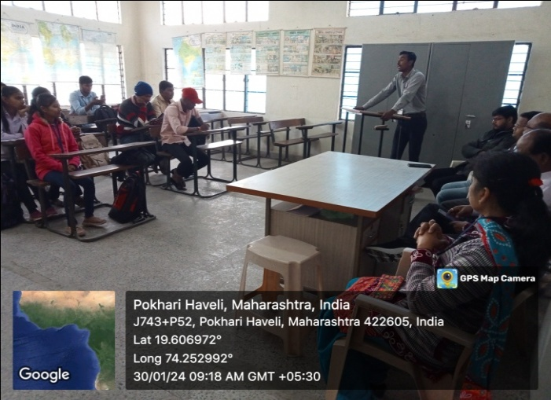
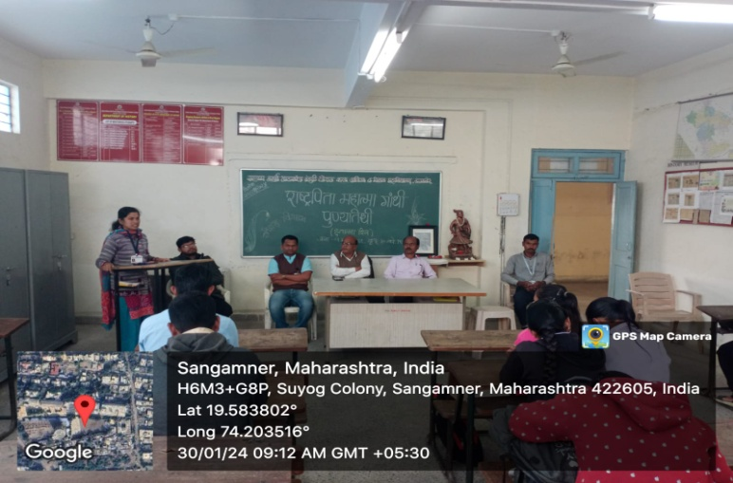
Achoring the program, Prof. Thitame madam & Prof. Shrikant Dapse while introducing the program

History Department Head Prof.Dr. Rajdev T.B. He also guided the students about Gandhiji and his life work
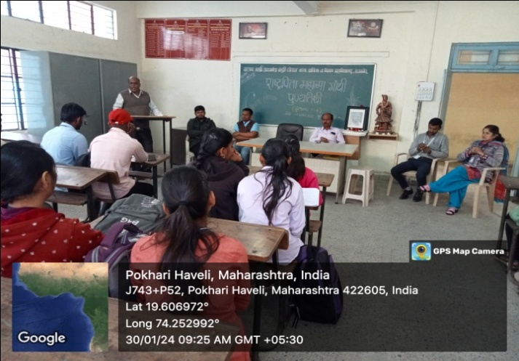
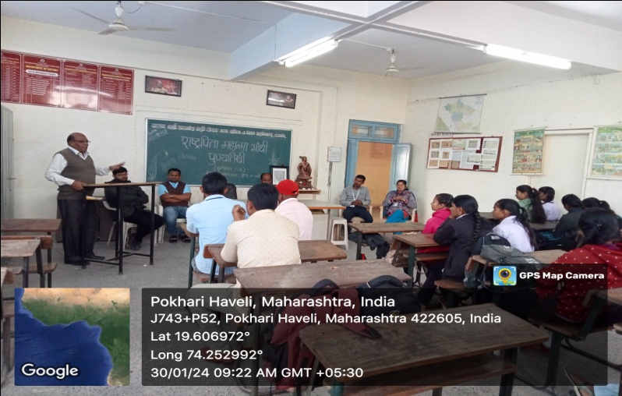

Dr. Vilas Kolhe Sir, Vice Principal of the college explained various incidents in the life of Mahatma Gandhi under his guidance.

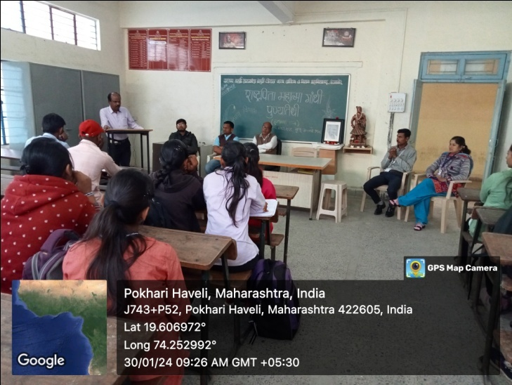
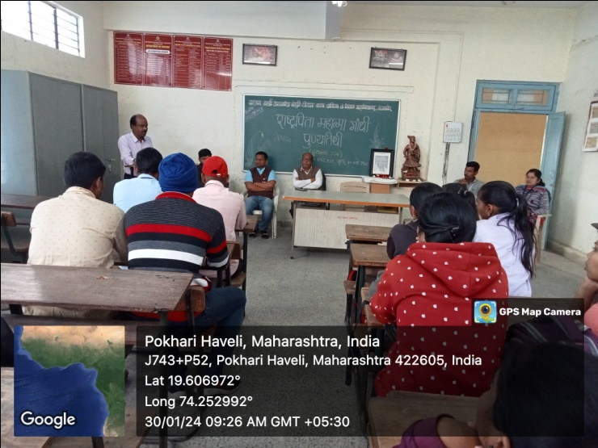

Prof. Minesh Satpute, Head of Hindi Department while expressing his gratitude for the program
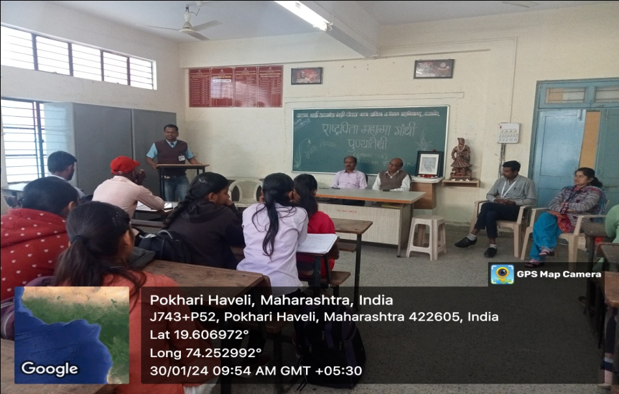

Outcomes of the program
- All the students got to know about the precious work done by the great person Mahatma Gandhi, the father of the nation, for the country.
- The students came to know how it is necessary to educate the society to implement the thoughts that Mahatma Gandhi gave to the people.
- The work of all patriots, social reformers is really great. So why is he remembered only on his birth anniversary or death anniversary? In fact, it is necessary to implement the thoughts of national men in daily life. The students realized this
- Self-confidence, enterprising attitude, organizational skills were developed among the students.
- Mere knowledge obtained from books is not enough. So it is important to give students experience outside the books to give them complete knowledge. He got perfect knowledge from this program
- Developing values ​​requires working together. Students worked as a group in planning the event. Due to this, values ​​and team spirit grew in them.

