S.B.V.P.Samaj’s

**S.M.B.S.T.College, Sangamner**

**Department of Zoology**

|  |  |  |
| --- | --- | --- |
| 1 | Title of the Activity | “Welcome ceremony of new teaching staff and students” |
| 2 | Place | Department of Zoology |
| 3 | Objective of the Activity | To welcome all new students as well as staff so that they may socialize with other students and also with academic staff. |
| 4 | Date & Time of Activity | Date: 22nd August 2023  Time: 10:30 to 11:30am |
| 5 | Number of students Participated | 23 students |
| 6 | Guest Lecturer |  |
| 7 | Chief Guest | Hon.Principal Dr.Dinanath Patil and Vice principal Prof.B.D.Wagh |
| 8 | Beneficiary/Progamme Outcome | Interaction of new students with seniors, among themselves and with teachers was take place.  Introduction with each other will improve teaching learning process more interesting. |

Program Coordinator IQAC Coordinator Principal

**“Welcome ceremony of new teaching staff and students”**

Report

S.M.B.S.T. Arts Science & Commerce College Sangamner. Department of Zoology celebrated a welcome ceremony of new teaching staff and students (T.Y.B.Sc. & M.Sc.).

The purpose of welcome ceremony is to welcome new students in a friendly atmosphere and to encourage their creative impulse to boost their confidence. It is the day where seniors and juniors finally bond and unite to celebrate a being part of the college.

On the occasion of welcome ceremony of newly joined Faculty ( PG & UG Section) and students (M.Sc.,T.Y.B.Sc) ,invited Chief Guest Hon.Principal Dr.Dinanath Patil and Vice principal Prof.B.D.Wagh were present Along with all teaching and non teaching staff and students of Zoology Department. NAAC Co- ordinater Dr.Ghaywat L.D. delivered welcome speech. he heartily welcomed all the students and ensured that “we will do everything possible to equip students with the best possible teaching resources, practical exposure and training methods so that students will able to shape up there life and career for a challenging world out there”.

Dr. Dhakane K.R. felicitated Hon.Chief guests with a bouquet. All the new faculties and students were felicitated by giving a red rose and small gift by Hon. Chief Guests.

After that Vice principal Prof.B.D.Wagh gave guidance speech to all students by appreciating them for their choice of Zoology subject. Chief Guest Hon.Principal Dr.Dinanath Patil delivered a speech which was encouraging for students. They ask student to set a goal and do hard work to achieve that goal. They also mentioned that today’s society is knowledge based society and we should upgrade our self with current scientific knowledge and research. They also appreciated newly joined faculty.

Dr.Dhakne K.R. gave vote of thanks to our Chief Guest for giving their precious time to us and for encouraging students.

HOD

Prof.G.J.Thorat

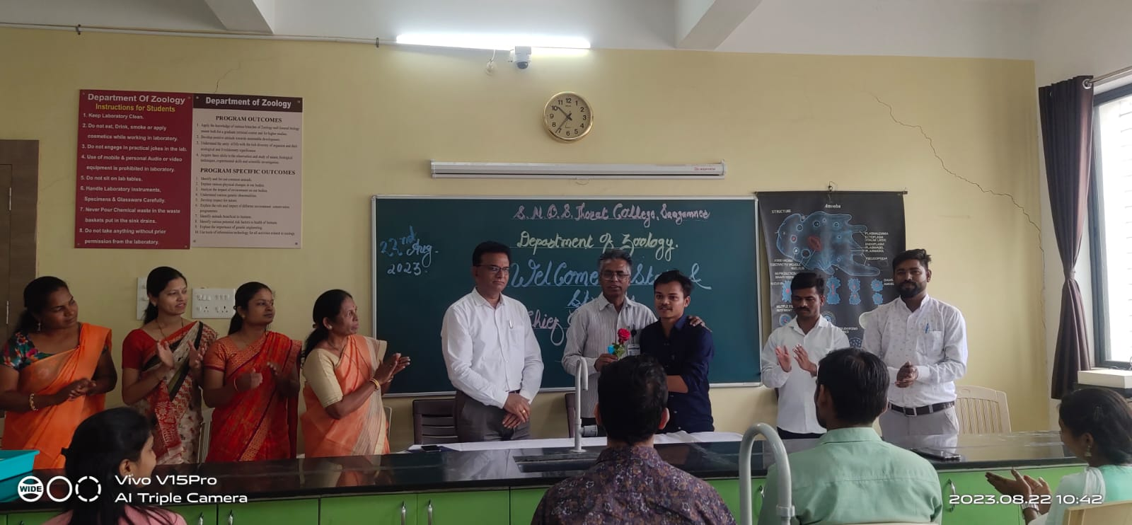

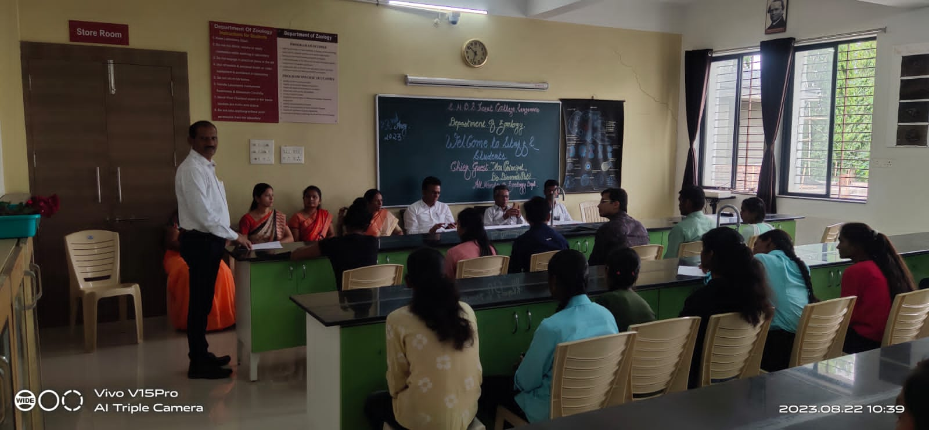

**Photographs of Welcome ceremony**