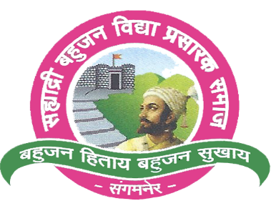

S.B.V.P. Samaj’s

SahakarMaharashi Bhausaheb Santuji Thorat College of Arts, Science And Commerce,Sangamner-422605Dist.Ahmednagar.

(NACC Reaccredited by ‘B’Grade)

**Certificate**

Department Of Zoology

This is to certify that, Mr./Miss _______________________

Of M.Sc. Zoology- I Class has complete, Field visit Report

Practical Course No.______________ as laid down by the

**Savitribai Phule Pune University during the academic year 2023-2024.**

Exam Seat No.

Date: / /20

Practical In Charge Head of the Dept.

Internal Examiner External Examiner

**Report on Field visit to a “Lentic water body -Nilwande dam,Akola,district-Ahmednagar.”**

**Introduction:**

As per the Freshwater zoology Practical Zoo 511MJP we all went to on a field visit to a lentic water body that is Nilwande Damon 9 October 2023. Nilwande dam, also called as Upper Pravara dam, in the [Indian](https://en.wikipedia.org/wiki/India) state of [Maharashtra](https://en.wikipedia.org/wiki/Maharashtra) is the second largest dam on the [Pravara river](https://en.wikipedia.org/wiki/Pravara_River). The dam is located near [Akole](https://en.wikipedia.org/wiki/Akole), [Ahmednagar district](https://en.wikipedia.org/wiki/Ahmednagar_district).Nilwande dam, also called as Upper Pravara dam, in the [Indian](https://en.wikipedia.org/wiki/India) state of [Maharashtra](https://en.wikipedia.org/wiki/Maharashtra) is the second largest dam on the [Pravara river](https://en.wikipedia.org/wiki/Pravara_River). The dam is located near [Akole](https://en.wikipedia.org/wiki/Akole), [Ahmednagar district](https://en.wikipedia.org/wiki/Ahmednagar_district).The height of the dam above lowest foundation is 73.91 m (242.5 ft) while the length is 583 m (1,913 ft).

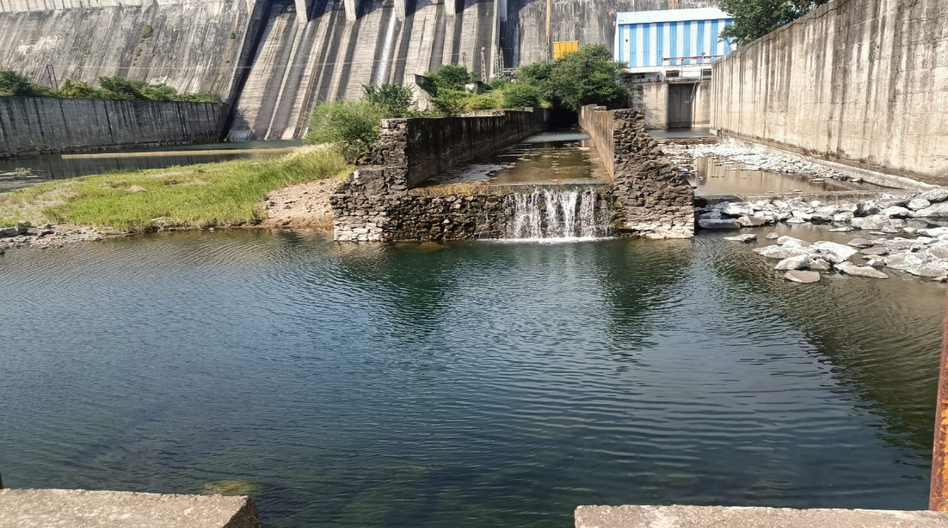

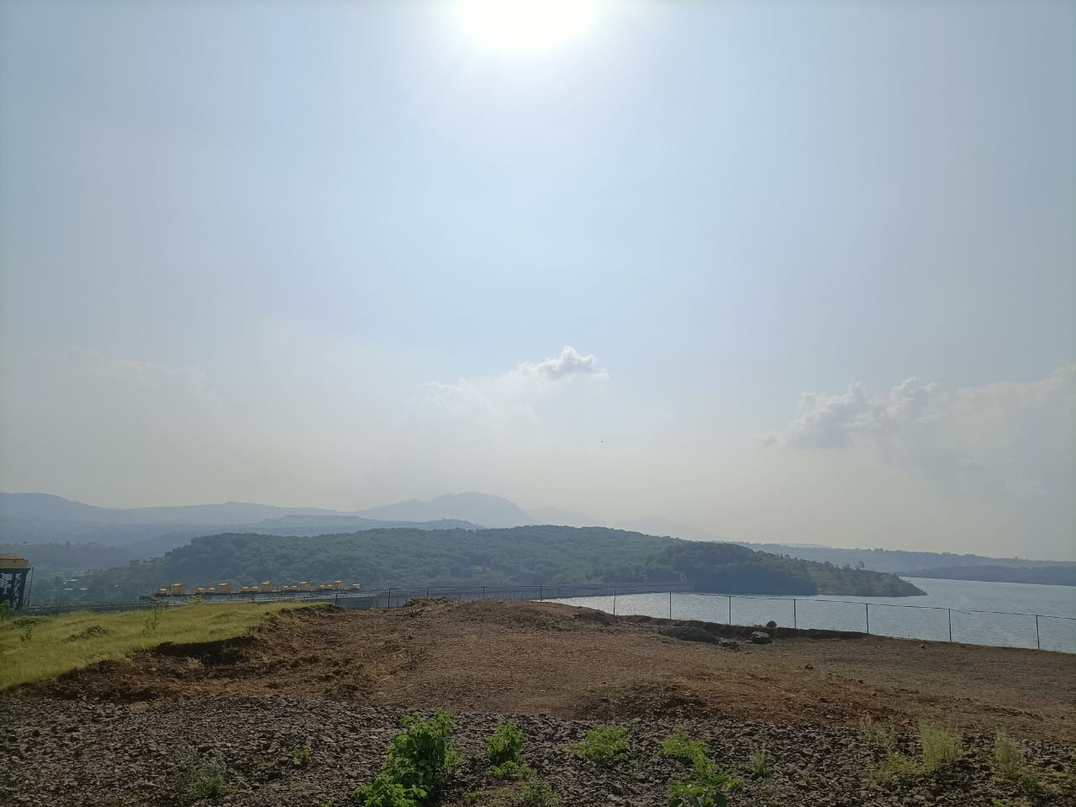

There we observed several freshwater nektons which are mentioned below.

**1)Dragonflies**:we observed three types of different dragonflies there

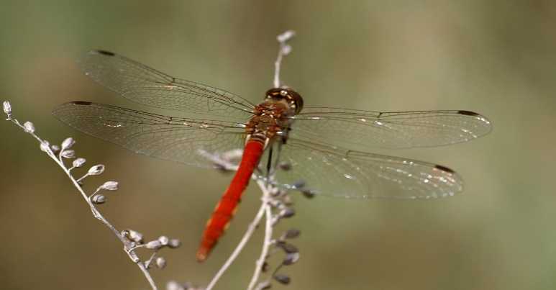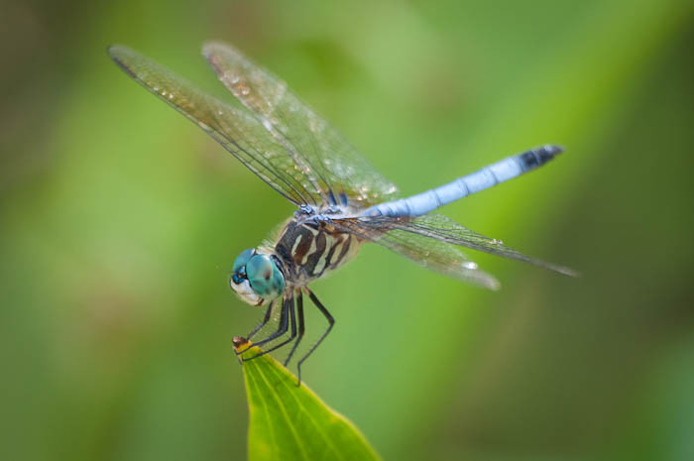

* **Red Groundling**: (*Brachythemis)* These usually Found Near the water bodies such as rivers, Dams, Lakes and Ponds. These are bright red coloured dragonflies, Small in Size and have large orangesplashes on wings. They looked very attractive.
* **Blue dasher**:*(Pachydiplaxlongipennis)*It is blue coloured dragonfly, they bear long wings but not a lot longer than their relative species.
* **Common Hawker:***(Aeshna juncea)*The Common **Hawker**is a large **hawker dragonfly** which is on the wing from the end of June through to October.

**2) Eel Fish:**

* + Eels are elongated fish, ranging in length from 5 cm (2 in) in the one-jawed eel ([*Monognathus*](https://en.wikipedia.org/wiki/Monognathus)*ahlstromi*) to 4 m (13 ft) in the [slender giant moray](https://en.wikipedia.org/wiki/Slender_giant_moray).
  + Adults range in weight from 30 g (1 oz) to well over 25 kg (55 lb).
  + They possess no [pelvic fins](https://en.wikipedia.org/wiki/Pelvic_fin), and many species also lack [pectoral fins](https://en.wikipedia.org/wiki/Pectoral_fin). The [dorsal](https://en.wikipedia.org/wiki/Dorsal_fin) and [anal fins](https://en.wikipedia.org/wiki/Anal_fin) are fused with the [caudal](https://en.wikipedia.org/wiki/Caudal_fin) fin, forming a single ribbon running along much of the length of the animal.Eels swim by generating waves that travel the length of their bodies.
  + They can swim backward by reversing the direction of the wave.
  + They usually live in shallow water,here we saw many young Eel fish.

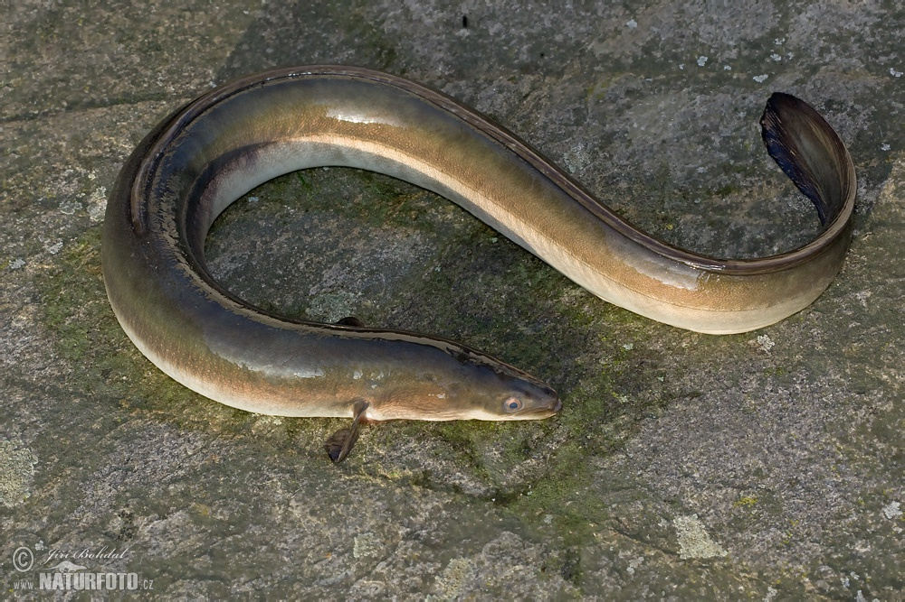

There was a huge area which was covered by the algae, it was blue green algae and also, we observed that there was a part which covered by yellow colour algae.

The water may also contain several zooplanktons as well as phytoplanktons.

**Zooplanktons** such as

* + paramecium
  + Euglena
  + Vorticella
  + daphnia
  + copepods etc.

**Phytoplanktons** such as

* Spirogyra
* *Chlorophyta*
* *Chrysophyceae*
* Microspora
* Diatoms etc.

It was a very good opportunity for all of us to observe lentic body and its surroundings closely,It was knowledgeable study tour.

