S.B.V.P.Samaj’s

**S.M.B.S.T.College, Sangamner**

**Department of Zoology**

|  |  |  |
| --- | --- | --- |
| 1 | Title of the Activity | **“Spelling Competition”** |
| 2 | Place | Department of Zoology,  S.M.B.S.T.College, Sangamner |
| 3 | Objective of the Activity | To improve grammar  To increase knowledge of the origin of words. |
| 4 | Date & Time of Activity | Date: 15thJanuary 2024  Time: 12:30 to 01:00am |
| 5 | Number of students Participated | 26 students |
| 6 | Guest Lecturer |  |
| 7 | Chief Guest | Dr. B.D.Wagh  Vise Principal , S.M.B.S.T. College , Sangamner |
| 8 | Beneficiary/Program Outcome | It helped Students to gain competency in vocabulary building, allowing them to improve significantly at reading, writing and speaking. |

Program Coordinator IQAC Coordinator Principal

“Spelling Competition”

Report

On January 15, 2023, the Department of Zoology at S.M.B.S.T. Arts Science & Commerce College Sangamner hosted a "Spelling Competition."

Spelling contest is a great opportunity for students to expand their vocabulary, sharpen their listening comprehension, and gain a thorough command of the English language.

It was conducted in the Department of Zoology. Students actively participated and enjoyed the contest. 35 words have been chosen from their syllabus. The majority of the words were Zoology syllabus-related and scientific. The students were seated apart from one another. At the outset, rules, restrictions, and word count were explained. 30 seconds were allotted to one word. There were 26 students that took part in the spelling contest.It helped Students to gain competency in vocabulary building, allowing them to improve significantly at reading, writing and speaking.

Three winners were selected based on the highest marks received, and they are as follows:

1)Jadhav Payal Santosh

2)Shaikh Ayesha Sajid

3)Khule Prasad Babasaheb

HOD

Prof.Dr.Dhakne K.R.

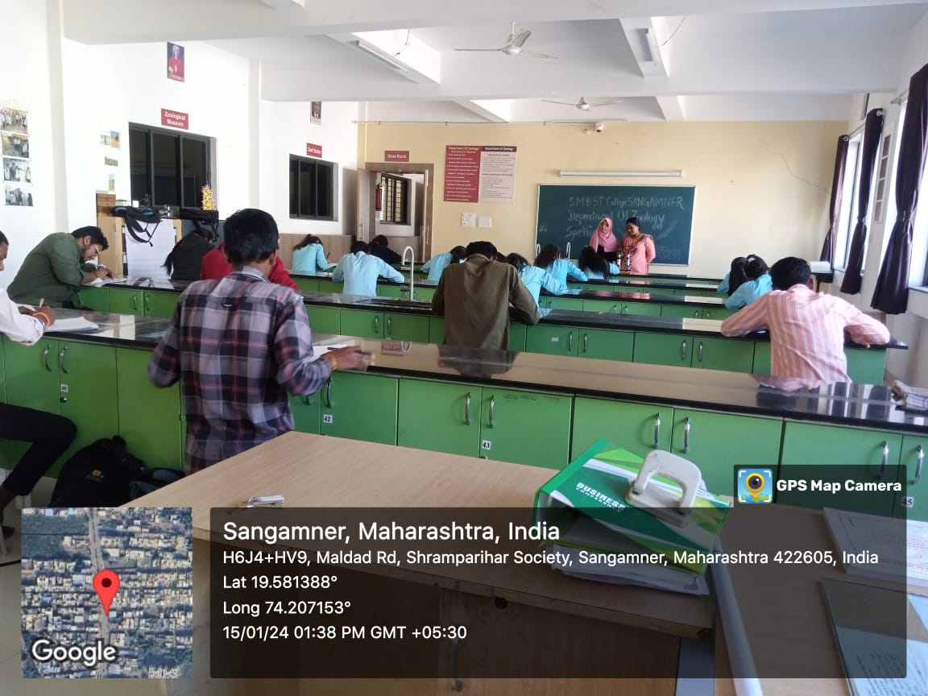

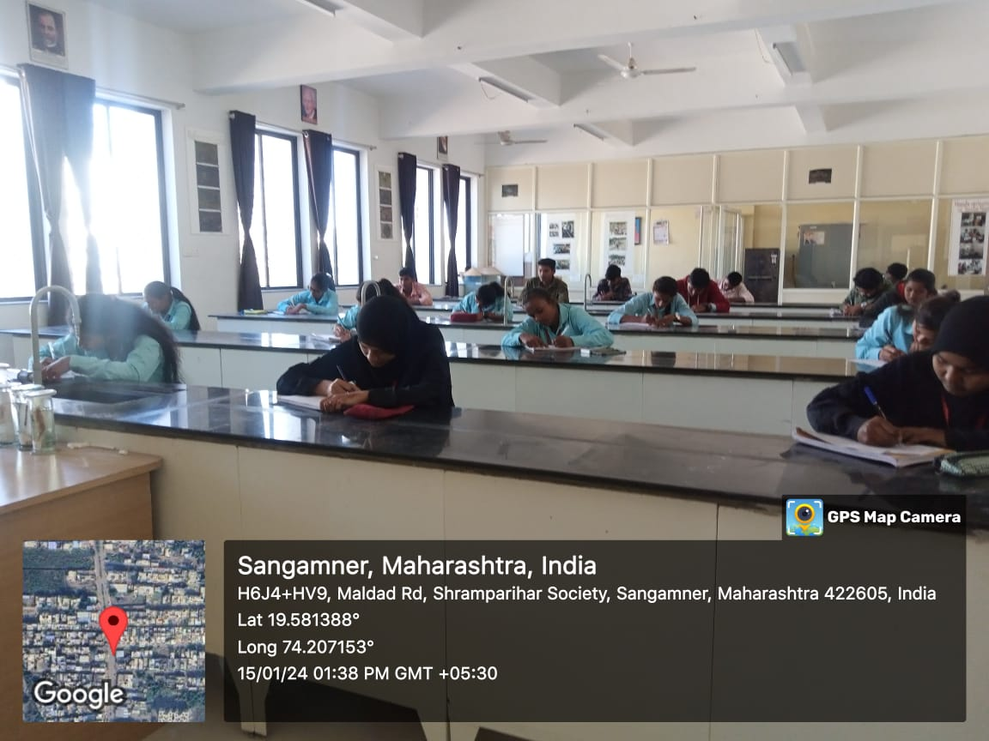

Spelling competition