S.B.V.P.Samaj’s

**S.M.B.S.T.College, Sangamner**

**Department of Zoology**

|  |  |  |
| --- | --- | --- |
| 1 | Title of the Activity | **“Sparrow Day Celebration”** |
| 2 | Place | S.M.B.S.T. College Sangamner , College Campus |
| 3 | Objective of the Activity | To promote awareness  To make conservation efforts for declining sparrow population. |
| 4 | Date & Time of Activity | Date: 10th October 2024  Time: 12:00 pm Onwards |
| 5 | Number of students Participated | 03 students of Nutan College, Rajapur.  11 students from SMBST College, Sangamner. |
| 6 | Lecturer | Prof.DR.L.D.Ghaywat |
| 7 | Chief Guest | Dr.D.D.Patil (Principal ,SMBST College ) |
| 8 | Beneficiary/Progamme Outcome | It helped to raise awareness in students, instill a sense of responsibility towards nature, and inspire ongoing efforts to protect sparrows and their habitats. |

Program Coordinator IQAC Coordinator Principal

Sparrow day celebration

Report

Sparrow Day, observed annually on March 20th, serves as a reminder of the declining sparrow population globally and aims to promote awareness and conservation efforts. This report details the Sparrow Day celebration organized by the Zoology Department of S.M.B.S.T. Collegein collaboration with Nutan College Rajapur on March 20th , 2024.

Students and faculty members of the Zoology Department at S.M.B.S.T. College, along with three students from Nutan College Rajapur, came together to commemorate Sparrow Day. The event aimed to educate participants about the importance of sparrows in ecosystems and to encourage practical actions for their conservation.

A total of 11 students participated in the event, comprising seven TYBSc students, four MSC students from SMBST College, and three students from Nutan College Rajapur. Dr. L.D. Ghaywat, a faculty member from the Zoology Department S.M.B.S.T. College, played a pivotal role in organizing and leading the event.

Dr. L.D. Ghaywat delivered an informative session to the participants, highlighting the ecological significance of sparrows and the factors contributing to their declining populations. Following the session, students engaged in a hands-on activity where they crafted bird feeders using locally available materials.

The Sparrow Day celebration at S.M.B.S.T. College facilitated meaningful engagement and learning among students and faculty members. By actively participating in the creation and installation of bird feeders, students took concrete steps towards fostering sparrow-friendly environments within the college campus.

The collaborative effort between S.M.B.S.T. College and Nutan College Rajapur exemplifies the importance of collective action in wildlife conservation. The Sparrow Day celebration served as a platform to raise awareness, instill a sense of responsibility towards nature, and inspire ongoing efforts to protect sparrows and their habitats.

Moving forward, it is essential to sustain the momentum generated by the Sparrow Day celebration through continued education, community engagement, and habitat restoration initiatives. By working together, we can ensure a brighter future for sparrows and contribute to the preservation of biodiversity.

This report encapsulates the spirit of Sparrow Day and highlights the collective commitment towards sparrow conservation demonstrated by the students and faculty members of S.M.B.S.T. College and Nutan College Rajapur.

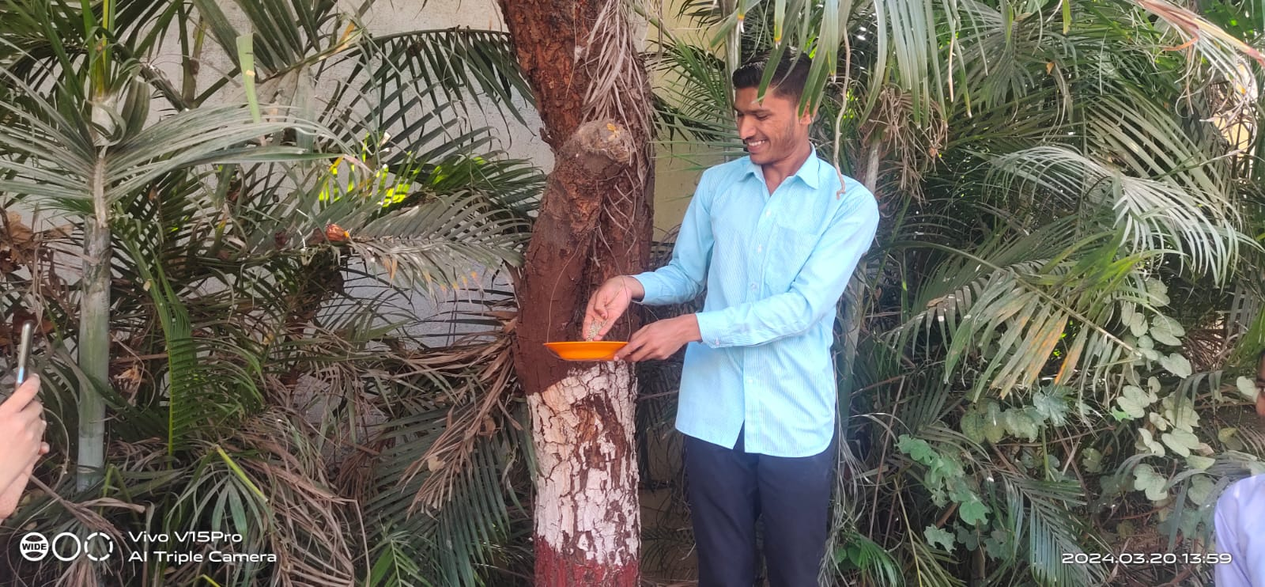

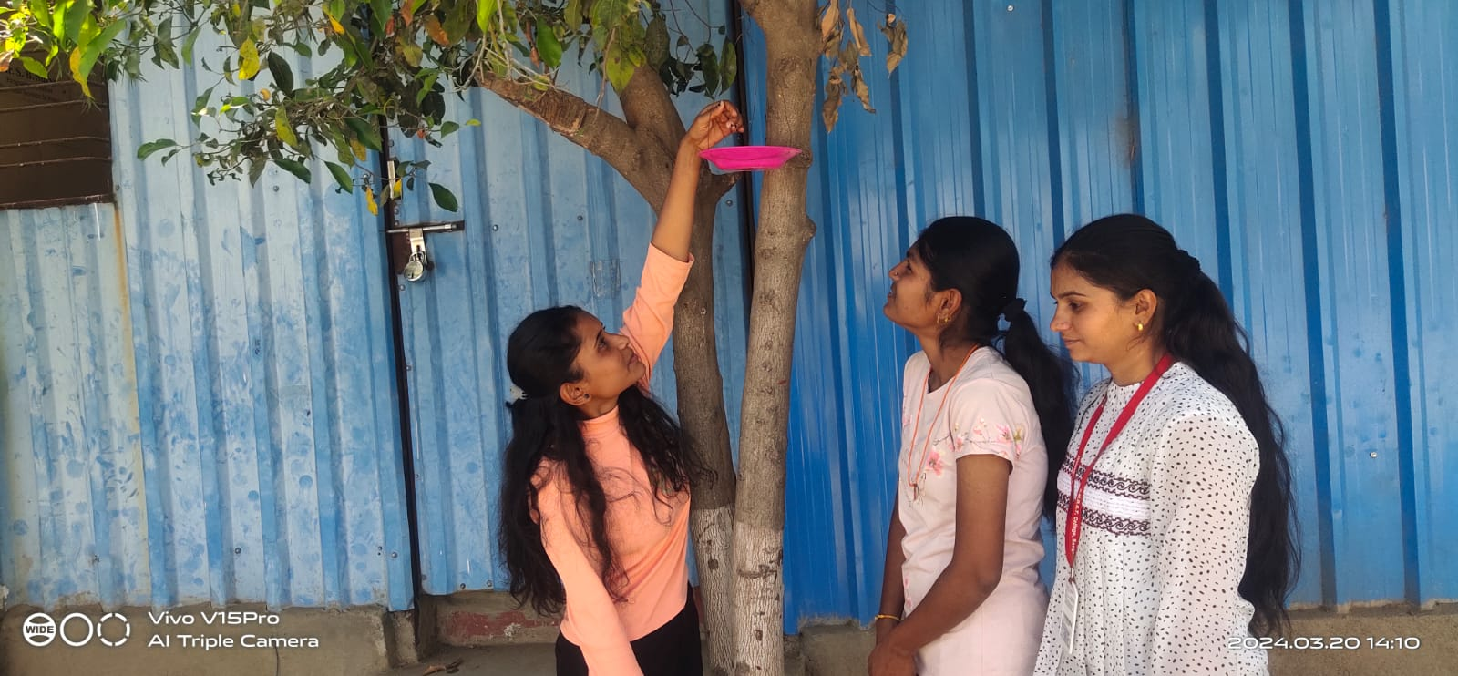

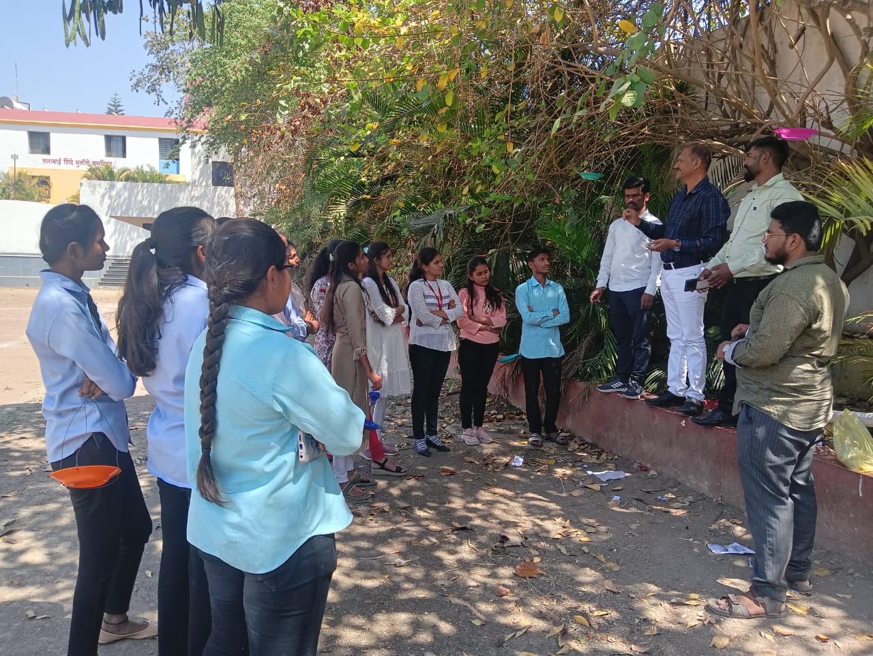

**Photographs while setting up the Bird Feeders**