**S.B.V.P. Samaj’s,**

**S.M.B.S.T. College Sangamner.**

**Department of BCA(Science)**

**Departmental Activities**

“**Power Point Presentation Competition**” in our college is an activity which improve Confidence of stage Performance .It also Improve latest’s Industrial Technology Knowledge (AI ,Cloud Computing ,Cyber Security Data Science etc). The 9th of July 2023 was as a memorable day in the life of every Student of B.C.A (Science) batch 2023-24 at S.M.B.S.T. College, Sangamner campus.

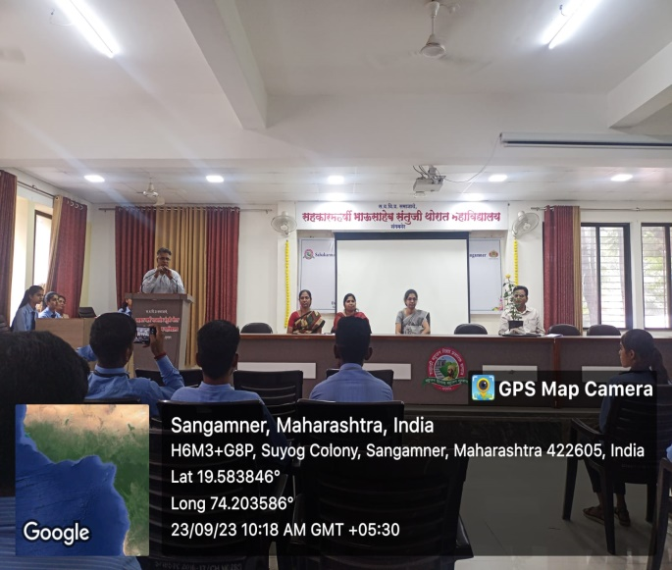 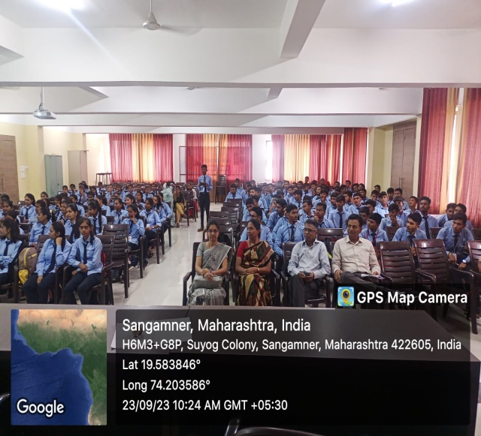

**Power Point Presentation Competition**

