S. B.V. P. Samaj’s
Sahakar Maharshri Bhausaheb Santuji Thorat College Sangamner, A. Nagar
Student mentoring cell
Activity of Mentee
(Academic Year 2022-23)
Campus Visit

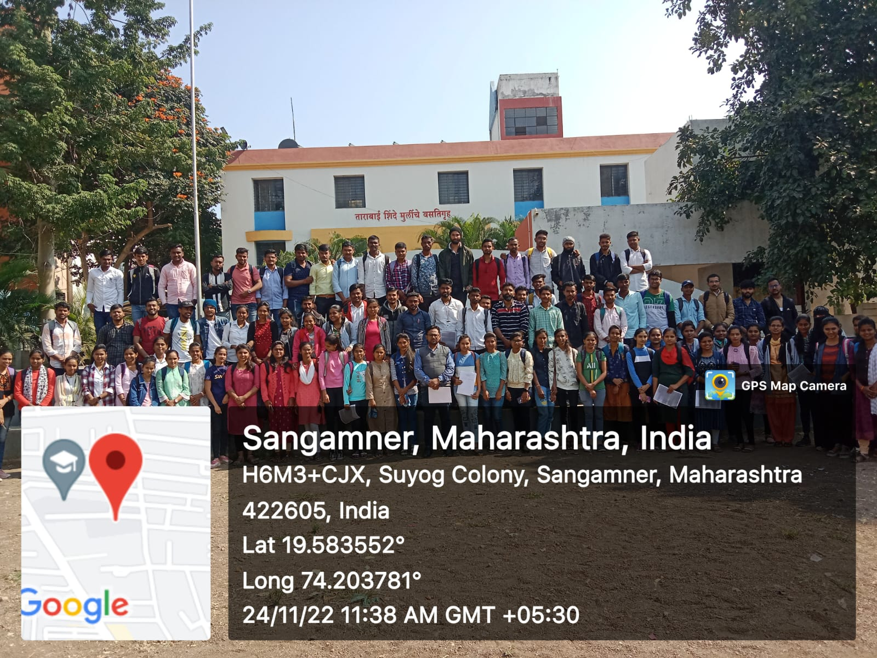

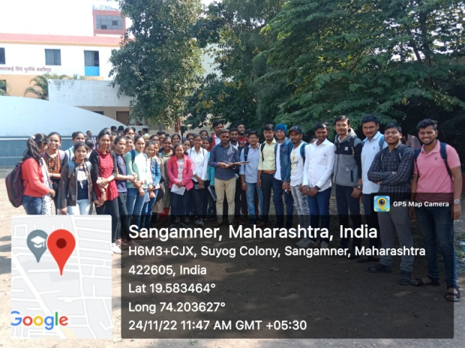
M.Com II Years students visit to college campus for the informative activities.

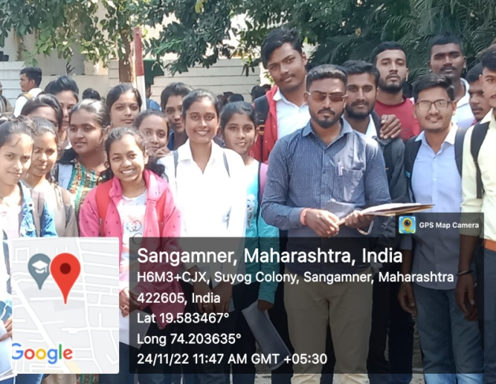

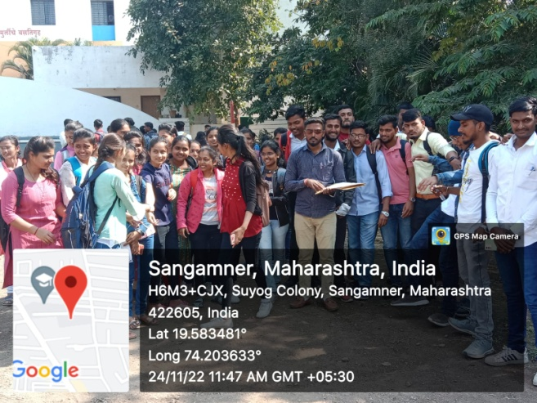

M.Com II Years students visit to college campus for the informative activities.

