**SBVP Samaj’s**

**Sahakar Maharshi Bhausaheb Santuji Thorat**

**Arts, Science & Commerce College, Sangamner**

To,

The Principal,

S.M.B.S.T. College Sangamner

Sub: Report of Activity Human-Leopard Conflict Mitigation Awareness Program

Occasion of Human-Leopard Conflict Mitigation Awareness Program

Date: - 29/08/2024 Time :- 11:00 am on wards Venue :- K.B. Dada Hall, S.M.B.S.T. college Sangamner

|  |  |  |  |  |  |  |
| --- | --- | --- | --- | --- | --- | --- |
| **Sr.No.** | **Event Activity Description** | **Description** | | | | |
| 1 | Introduction | In many parts of India, Leopard lives in close proximity to human habitation with surprisingly low levels of conflicts. Human-Leopard Conflict is when humans and leopards have negative interactions that can harm humans or their resources. This can include injuries or deaths to humans and loss of property like cattle or poultry. | | | | |
| 2 | Aim and Objective | * To understand the reasons behind this Human-Leopard conflict. * To find out remedy to protect humans and their lively hood. * To learn what can be done to reduce this conflict. * To inform the local community about leopard behavior and the nuances of human-wildlife conflict. | | | | |
| 3 | Organizer | IQAC,Science Association and Department of Zoology | | | | |
| 4 | Beneficiary | Student | Other College | Teacher / Staff | Stakeholder | Total |
| 132 |  | 21 |  | 153 |
| 5 | Resource Persons | Mr.Abhijeet Mahale  RESQ Nashik Division | | | | |
| 6 | Topic Covered | 1. Perspective on managing human-leopard interactions. 2. Effective conflict reduction strategies. 3. Practical measures to ensure the safety of both humans and leopard. | | | | |
| 7 | Outcomes | * Participant got the knowledge of how one can manage the humanleopard interactions. * They cleared doubt and misconceptions about leopard. * They learn effective conflict reduction stratergies | | | | |
| 8 | Acknowledgement | Wewould like to thank Mr.AbhijeetMahaleand his team  RESQ Nashik Division with whom we get chance to interact.  In particular we would like to thank Dr. D.D. Patil (Principal) and Dr. L.D Ghaywat (IQAC co-ordinater) for their interest, support and help. | | | | |
| 9 | Short report of the activity-  The IQAC,Science Association and Department of Zoology organized a Human-Leopard Conflict Mitigation Awareness Program on Tuesday, 29th August 2024 at K. B. Dada Hall, S.M.B.S.T. college, Sangamner.  The event featured an insightful session led by Abhijeet Mahale from RESQ trust Nashik Division, whose expertise provided valuable perspectives on managing human-leopard interactions. The session was made more interesting by sharing the experiences of rescue of leopard from human habitat. They also showed various video of leopard rescue. A well-equipped team with necessary gears, reaches location and assess the surrounding. Then proceeds with extreme caution and tranquilizes the leopard from safe distance. After sedation is done, the capture leopard is examining for any injury and then released to forest area. Participants gained a deeper understanding of effective conflict reduction strategies, the importance of wildlife conservation, and practical measures to ensure the safety of both humans and leopards. Participants cleared their doubts by asking questions. The session was very informative for the entire participant. | | | | | |

Note: Attach geo-tag photo of the activity and submit the report to IQAC after sign by the Principal.

Head of The Dept. . Principal Coordinator IQAC

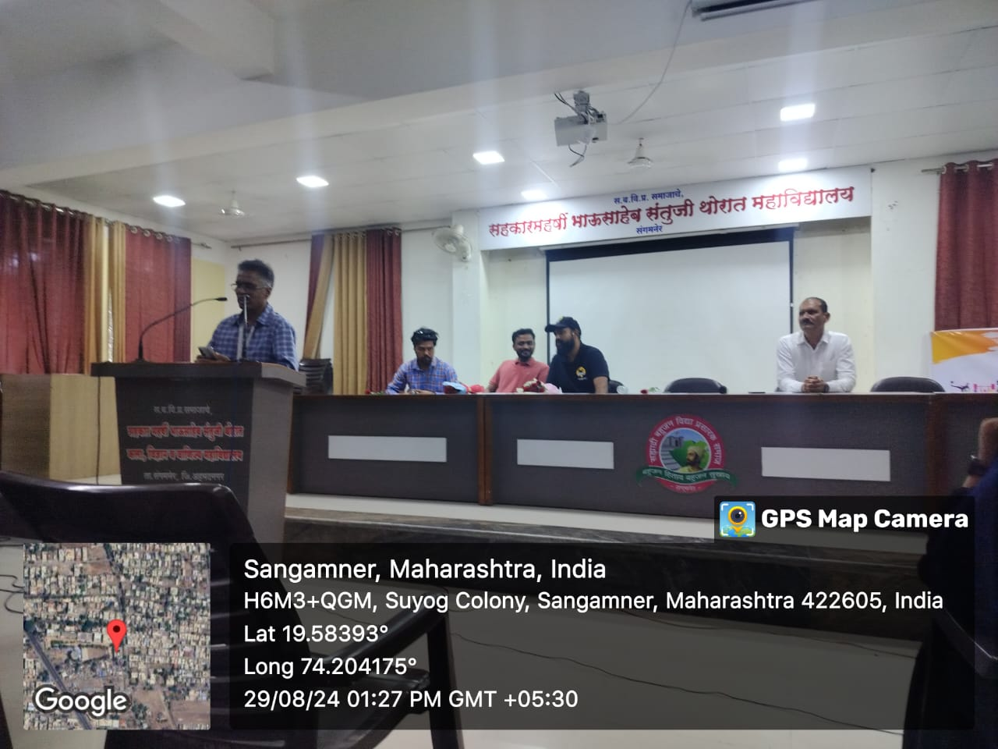

Introduction of the guest

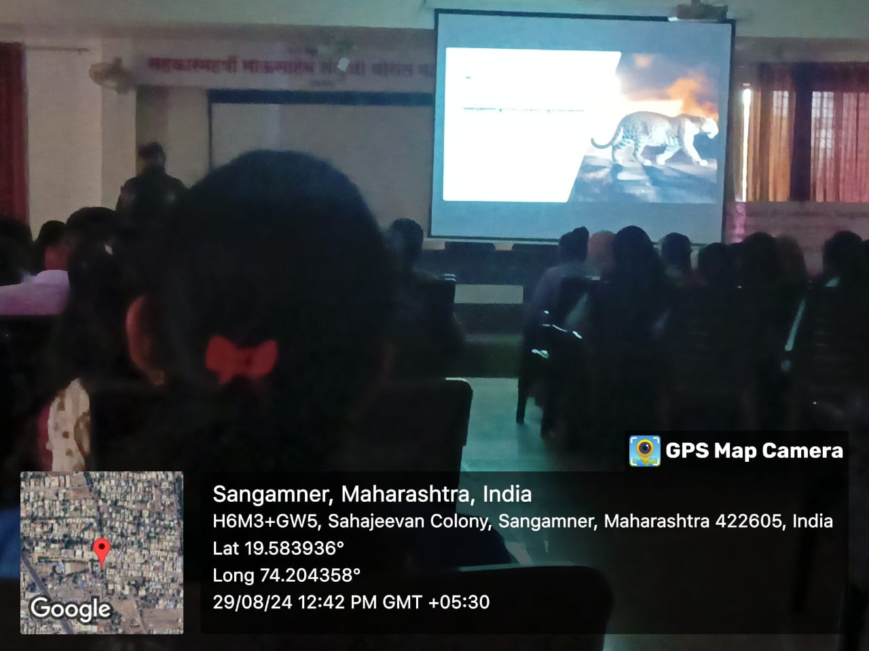

Resource person delivering information about leopards

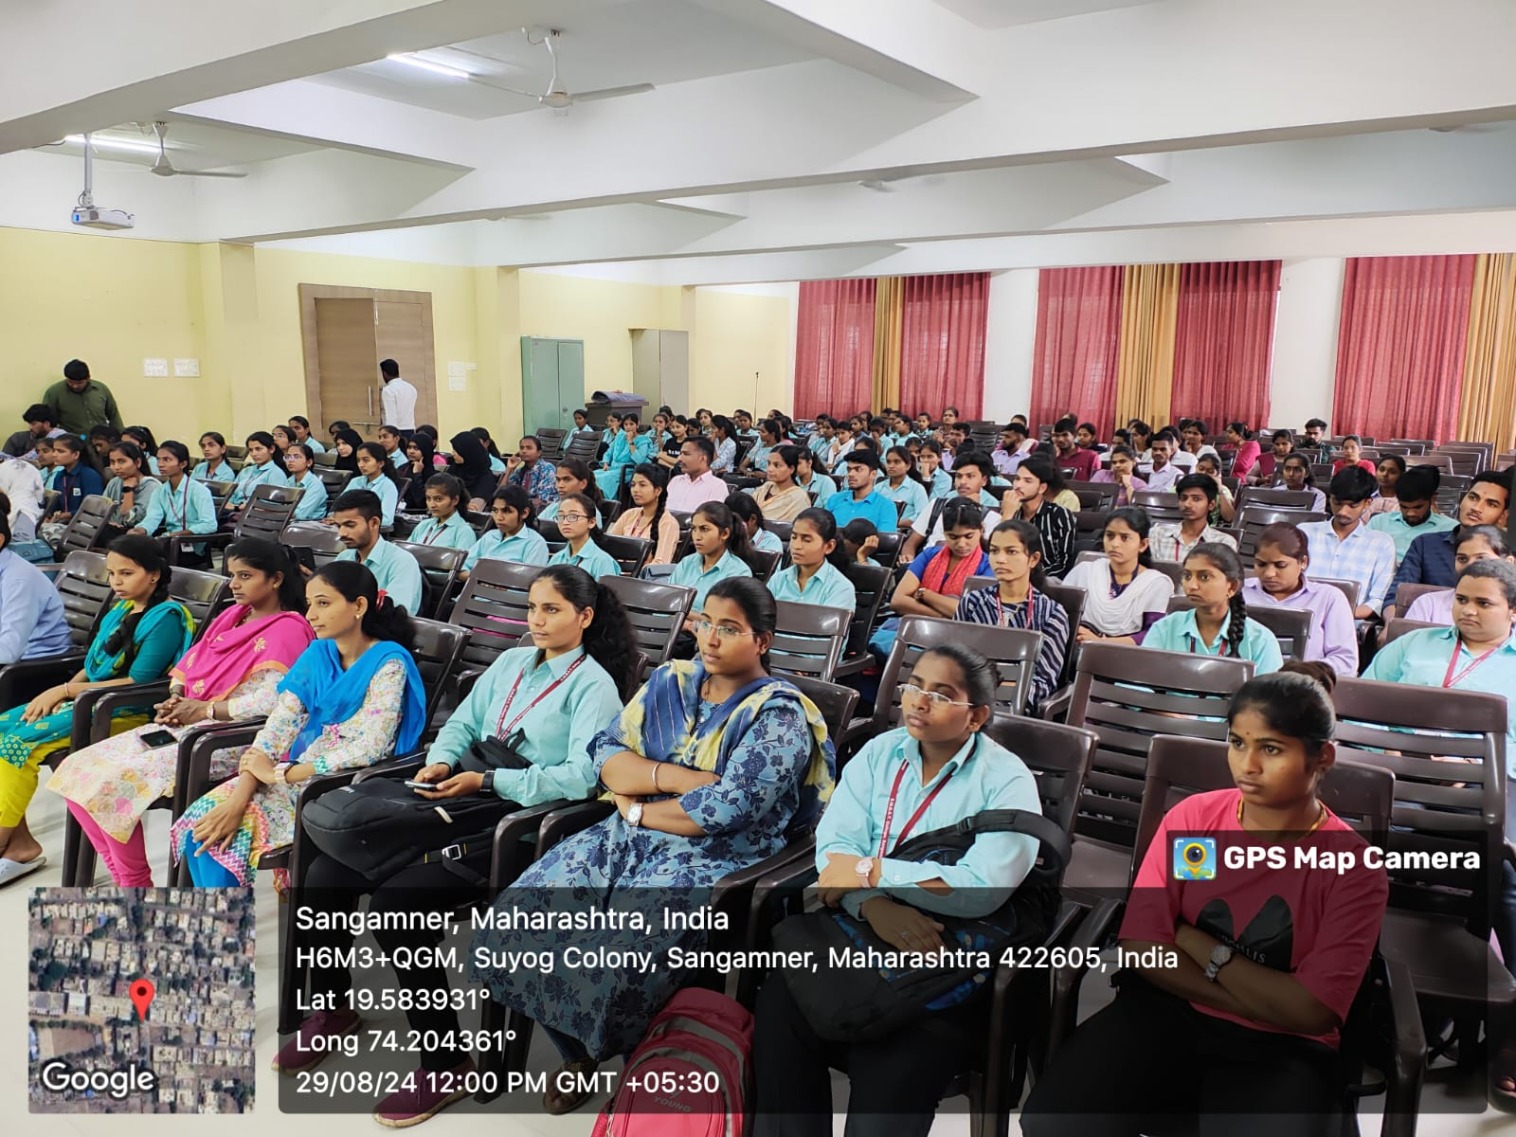

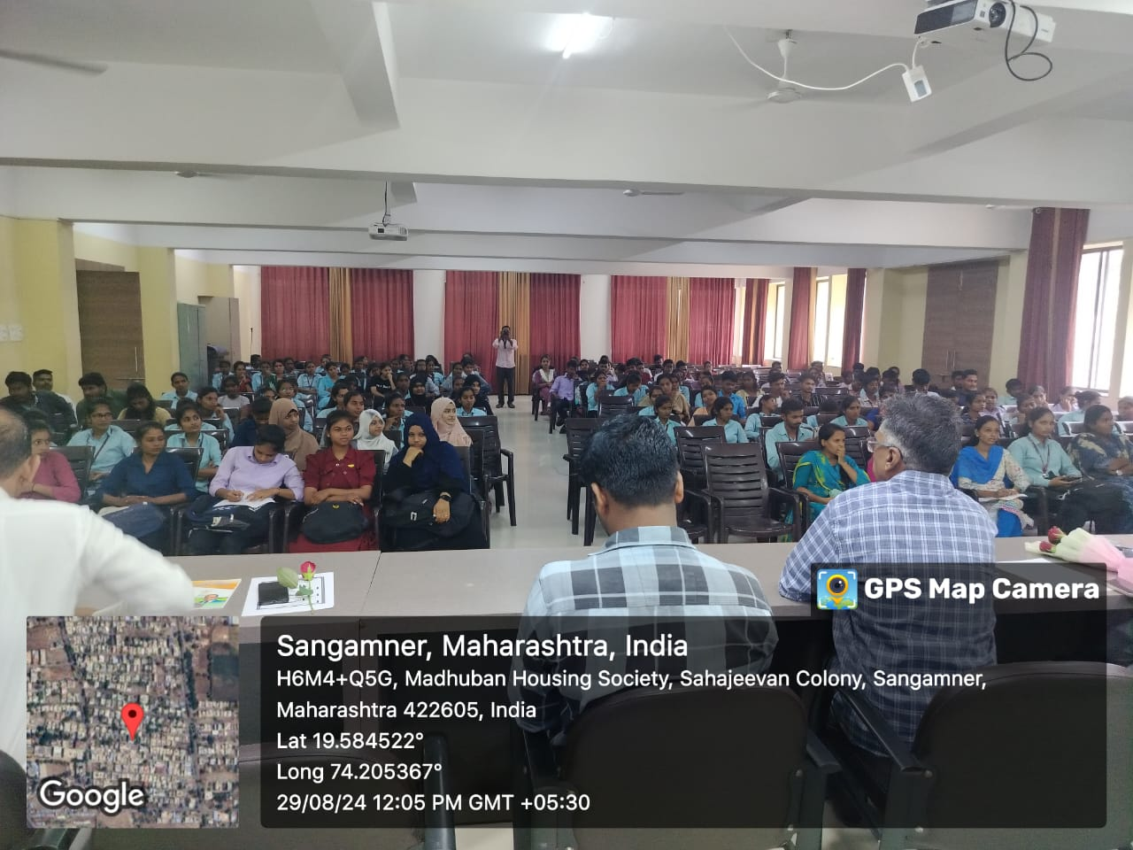

Q and A Session

