# S.B.V.P. Samaj’s

# SahakarMaharashi Bhausaheb Santuji Thorat Arts,Science & Commerce College Sangamner.

To,

The Principal,

S.M.B.S.T. College Sangamner.

### Sub: Report of Activity- “A Healthy and Nutritious Diet for the Youth”

Date: - 06 / 09 /2024 Time: - 10.00 am Venue: - K.B.D. Hall

|  |  |  |  |  |  |  |
| --- | --- | --- | --- | --- | --- | --- |
| **Sr. No.** | **Event Activity Description** | **Description** | | | | |
| **1** | **Introduction** | Adolescence is a critical period of growth and development, making it essential for young individuals to adopt healthy and nutritious dietary habits. A balanced diet not only supports physical growth but also enhances cognitive function, emotional well-being, and overall health. [Proper nutrition during these formative years can prevent various health issues such as obesity, type 2 diabetes, heart disease, and deficiencies in essential nutrients](https://www.cdc.gov/healthyschools/nutrition/facts.htm)  Educating young people about the importance of a healthy diet and safe eating practices empowers them to make informed choices that will benefit their long-term health. [By fostering these habits early on, we can help the youth build a strong foundation for a healthier future](https://www.myplate.gov/tip-sheet/healthy-eating-teens) | | | | |
| **2** | **Aim an**  **Objective** | The lecture aimed to educate and inspire young students about the significance of maintaining a healthy and nutritious diet, crucial for their growth and overall well-being. | | | | |
| **3** | **Organizer** | **Lions club , I.Q.A.C. & Department of Zoology** | | | | |
| **4** | **Beneficiary** | Student | Other College | Teacher / Staff | Stakeholder | Total |
| 33 | 0 | 58 | 0 | 91 |

|  |  |  |
| --- | --- | --- |
| **5** | **Resource Persons** | **Sakshi Sachin Somani** |
| **6** | **Welcome & Felicitation of resource person** | **Dr.D.D. Patil (Principal )** |
| **7** | **Topic Covered** | 1. [Balanced Diet: Emphasize the importance of consuming a variety of foods from all food groups: fruits, vegetables, grains, protein foods, and dairy or fortified soy alternatives](https://www.myplate.gov/tip-sheet/healthy-eating-teens). 2. Macronutrients: 3. Micronutrients: 4. Hydration: Stress the importance of drinking plenty of water and limiting sugary drinks. [Encourage the consumption of water, milk, and natural fruit juices](https://www.myplate.gov/tip-sheet/healthy-eating-teens)[4](https://www.hopkinsmedicine.org/health/wellness-and-prevention/healthy-eating-during-adolescence). 5. [Healthy Snacking: Provide ideas for nutritious snacks, such as fruits, vegetables, yogurt, and nuts, instead of processed snacks high in sugar and unhealthy fats](https://www.myplate.gov/tip-sheet/healthy-eating-teens).. 6. Meal Planning: Teach how to plan balanced meals and the importance of regular meal times. [Include tips on portion control and the benefits of eating a variety of foods](https://www.myplate.gov/tip-sheet/healthy-eating-teens). 7. [Reading Nutrition Labels: Educate on how to read and understand nutrition labels to make informed food choices](https://www.myplate.gov/tip-sheet/healthy-eating-teens). 8. Physical Activity: Highlight the connection between diet and physical activity. [Encourage regular exercise as part of a healthy lifestyle](https://www.myplate.gov/tip-sheet/healthy-eating-teens). 9. [Special Diets: Address dietary needs for specific conditions, such as vegetarianism, lactose intolerance, or food allergies](https://www.myplate.gov/tip-sheet/healthy-eating-teens). 10. [Mental and Emotional Health: Discuss the impact of diet on mental health and the importance of a positive relationship with food](https://www.healthline.com/nutrition/healthy-eating-for-teens). |
| **8** | **Outcomes** | 1. **Improved Knowledge**: Youth will gain a better understanding of what constitutes a balanced diet and the importance of various nutrients. 2. **Healthy Eating Habits**: They will learn to make healthier food choices, which can lead to better eating habits and overall health. 3. **Enhanced Physical Health**: With better nutrition, youth can experience improved physical health, including better growth, stronger bones, and a healthier immune system. 4. **Better Mental Health**: Understanding the link between diet and mental health can help youth make food choices that support their emotional well-being. 5. **Increased Energy Levels**: A nutritious diet can lead to higher energy levels, which can improve concentration and performance in school and extracurricular activities. 6. **Prevention of Health Issues**: Educating youth on healthy eating can help prevent diet-related health issues such as obesity, diabetes, and heart disease. 7. **Empowerment**: Youth will feel empowered to take control of their health and make informed decisions about their diet. 8. **Positive Relationship with Food**: They will develop a healthier relationship with food, understanding that it’s not just about eating but about nourishing their bodies. |
| **9** | **Acknowledgement** | We would like to thank the Lions Club, I.Q.A.C., and the Zoology Department of S.M.B.S.T. College, Sangamner for organizing this insightful event. Your dedication and hard work made this possible.  A special thanks to our esteemed resource person, Ms. Sakshi Sachin Somani, for sharing her valuable knowledge and expertise. Your engaging presentation and practical advice have undoubtedly inspired our students to adopt healthier eating habits.  We also appreciate the participation of the 30 students who attended the lecture. Your enthusiasm and active involvement made the session interactive and enriching.  Lastly, we acknowledge the support of all faculty members and staff who assisted in the smooth execution of this event. |
| **10** | **Short report of the activity** | |

### Report on One-Day Lecture: “A Healthy and Nutritious Diet for the Youth”

**Date:** 6th September 2024

**Venue:** K..B. Dada Hall, Science Building, S.M.B.S.T. College, Sangamner

**Organized by:** Lions Club, I.Q.A.C., and Zoology Department of S.M.B.S.T. College, Sangamner

**Resource Person:** Ms. Sakshi Sachin Somani

**Number of Students Present:** 33

On 6th September 2024, a one-day lecture on “A Healthy and Nutritious Diet for the Youth” was held at K.B. Dada Hall, Science Building, S.M.B.S.T. College, Sangamner. The event was a collaborative effort organized by the Lions Club, the Internal Quality Assurance Cell (I.Q.A.C.), and the Zoology Department of S.M.B.S.T. College Sangamner . The lecture aimed to educate young students about the importance of maintaining a healthy and nutritious diet.

The session began with a warm welcome and felicitation of the resource person, Ms. Sakshi Sachin Somani, by the principal, Dr. D.D. Patil. The resource person for the lecture was Ms. Sakshi Sachin Somani, a renowned nutritionist and health advocate. Ms. Somani began the session by highlighting the critical role of nutrition in the overall development and well-being of youth. She emphasized that adolescence is a crucial period for growth and development, making it essential to adopt healthy eating habits.

Ms. Somani discussed various aspects of a balanced diet, including the importance of consuming a variety of foods from different food groups. She explained how nutrients like proteins, carbohydrates, fats, vitamins, and minerals contribute to physical and mental health. The lecture also covered practical tips for incorporating healthy foods into daily meals, such as choosing whole grains, fresh fruits, and vegetables, and reducing the intake of processed foods and sugary drinks.

The session was interactive, with students actively participating and asking questions. Ms. Somani addressed common myths and misconceptions about dieting and provided evidence-based advice on how to make healthier food choices. She also shared simple and nutritious recipes that students could easily prepare at home.

The lecture concluded with a Q&A session, where students had the opportunity to seek personalized advice from Ms. Somani. The event was well-received, and the students expressed their appreciation for the valuable insights and practical knowledge they gained.

Overall, the one-day lecture on “A Healthy and Nutritious Diet for the Youth” was a resounding success. It not only raised awareness about the importance of nutrition but also empowered students to make informed choices about their diet and lifestyle.

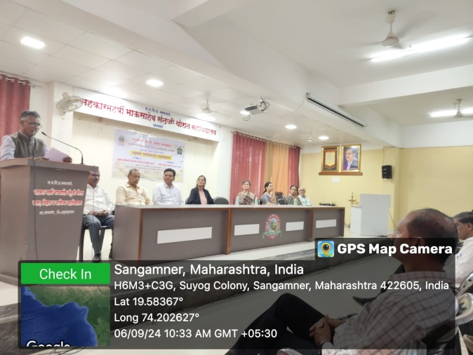 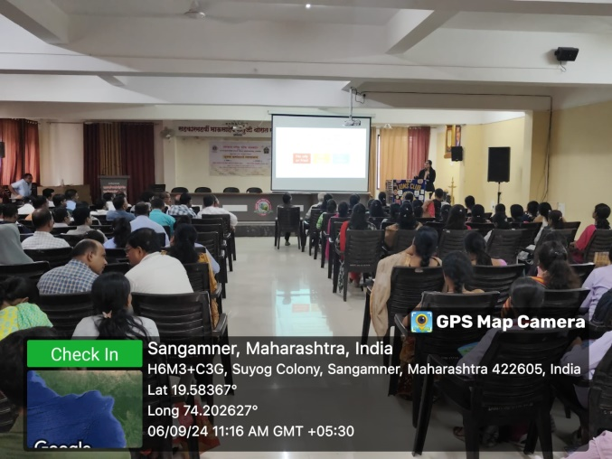

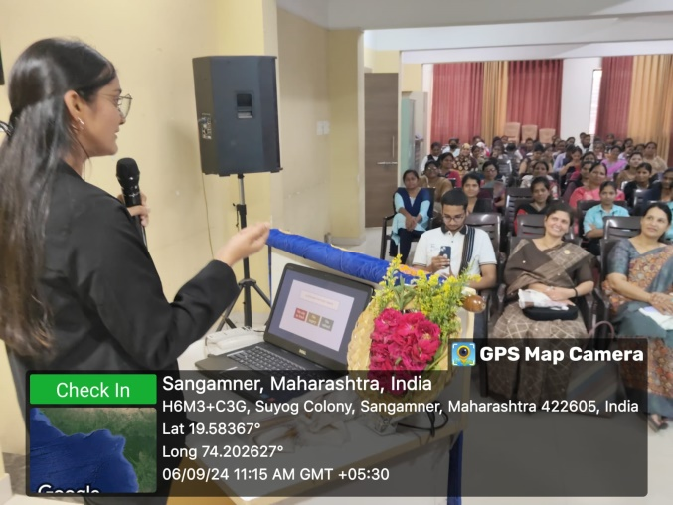 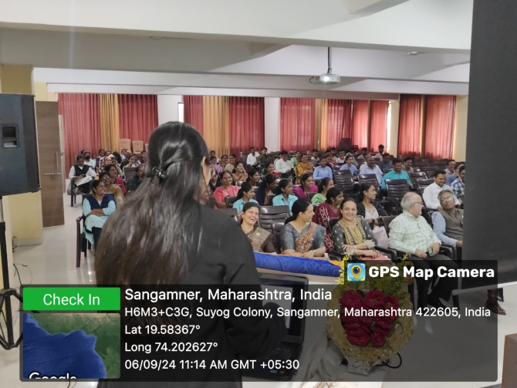

Ms. Sakshi Somani Explaining about a Healthy Diet .