**Sahakar Maharshi Bhausaheb Santuji Thorat**

**Arts, Science & Commerce College, Sangamner**

To,

The Principal,

S.M.B.S.T. College Sangamner

Sub: Organizing ‘Welcome Function’ for Geography Special S.Y. Students.

Date: - From 31 / 07 /2024 Time: - Daily 10:00 am to 11:00 am

Venue: - Department of Geography, Laboratory S.M.B.S.T. College, Sangamner.

|  |  |  |  |  |  |  |
| --- | --- | --- | --- | --- | --- | --- |
| **Sr.No.** | **Event Activity Description** | **Description** | | | | |
| 1 | Introduction | Welcome Function helps to glorify the occasion. Everybody expects an introductory speech for an event. It helps to connect specialization students to department. | | | | |
| 2 | Aim and Objective | The goal of a welcome party is to create a warm and inviting atmosphere to celebrate the arrival of a guest or group of guests and make them feel comfortable and appreciated. A welcome party is an event or gathering designed to welcome and celebrate the arrival of a guest or group of guests. | | | | |
| 3 | Organizer | Department of Geography | | | | |
| 4 | Beneficiary | Student | Other College | Teacher / Staff | Stakeholder | Total |
| 33 | - | 6 | 1  Dept. of Geography, S.M.B.S.T. College, Sangamner. | 39 |
| 5 | Resource Persons | * Guest Speaker: - Mr. Dr.D.V. Pokharkar * Chief Guest- Dr.Kolhe Sir (Vice Principal) * Special Appearance- Dr. Wagh Sir (Vice Principal) * Special Appearance- Dr. Ghayavat Sir (IQAC Co-Ordinator) * Asst.Prof.- Mr.Gaikwad P.M. (H.O.D) * Asst. Prof.- Mr Kadam R.K. * Asst.Prof.- Mr.Patil A.B. * .Asst.Prof.- Mr. Sonvane B.V. * Asst.Prof.- Mr. Gund S.P. * Asst.Prof.- Mr. Gosavi S.R. | | | | |
| 6 | Topic Covered | * Introducing new Friends * Introducing new teachers * To increase participation of Student in Departmental Activity. | | | | |
| 7 | Outcomes | It sets the tone for the event and can make attendees feel more comfortable and welcome. Additionally, a well-crafted welcome speech can help to promote the event to those who may not be familiar with it. Finally, a good welcome speech can help to build excitement and anticipation for what is to come. | | | | |
| 8 | Acknowledgement | * All Administrative Staff, Dept. of Geography, S.M.B.S.T. College, Sangamner. | | | | |
| 9 | Short report of the activity-  From July 31, 2024, the Dept. of Geography at S.M.B.S.T. College, Sangamner, organized ‘Welcome Function for S.Y. Students’ arranged by T.Y. Geography Specialization students. On this occasion, the Department of Geography organized  *Guest Lecture by – Mr.Dr.D.V. Pokharkar  •Chief Guest- Dr.Kolhe Sir (Vice Principal)  •Special Appearance- Dr. Wagh Sir (Vice Principal)  •Special Appearance- Dr. Ghayavat Sir (IQAC Co-Ordinator)  * Introduction Related Bhoogol Mandal given by – Mr.P.M. Gaikwad (H.O.D.)  *Student Delivered speech by- Mr.Sonavane ,Mrs.Kompalli, Mrs.Gadakh.  * Vote of Thanks given by- Asst.Prof. Patil A.B. | | | | | |

Note: Attach geo-tag photo of the activity and submit the report to IQAC after sign by the Principal.

Head of The Dept. Chairman. Coordinator IQAC Principal

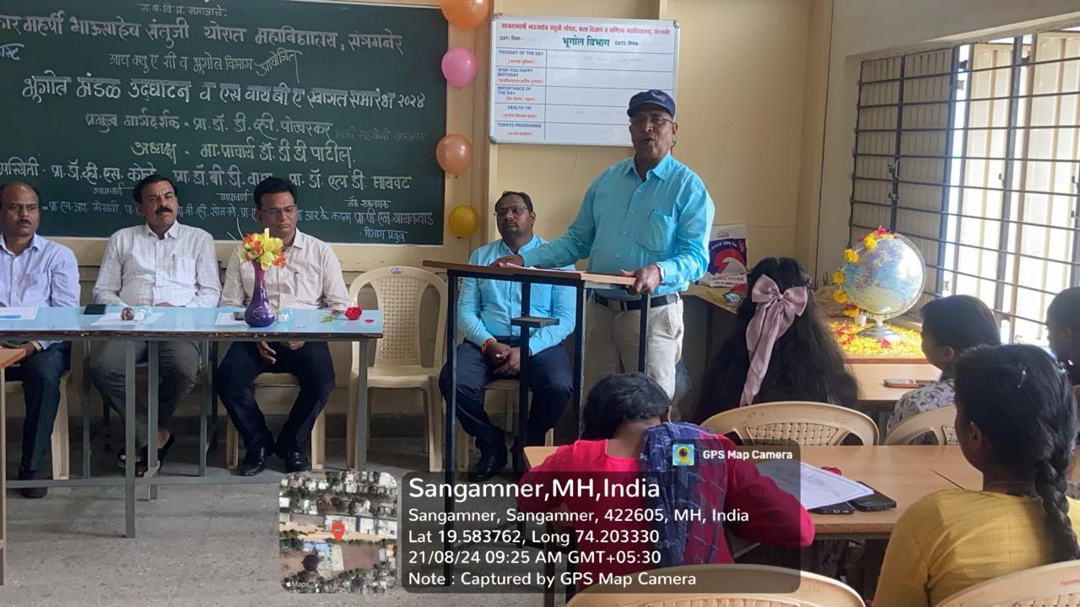 Welcome addressing Lecture delivered by H.O.D. Mr.P.M. Gaikwad Sir.

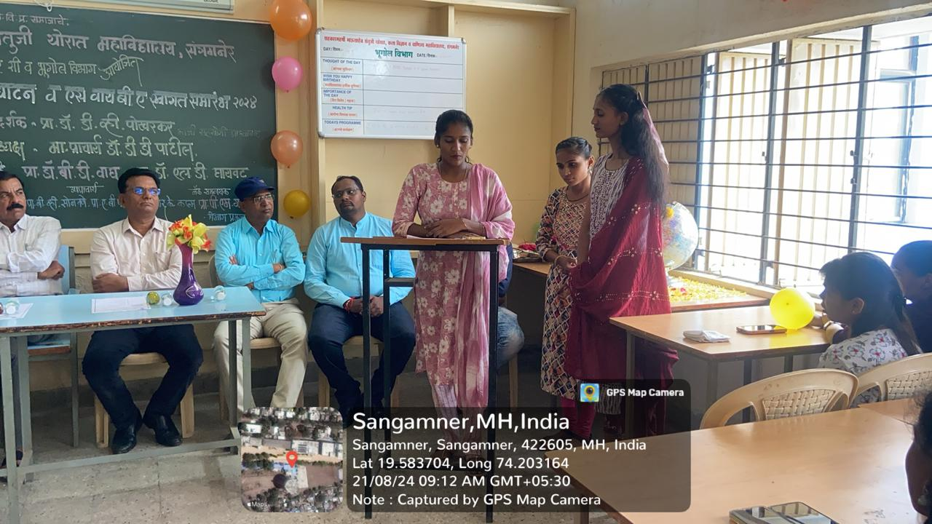

Student delivered speech on the occasion of Welcome Ceremony

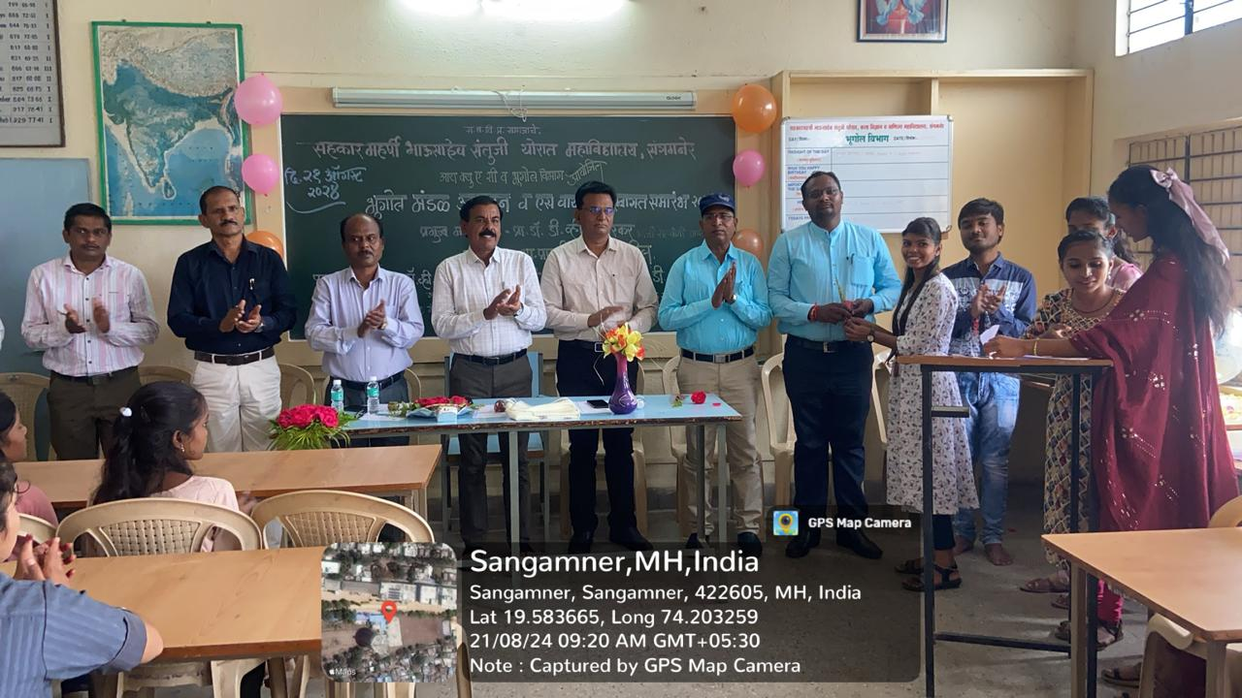 Student Welcomed by Department