**S.B.V.P. Samaj’s,**

**S.M.B.S.T. College Sangamner.**

**Department of BCA (Science)**

**Departmental Activities**

In Our College we Celebrate “**Teachers Day**”. On that Day All interested Student Participate in Teacher Day Activity by become a teacher and conducted lectures. This activity Encourage student for Stage Confidence and also increase respect towards teachers. Every year, Indians celebrate Teachers Day on 5th of September to Commemorate the Birthday of Dr Sarvepalli Radhakrishnan the Country of First Vice President. The 5th of July 2023 was as a memorable day in the life of every B.C.A (Science) batch 2023-24 at S.M.B.S.T. College, Sangamner campus.

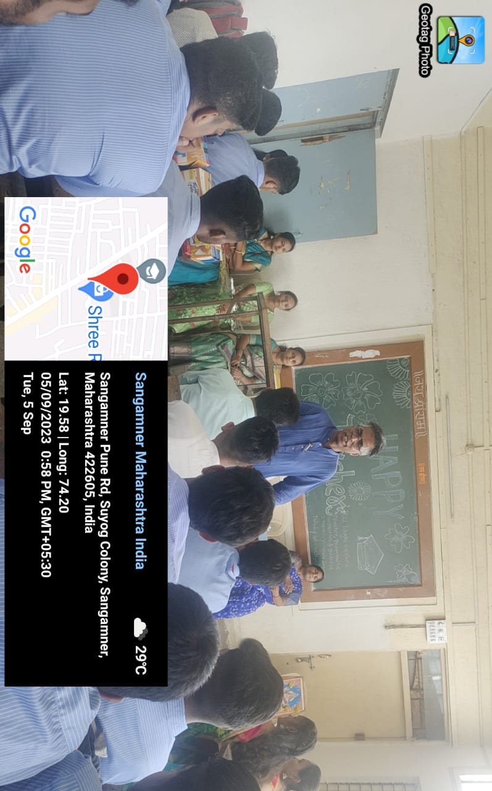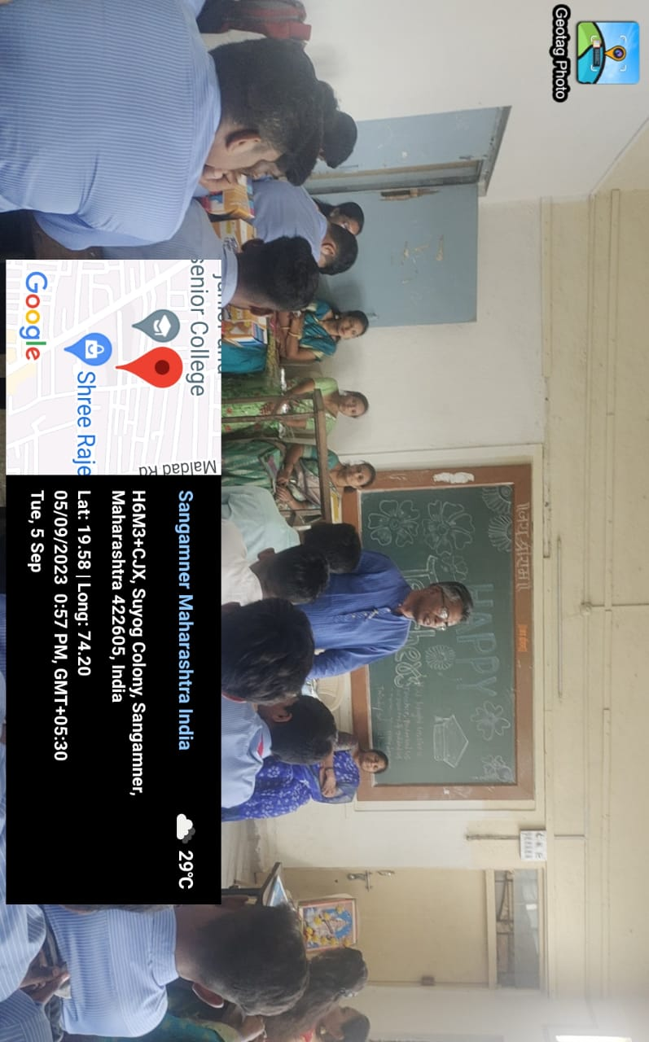**Techers Day Program**

