**SBVP Samaj’s**

**Sahakar Maharshi Bhausaheb Santuji Thorat**

**Arts, Science & Commerce College, Sangamner**

To,

The Principal,

S.M.B.S.T. College Sangamner

Sub: Report ofActivityOne Day Workshop on “Research Methodology”

Occasion of One Day Workshop on “Research Methodology”

Date :- 27/08/2024Time :- 10: 00 Am onwards Venue :- K.B.Dada hall, S.M.B.S.T. college, Sangamner

|  |  |  |  |  |  |  |
| --- | --- | --- | --- | --- | --- | --- |
| **Sr.No.** | **Event Activity Description** | **Description** | | | | |
| 1 | Introduction | This workshop is designed to impart knowledge on research methodology in the context of qualitative and quantitative research. A good research methodology is a key to sound research output. | | | | |
| 2 | Aim an Objective | * To facilitate the participants,define research problem, develop an approach to research problem and selection of suitable research design. * To enable the participants to report writing and writing research proposals, research project etc. | | | | |
| 3 | Organizer | IQAC and Department of Zoology,  S.M.B.S.T. college, Sangamner | | | | |
| 4 | Beneficiary | Student | Other College | Teacher / Staff | Stakeholder | Total |
| 153 |  | 15 |  | 168 |
| 5 | Resource Persons | 1.Dr.Rasool Jamadar,  Arts Commerce and Science college, Narayangaon, Junnar ,Pune  2. Mr. Sandip Kudner  3.Dr. Anupama Kandalgaonkar  4. Mr. Vikas Gunjal  5. Mrs. Pratibha Kurkute  6. Miss. Shaila Borase  S.M.B.S.T. college, Sangamner | | | | |
| 6 | Topic Covered | * Research methodology * Planning of research project * Selection of topic * Abstract writing * Data collection * Discussion and conclusion * Layout of research paper | | | | |
| 7 | Outcomes | 1. Participants will be able to understandand comprehend the basics of research methodology and apply them in research /project work. 2. This workshop will help them to select appropriate research topic. 3. Participant will enable to collect the data, edit it properly and analyse it accordingly. 4. They will be able to demonstrate the ability to choose methods appropriate to research objectives. | | | | |
| 8 | Acknowledgement | We would like to thank Mr. Rasool Jamadar (Arts Commerce and Science college, Narayangaon, Junnar , Pune) with whom we get chance to interact. We also thank all the other speakers who gave there contribution make this workshop resourceful.  In particular we would like to thank Dr. D.D. Patil (Principal) and Dr. L.D Ghaywat (IQAC co-Ordinator) for their interest, support and help. | | | | |
| 9 | Short report of the activity-  The IQAC and Department of Zoology organized a one-day Workshop on “Research Methodology” ForM.Sc. and T.Y.B.Sc. students in all discipline on Tuesday, 27th August 2024 at K. B. Dada Hall, S.M.B.S.T. college, Sangamner. The workshop was intended to disseminate knowledge relating to the methods and methodology in research for students.  The participant includedstudents and teachers belonged to diverse disciplines including science, economics, history and commerce. Altogether there were 7 technical sessions which dealt with different aspects of research methodology.  Dr.LaxmanD.Ghaywat welcome the guest.Dr.D. D. Patil felicitated Hon. Resource Person with a bouquet. All the otherfaculties were felicitated by giving a red rose.  Asst. Prof. Manisha K. Balsane explained the need of this workshop by a small introductory speech on Research Methodogy.  The first technical session was handled by Asst. Prof. Sandip S. Kudner. He provided an overall idea about planning of research project.  It was followed by the technical session handled by Asst. Prof.Dr. Anupama A.K. the title of the session was selection of research topic, she provided adequate help to the participant by mentioning suitable examples of how one can select an appropriate research topic.  The next session was by Asst. Prof. Vikas S. Gunjal he spoke on Abstract writing for submission of research paper for publication in Journals, Conferences.  There was also a session on data collection handled by Asst. Prof. Shaila Borase,shefocused on quantitative and qualitative methods of data collection.particularlyondos and don’ts while preparing aquestionnaireand while scheduling an interview.  The session on discussion and conclusion was handled by Asst. Prof. Pratibha kurkuteshe spoke about how to analyze, interpret the results and suggest future research.  The resource person Dr. Rasool Jamadar focused on research methodology. he briefly discussed the steps to develop a good research proposal and related key components. He underlined the importance of carrying out ethical research.  To conclude the research methodology workshop turned to be a rich experience for the participants, raising their confidence to proceed with scientific research and produce quality output. | | | | | |

Note: Attach geo-tag photo of the activity and submit the report to IQAC after sign by the Principal.

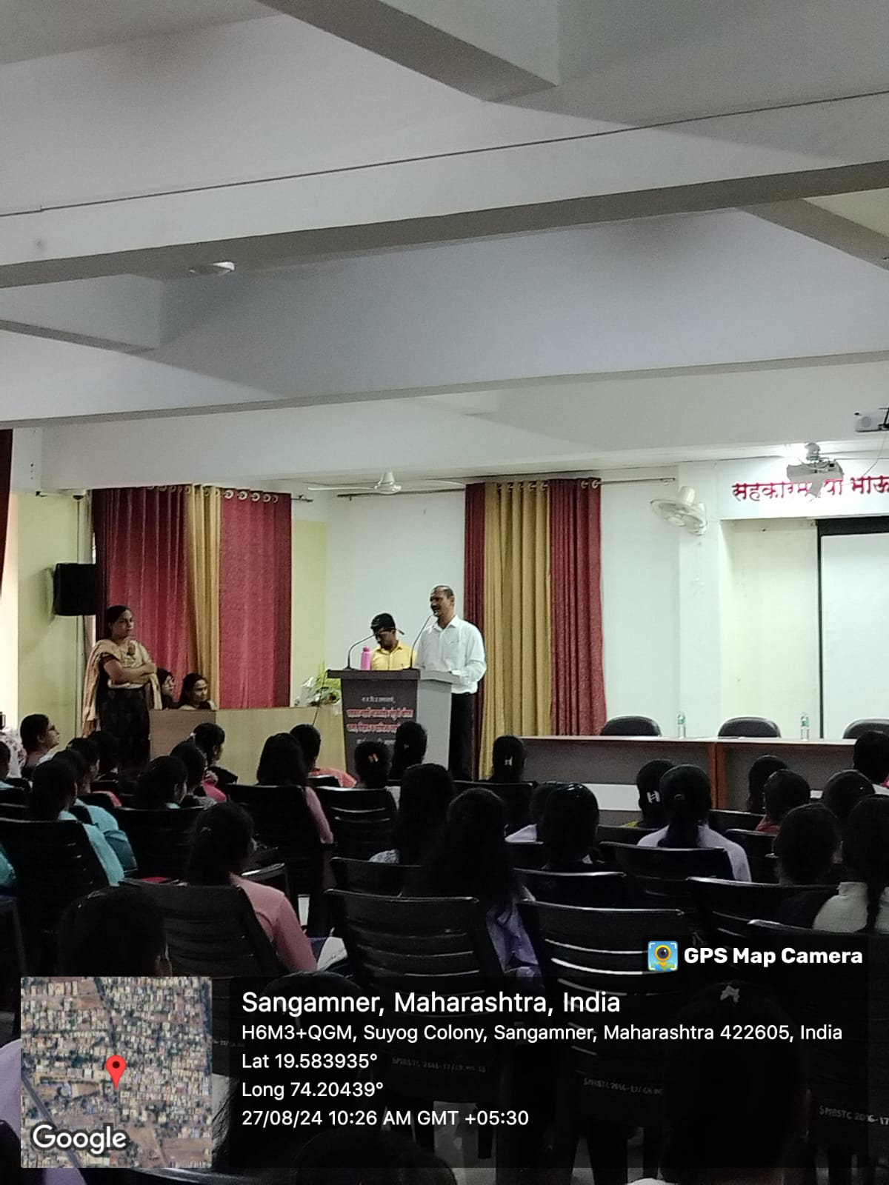

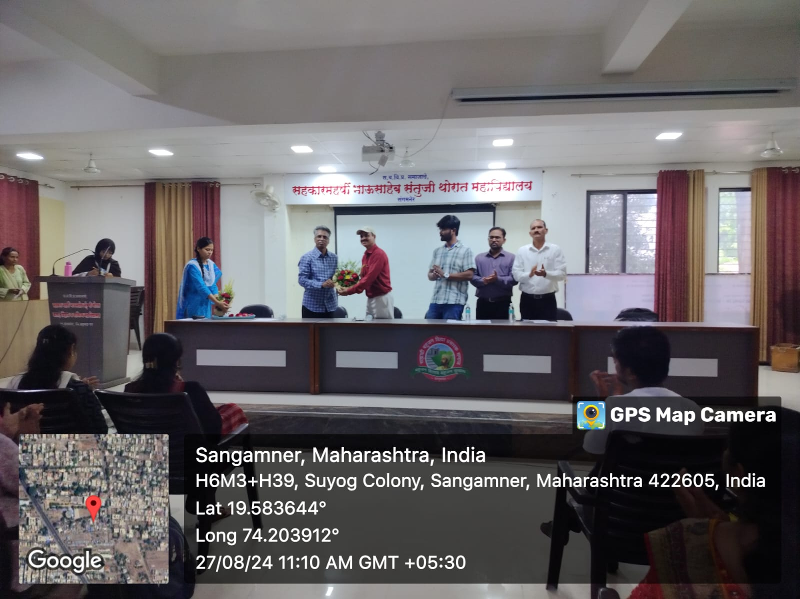

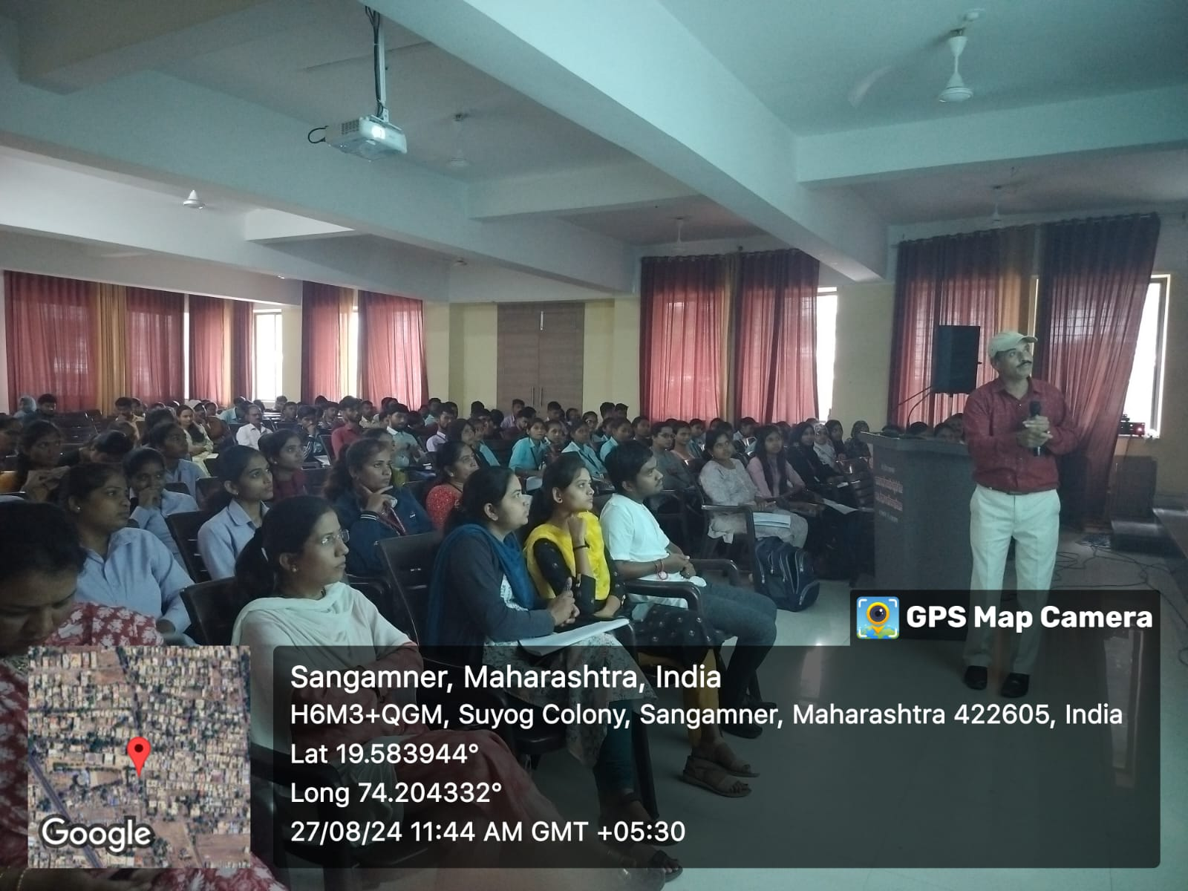

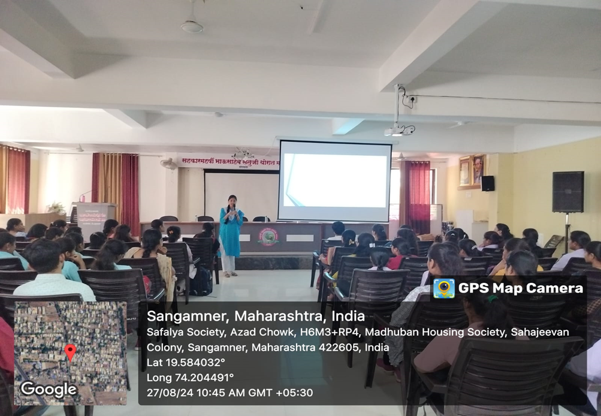

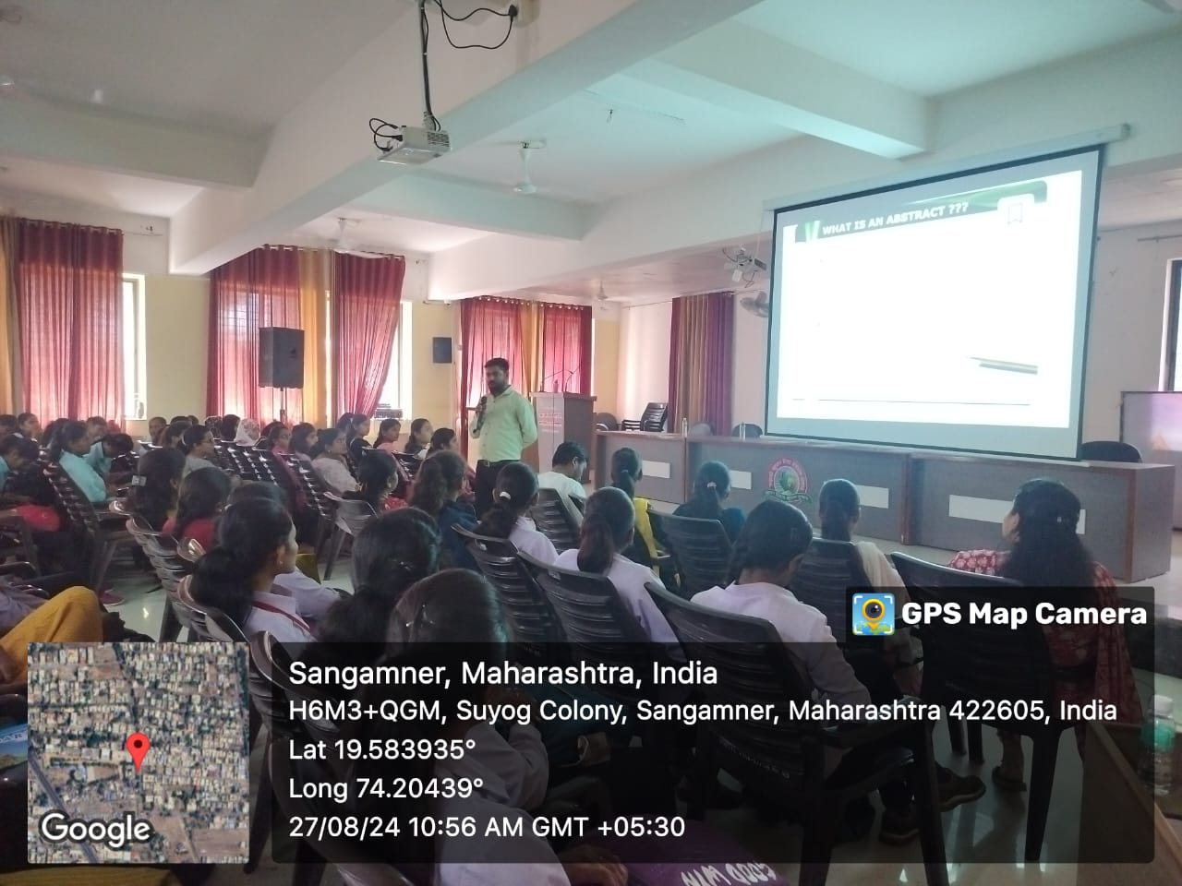

Head of The Dept . Principal Coordinator IQAC

One day Workshop on “Research methodology”

27th August 2024

**Programme Schedule**

|  |  |  |  |
| --- | --- | --- | --- |
| **Sr.No.** | **Time** | **Topic** | **Resource Person** |
|  | 10:00 to 11:00 am | Planning of research project | Mr. Sandip S. Kudner |
|  | 11:00 to 12:00 am | Selection of topic | Dr. Anupama A.K. |
|  | 12:00 to 01:00 pm | Abstract writing | Mr. Vikas S. Gunjal |
|  | 1:00 to1:30 pm Lunch Break | | |
|  | 01:30 to 02:30 pm | Data collection | Miss. Shaila Borase |
|  | 02:30 to 03:30 pm | Discussion and conclusion | Mrs. Pratibha Kurkute |
|  | 03:30 to 04:30 pm | Layout of research paper | Miss.Rida R. Maniyar |
|  | 04:30 to 05:30 pm | Research Methodology | Dr.Rasool Jamadar |