**Sahakar Maharshi Bhausaheb SantujiThorat**

**Arts, Science & Commerce College, Sangamner**

To,

The Principal,

S.M.B.S.T. College Sangamner

Sub: Report of Activity Population Awareness Camp.

Occasion of International Population Day.

Date: - 30 / 07/2024 Time: - 09:00 am to 12:00 am Venue: - Chandneshwar Vidyalaya, Chandanapuri, Tal- Sangamner, Dist.- Ahmednagar.

|  |  |  |  |  |  |  |
| --- | --- | --- | --- | --- | --- | --- |
| **Sr.No.** | **Event Activity Description** | **Description** | | | | |
| 1 | Introduction | The total number of people living in a particular place, at a particular time, is known as a population. Population education can be defined as process of developing awareness. | | | | |
| 2 | Aim an Objective | * Aims – 1.To educate individuals about the importance of family planning and the methods available for it.   2.To promote gender equality and women's empowerment, this plays a significant role in controlling population growth.  3. To encourage individuals to adopt healthy and responsible behavior towards sexual and reproductive health.   * Objectives - Population education aims to increase awareness and increase awareness and understanding of population–related issues, such as population growth, reproductive health, and sustainable growth. It seeks to educate individuals about the social, economic, and environmental implications of population dynamics. | | | | |
| 3 | Organizer | Department of Geography of S.M.B.S.T. College of Arts, Science and Commerce, Sangamner. | | | | |
| 4 | Beneficiary | Student | Other College | Teacher / Staff | Stakeholder | Total |
| 29 | 95 | 4 | Dept. of Geography, S.M.B.S.T. College, Sangamner. | 128 |
| 5 | Resource Persons | * Asst.Prof.- Mr. Kadam R.K. * Asst. Prof.- Mr. Patil A.B. * Asst.Prof.- Mr. Gosavi S.R. * Asst.Prof.- Mr. Sonvane B.V. | | | | |
| 6 | Topic Covered | * Population Control and Awareness * Future Consequences of Population Growth * Gender and Population * Population Policies in Developed and Developing Countries * History of International Population Day * Indian Population Policies. | | | | |
| 7 | Outcomes | The rapidly growing population transforms the economy transforms the economy into mass unemployment and low employment. As the population increases, the ratio of workers to the total population increases. The result is that with an increase in the labour force, unemployment and low employment increases. | | | | |
| 8 | Acknowledgement | * Grampanchayat Administration, Chandanapuri, Tal- Sangamner, Dist- Ahmednagar. * All Teaching and Non-Teaching staff, Chandaneshwar Vidyalaya, Chandanapuri. * All Administrative Staff, Dept. of Geography, S.M.B.S.T. College, Sangamner. | | | | |
| 9 | Short report of the activity-   * 7.30 am – Started journey from Sangamner to Chandanapuri by Bus. * 8.30 am – Population Awareness rally by students at Chandanapuri village. * 9.30 am – Inauguration function on Population Awareness at Chandaneshwar Junior College, Chandanapuri, Tal- Sangamner, Dist.- Ahmednagar. * 10.00 am to 11 am – Population Awareness lecture delivered by Resource Person  1. Mr. Kadam R.K.   2)Mr. Patil A.B.  3) Sonawane B.V.  4) Gosavi S.R.   * 11 am to 12pm – Student interaction with local people regarding Population Awareness. | | | | | |

Note: Attach geo-tag photo of the activity and submit the report to IQAC after sign by the Principal.

Head of The Dept. Chairman. Coordinator IQAC Principal

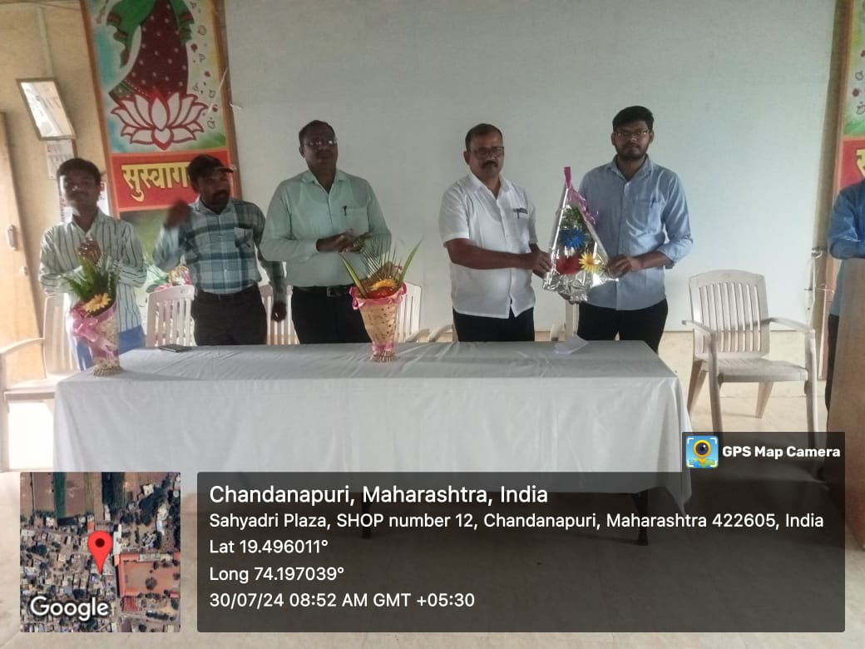

Facilitation to Resource Person Mr. Gosavi Sir by Chandaneshwar Vidyalaya

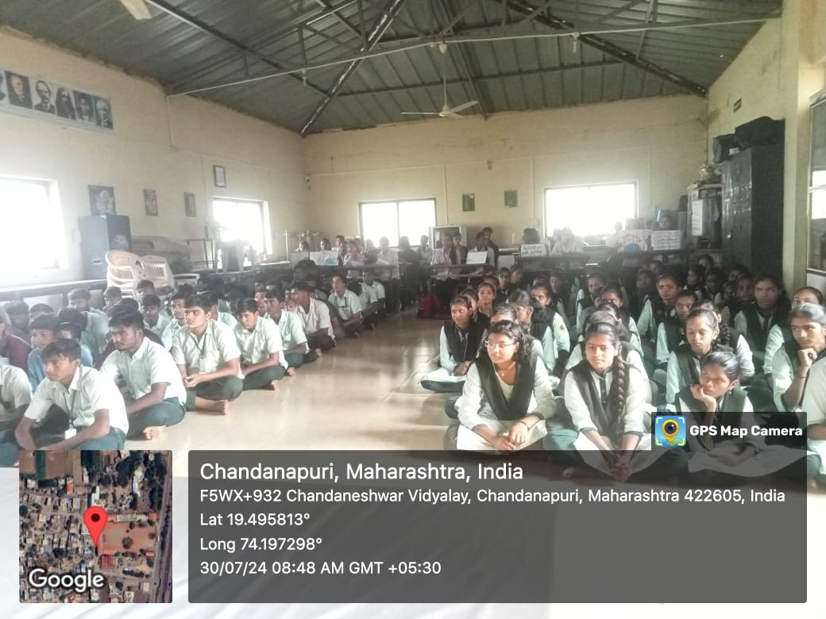

Chandaneshwar Jr.College Students attending lecture

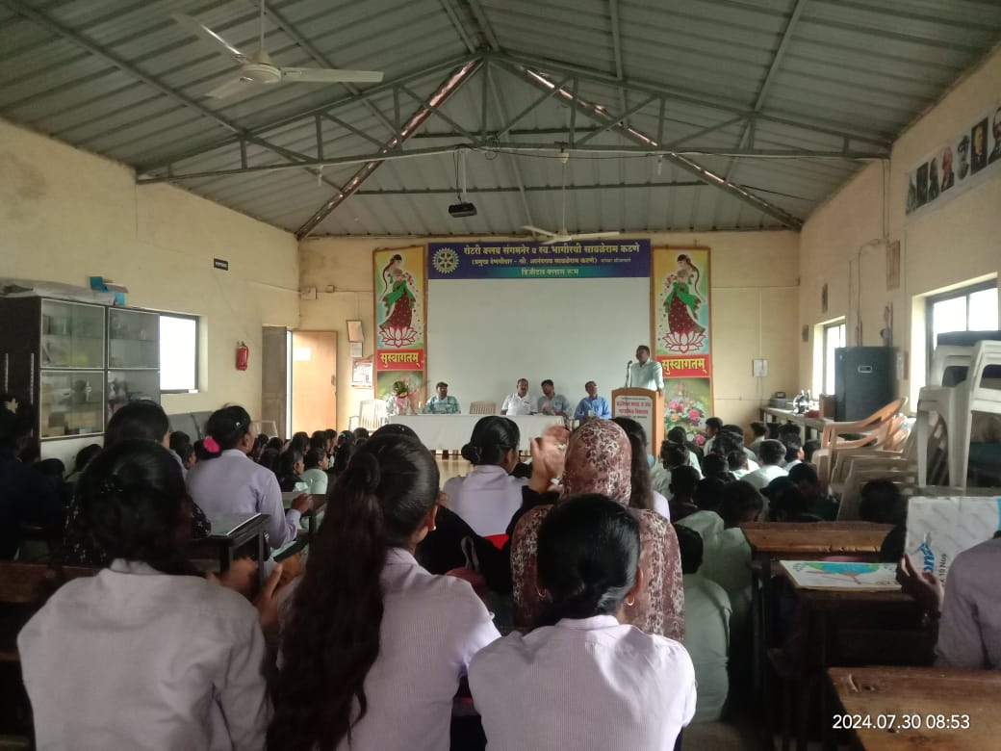

Resource Person Mr. Kadam Sir delivering lecture

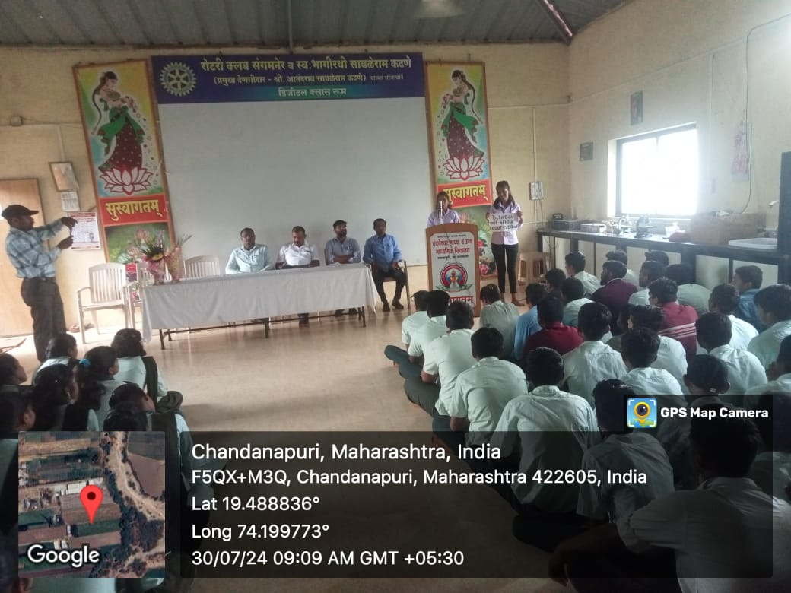

T.Y.B.A. student Pooja Gosavi delivering speech

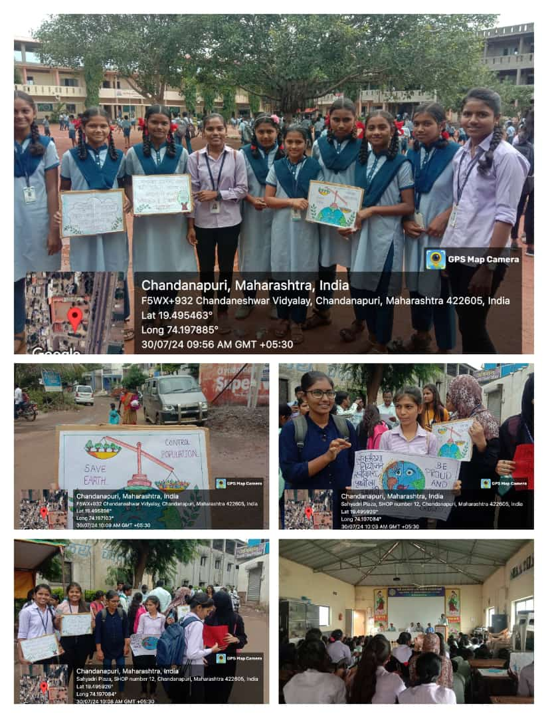

Above Photo Plate shown the picture of Students of Geography Dept. S.M.B.S.T. College, gave information related Population Awareness to Local residents and Students in Chandaneshwar Jr. College Campus.

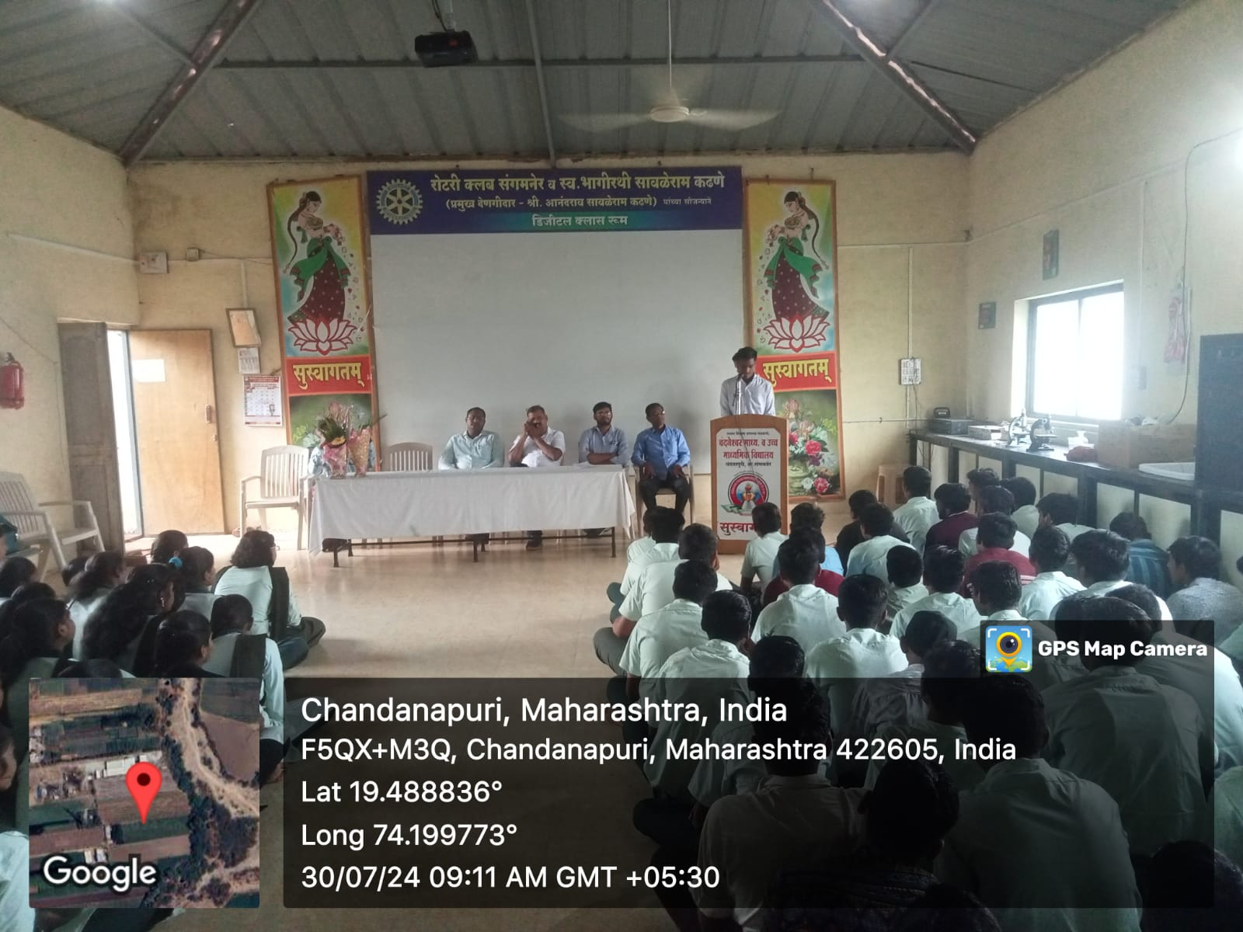

S.Y.B.A. Geography Student Vali Pathan delivered speech regrading Problems of Population Explosion.