# Sahakar Maharshi Bhausaheb Santuji Thorat Arts, Science & Commerce College, Sangamner

To,

The Principal,

S.M.B.S.T. College Sangamner.

Sub: Report of Activity- Parents-Teachers Meeting in the Zoology Department

Date: - 23/12/2024 Time: - 10.30 am Venue: - Zoology Department

|  |  |  |  |  |  |  |
| --- | --- | --- | --- | --- | --- | --- |
| **Sr. No.** | **Event Activity Description** | **Description** | | | | |
| **1** | **Introduction** | A Parents-Teachers Meeting (PTM) serves as a crucial platform for fostering collaboration and communication between parents and educators. It provides an opportunity for teachers to share insights into students' academic progress, strengths, and areas for improvement, while parents can offer valuable perspectives on their children's learning and development. PTMs help build a supportive network that encourages students' growth, addresses any challenges, and ensures a well-rounded educational experience. This partnership between parents and teachers is essential for enhancing student outcomes and promoting a positive, engaging learning environment. | | | | |
| **2** | **Aim an Objective** | **Aim**: The primary aim of the Parents-Teachers Meeting (PTM) is to foster effective communication and collaboration between parents and educators, ensuring a supportive and cohesive environment that promotes students' academic and personal growth.  **Objectives**:   1. **Share Academic Progress**: To provide parents with detailed insights into their children's academic performance, strengths, and areas for improvement. 2. **Discuss Developmental Needs**: To address the developmental needs of students, including behavioral, social, and emotional aspects, ensuring a holistic approach to education. 3. **Identify Challenges**: To identify and discuss any challenges or obstacles students may be facing in their learning journey, and to collaboratively find solutions. 4. **Enhance Parental Involvement**: To encourage active parental involvement in the educational process, fostering a partnership between home and school. 5. **Set Goals and Expectations**: To set clear goals and expectations for students' academic and personal development, ensuring alignment between parents and educators. 6. **Provide Feedback and Support**: To offer constructive feedback and support to both parents and students, helping them navigate their educational path more effectively. | | | | |
| **3** | **Organizer** | **Department of Zoology** | | | | |
| **4** | **Beneficiary** | Student | Parents | Teacher / Staff | Stakeholder | Total |
| 14 | 8 | 5 | 0 | 27 |
| **5** | **Outcomes** | * **Enhanced Communication**: The meeting fostered open communication between parents and teachers, allowing for a clearer understanding of students' academic progress and challenges. * **Personalized Feedback**: Parents received individualized feedback about their children's strengths and areas for improvement, helping them better support their academic and personal growth. * **Strengthened Collaboration**: The meeting strengthened the collaboration between parents and educators, emphasizing the importance of a united approach to student development. * **Increased Parental Involvement**: The event encouraged greater parental involvement in their children's education, fostering a supportive home environment that aligns with school efforts. * **Addressed Concerns**: Specific concerns and challenges faced by students were addressed, with collaborative solutions discussed to enhance their learning experience. * **Goal Setting**: Clear goals and expectations were set for students, ensuring that both parents and teachers are aligned in their efforts to support the students' success. * **Community Building**: The meeting helped build a sense of community and mutual support among parents, teachers, and students, creating a positive and engaging educational atmosphere. | | | | |
| **6** | **Acknowledgement** | We sincerely thank all the parents for attending the Parents-Teachers Meeting held on 23rd December 2024 in the Zoology Department of SMBST College. Special thanks to Assistant Professor Rida Maniyar, Shaila Borase, Manisha Balsane, Dr. Laxman Ghywat, and all faculty members for their valuable contributions. Your support and participation made the event a success. | | | | |
| **7** | **Short report of the activity** | - | | | | |

**Report on Parents-Teachers Meeting in the Zoology Department**

On 23rd December 2024, the Department of Zoology at SMBST College, Sangamner, held a Parents-Teachers Meeting for TYBSc Zoology students. The event began at 10:30 AM with an introduction by Assistant Professor Rida Maniyar, who explained the purpose of the meeting. Shaila Borase and Manisha Balsane felicitated the parents, creating a welcoming atmosphere.

Dr. Laxman Ghywat had a brief discussion with the parents about the students' academics and future prospects, emphasizing the department's commitment to student success. All faculty members provided individualized feedback on the strengths and areas for improvement for each student, fostering open communication and collaboration.

The meeting was a success, enhancing the partnership between parents and faculty, and reinforcing the importance of parental involvement in the students' academic journey. The event highlighted the department's dedication to supporting student development and academic excellence.

**Report on Parents-Teachers Meeting in the Zoology Department**

**Event**: Parents-Teachers Meeting **Date**: 23rd December 2024, Monday **Time**: 10:30 AM onwards **Venue**: Zoology Department, SMBST College, Sangamner

**Introduction**

The Parents-Teachers Meeting for TYBSc Zoology students was held on 23rd December 2024 in the Zoology Department of SMBST College, Sangamner. The meeting began at 10:30 AM and saw active participation from the parents of the TYBSc Zoology students, as well as all the faculty members of the department.

**Highlights of the Meeting**

* **Opening Address**: The meeting commenced with an introduction and explanation of the meeting's purpose by Assistant Professor Rida Maniyar. She warmly welcomed the parents and provided an overview of the agenda for the day.
* **Felicitation of Parents**: Shaila Borase and Manisha Balsane felicitated the parents, expressing their gratitude for their attendance and support. This gesture helped create a welcoming and appreciative atmosphere.
* **Academic Discussion**: Dr. Laxman Ghywat had a brief chat with the parents, discussing the academic performance and future prospects of the students. He highlighted the department's commitment to fostering academic excellence and career development.
* **Individual Student Assessments**: All faculty members took turns explaining the strengths and areas for improvement for each student. This personalized feedback aimed to help parents understand their children's academic journey and how they can support their growth.

**Outcome**

The meeting was a success, fostering a strong sense of collaboration between parents and the faculty. It provided a platform for open communication, allowing parents to engage with the faculty and gain insights into their children's academic progress and potential. The event underscored the importance of parental involvement in the students' educational experience and highlighted the department's dedication to student development.

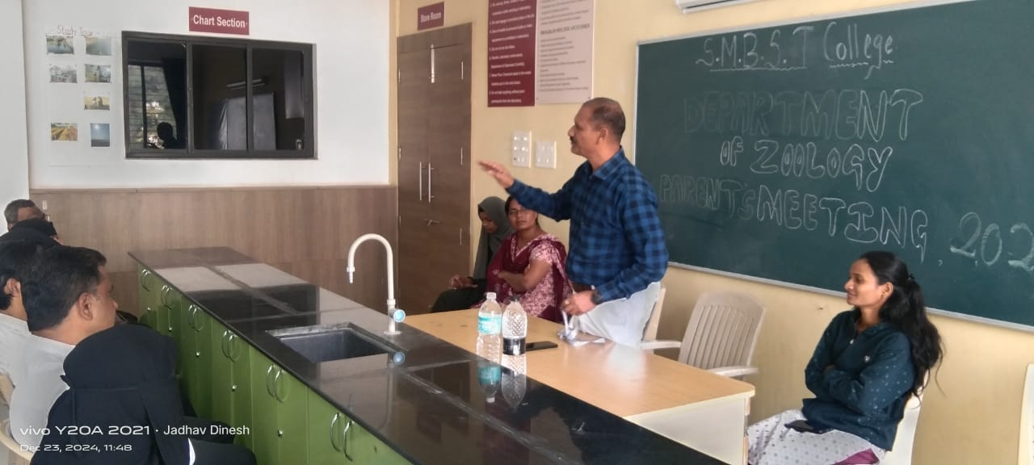

**Dr.L.D.Ghaywat Welcoming the Parents**

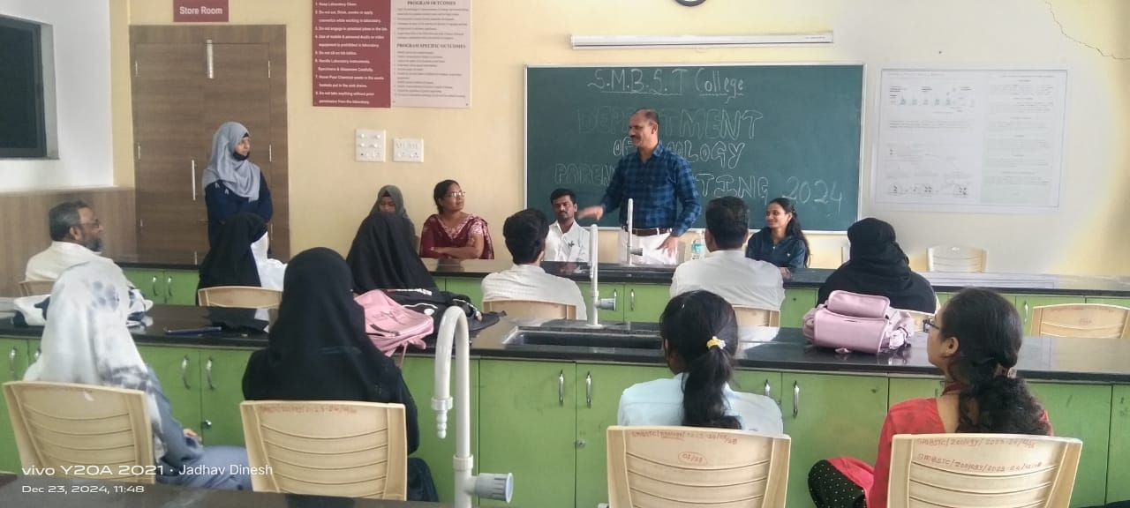

**Dr.L.D Ghaywat explaining each Students positive sides to their parents**

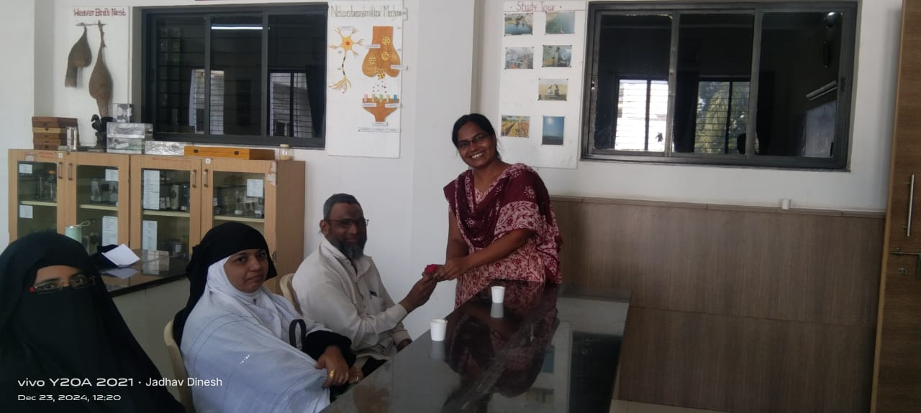

**Faculty Shaila Borase Felicitating the parents**

