**S.B.V.P. Samaj’s**

**Sahakar Maharshi Bhausaheb Santuji Thorat Arts, commerce and Science College Sangamner.**

**Department of Zoology**

**Exchange of knowledge under MOU**

**College Name**: **Ad. M. N. Deshmukh College Rajur Department of Zoology**

MOU Programme was runed in between SMBST College Sangamner and Ad.M.N. Deshmukh College Rajur. It was initiated for the exchange of ideas, culture and thoughts, with the students & teachers. On the 9th October 2023 teacher & Students from SMBST College, Sangamner were Departed for Ad.M.N Deshmukh college, Rajur.

After reaching their all teachers and students were warmly welcomed by the staff and students of Ad.M.N. Deshmukh College Rajur. DR.L.D.Ghaywat Delivered lecture on the scope of Zoology, after that Asst.Prof. Miss Rida Maniyar delivered a lecture on scope of Developmental Biology, Basic concepts of Developmental Biology & Fertilization, after awhile Asst.Prof. Mr.Sandip Kudnar gave a lecture on Capacitance, Acrosomal Reaction and Post Fertilization Changes Etc.

At last Asst.Prof.Mr Kasar gave a appreciation speech, With that the MOU Activity come to an end. A novel idea of a Student and teachers Exchange Program was completed successfully.

S.B.V.P.Samaj’s

**S.M.B.S.T.College, Sangamner**

**Department of Zoology**

|  |  |  |
| --- | --- | --- |
| 1 | Title of the Activity | “ **Exchange of knowledge under MOU**” |
| 2 | Place | Ad.M.N. Deshmukh College Rajur  Department of Zoology(Seminar Hall) |
| 3 | Objective of the Activity | To Exchange students as well as staff with students of other institute so that exchange of ideas, culture and thoughts will takes place. |
| 4 | Date & Time of Activity | Date: 9th October 2023  Time: 09:00 to 01:00 pm |
| 5 | Number of students Participated | 14 students of Ad.M.N. Deshmukh College, Rajur.  4 students from SMBST College, Sangamner. |
| 6 | Guest Lecturer | Prof.DR.L.D.Ghaywat  Asst.Prof. Mr.Sandip Kudnar  Asst.Prof. Miss Rida Maniyar |
| 7 | Chief Guest | Prof.Dr.Tapale.(HOD)  Department of Zoology  Ad.M.N. Deshmukh College, Rajur |
| 8 | Beneficiary/Progamme Outcome | Interaction of students with students and with teachers of other College was took place.  Student enthusiastically shared their ideas with each other. |

Program Coordinator IQAC Coordinator Principal

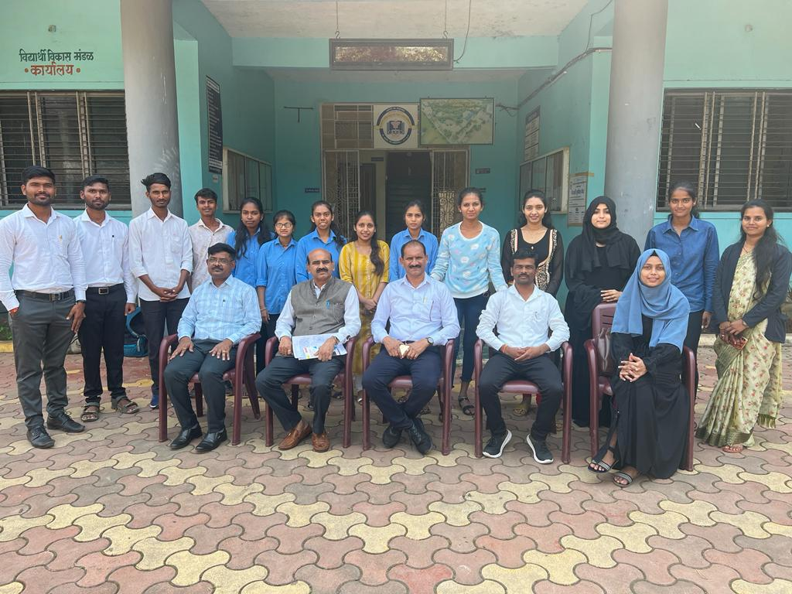

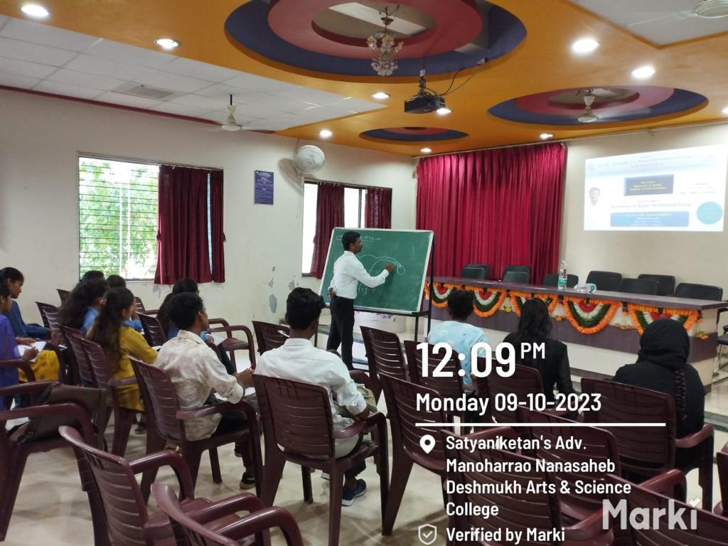

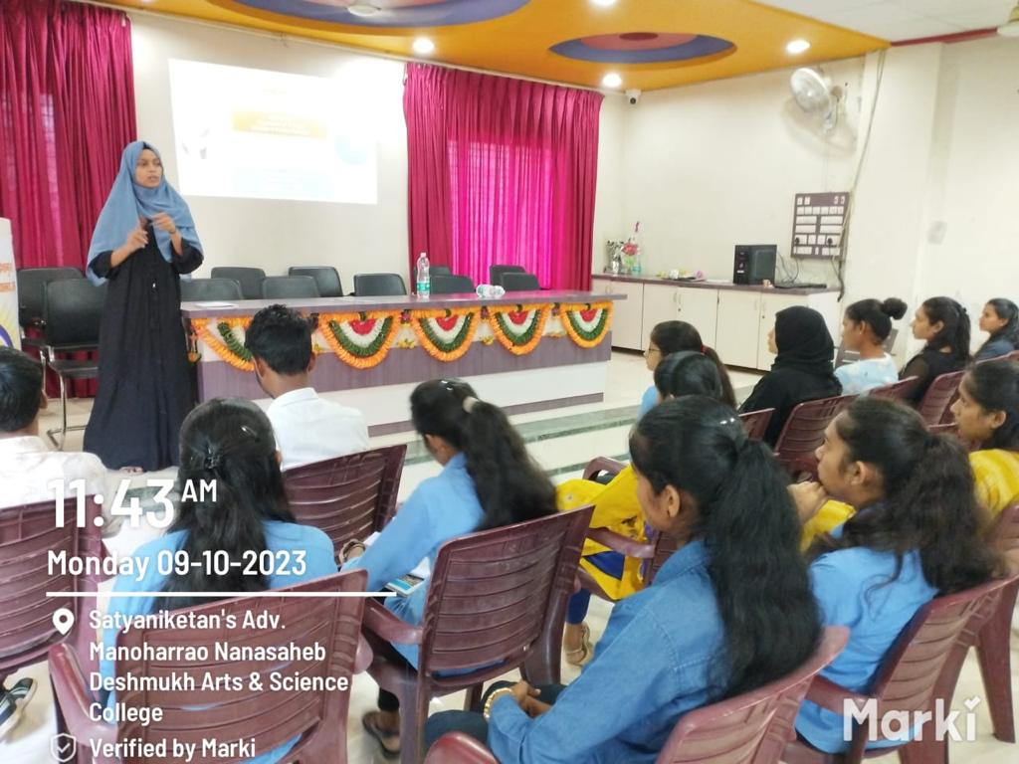

MOU Activity at Ad.M.N. Deshmukh College Rajur

S.B.V.P.Samaj’s

**S.M.B.S.T.College, Sangamner**

**Department of Zoology**

**MOU-Activity 2023-24**

**Staff & Students List**

|  |  |  |
| --- | --- | --- |
| **Sr.No.** | **Name of the student** | **Signature** |
| **1** | Bhalerao Shejal Rajendra |  |
| **2** | Chaudhari Prajwali Devram |  |
| **3** | Ghyawat Kanchan Laxman |  |
| **4** | Shaikh Aqsa Ayyub |  |
| **Name of Faculty** | | |
| **1** | Dr.L.D.Ghyawat |  |
| **2** | Mr.Sandip S.Kudnar |  |
| **3** | Miss:Rida R.Maniyar |  |

