S.B.V.P.Samaj’s

**S.M.B.S.T.College, Sangamner**

**Department of Zoology**

|  |  |  |
| --- | --- | --- |
| 1 | Title of the Activity | “Knowledge Sharing Programme” |
| 2 | Place | Department of Zoology |
| 3 | Objective of the Activity | To impart knowledge about Marine organisms,Snakes and their special characters with the help of laboratory specimens to the School students. |
| 4 | Date & Time of Activity | Date: 15th August 2023  Time: 09:00 to 10:00am |
| 5 | Number of students Participated | 15 Students |
| 6 | Guest Lecturer | Dr.Ghaywat L.D. |
| 7 | Chief Guest | Head Master Mrs.Namrata Pawar, Sahyadri College,Sngamner |
| 8 | Beneficiary/Progamme Outcome | Programme helped to retain intellectual assets and improved learning. It developed interest of students as well as teachers for learning amazing things about different animals. |

Program Coordinator IQAC Coordinator Principal

**“Knowledge Sharing Programme”**

Report

S.M.B.S.T. Arts Science & Commerce College Sangamner Department of Zoology Organized “Knowledge Sharing Programme” on the Occasion of Independence Day.

After celebration of Independence Day Primary and secondary school Students along with Head master and teachers of Sahyadri High school were came to visit Zoology Department.

Dr. Lakshman Ghaywat, along with Asst.Prof. Sandip Kudner, Asst.Prof.Shaila Borase, and Dr. Anupama Kandalgaonkar welcomed all the students and teachers at the zoology department.

We arranged exhibition of our laboratory specimens of “Marine organisms” such as star fish, sea horse, Hammer headed shark, Sea lily, Sting ray, Oyster, Saw fish, feather star etc. we explained them general characteristic of each organism. Dr.Ghaywat elaborated on specific characteristic of each organism which indicated the love, parental care, defense mechanism, inter- relationship and there adaptation for a particular life in Marine environment. Students as well as teachers were amazed after knowing such amazing things about marine animals.

After that we took all of them towards our laboratory specimens of “Poisonous & non-poisonous snake” Rat Snake, Viper snake & Cobra. At first they all were scared but Dr. Ghayawat made them feel good, with their lecture on “how to identify poisonous & non-poisonous snake”. Sir gave very easy identification mark that is Labial marks of snake. Sir further spoke about what precautions we should take after Snake Bite.

All students and teachers were happy, as they got an opportunity to handle and observe so many organisms and also to listened amazing things about them. Head Master Mrs.Namrata Pawar Madam gave vote of thanks to all faculty of Department of Zoology, She mentioned that this Programme helped us to collaborate and build collective knowledge and it gave us better experience.

.

HOD

Prof.G.J.Thorat

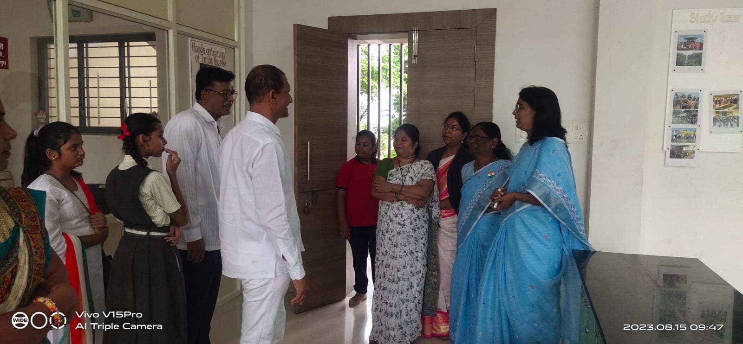

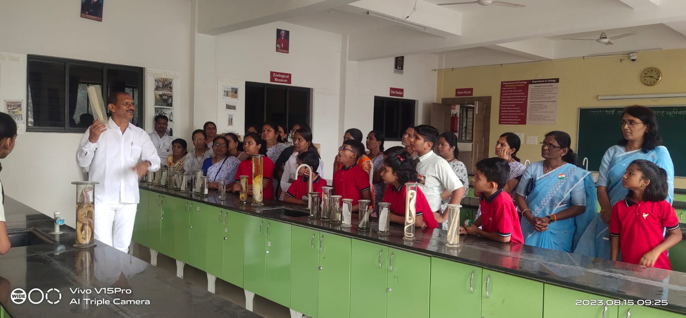

**Photograph of Knowledge Sharing Program**