S.B.V.P. samaj's
Sahakar Maharshi Bhausaheb Santuji Thorat College of Arts , Science and Commerce Sangamner , (422605) , Dist :-Ahamnadnagar.
Department of BBA (Administration)
Report of the Activity
Name of the activity |  | Industrial Visit
Aim of the activity |  | a. Industrial visits provide the students with an opportunity to learn practically through interaction, working methods and employment practices.  b. It gives the students an exposure to current work practices as opposed to theoretical knowledge being taught at their college classrooms.  c.Industrial visits grant the students a great opportunity to interact with industries and know more about industrial environment.
Place of the activity |  | a) Sahakar Maharshi Bhausaheb Thorat Sahakari Sakhar Karkhana Ltd., Sangamner.  b) Sangamner Taluka Sahakari Dudh Utpadak & Prakriya Sangh Ltd., Sangamner
Date of the activity |  | 11/02/2022
Organizer |  | Department of BBA , S.M.B.S.Thorat College Sangamner.
Guest/Expert
Number of teacher participated |  | 05
Number of Student participated |  | 53
Number of stakeholders participated
Outcome of Program |  | a. Industrial Visit brings clarity to important management concepts, as students practical experience firsthand how these concepts are put into action.  b. Industrial visit bridge the gap between classroom theoretical training and practical learning in a real-life environment.
Highlight if any
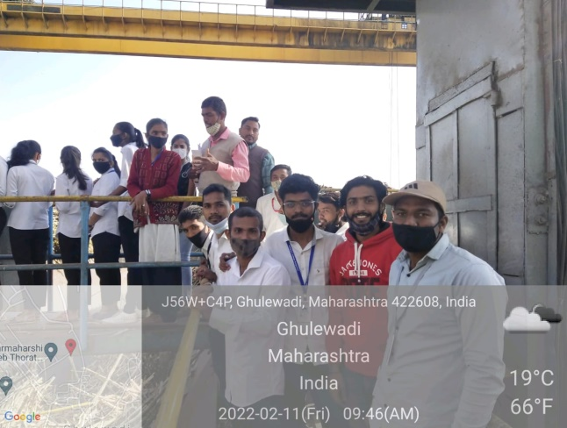 | 