**S.B.V.P. Samaj’s,**

**S.M.B.S.T. College Sangamner.**

**Department of BCA(Science)**

**Departmental Activities**

“Student Induction Program” in our college is an activity which inspire student regarding AI(Artificial Intelligent). It is an ability of Machine to Learn And perform tasks . It is also the field of study in Computer Science that develops and studies intelligent machines. The 12th of July 2023 was as a memorable day in the life of every fresher of B.C.A ( Science) batch 2023-24 at S.M.B.S.T. College, Sangamner campus.

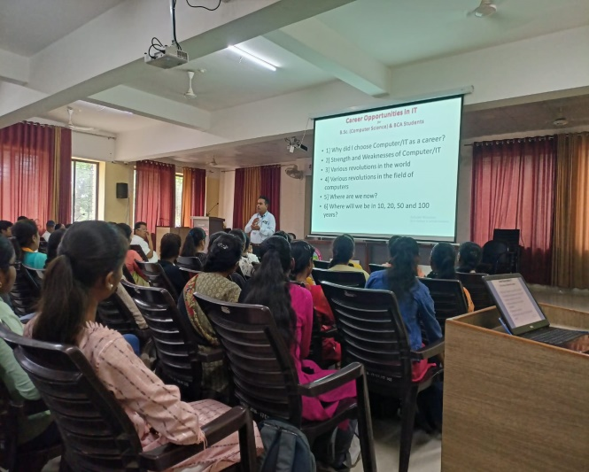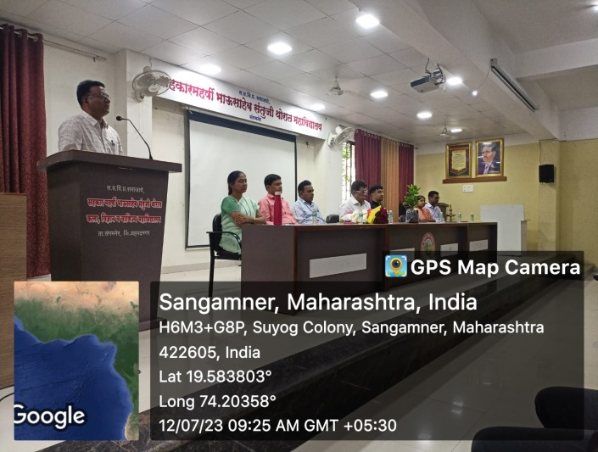

**Student Induction Program 2023-24**

