**Sahakar Maharshi Bhausaheb Santuji Thorat**

**Arts, Science & Commerce College, Sangamner**

To,

The Principal,

S.M.B.S.T. College Sangamner

Sub: Report of Activity on Workshop of Financial Literacy

Date :- 03/01 /2025 Time :- 09:00 am Venue :- K.B.D. Hall

|  |  |  |  |  |  |  |
| --- | --- | --- | --- | --- | --- | --- |
| **Sr.No.** | **Event Activity Description** | **Description** | | | | |
| 1 | Introduction | Creating Awareness among the students regarding Financial Literacy. | | | | |
| 2 | Aim an Objective | 1. To suggest measures so as to increase the Financial Literacy and awareness among the students  2. Introduces a basic financial concepts such as budgeting, saving, and investing.  3. The objective is to guide students in understanding the financial aspects of career choices and educational perspectives.  4. By gaining this knowledge early in life, students develop healthy financial habits that can have a long-lasting impact.  5. To analyse the money management skills possessed by Students. 6. To understand the challenges and goals they have with financial matters.  7. It’s a easier way to reach the goals if you identify them in advance  8. Financial literacy can help students avoid risky pitfalls and look forward to a secure future by making informed and wise decisions.  9. To understand the challenges and goals they have with financial matters. | | | | |
| 3 | Organizer | Department of BBA | | | | |
| 4 | Beneficiary | Student | Other College | Teacher / Staff | Stakeholder | Total |
| 76 | -- | 05 | -- | 81 |
| 5 | Resource Persons | Dr. Sachin Gunjal | | | | |
| 6 | Topic Covered | * Introduction * Budgeting * Savings * Long term Investment planning * Spending * Insurance * Risk Management * Financial Planning and Goals * Retirement Plans | | | | |
| 7 | Outcomes | 1. Financial literacy programs can help students learn how to manage their money effectively  2. It can assist them in developing financial plans, managing funds properly, saving money, and so on.  3. It can assist the students regarding long term investment.  4. Effective management of money and debt. | | | | |
| 8 | Acknowledgement | Thanks to Hon. Incharge Principal Dr. B.D.Wagh, Vice Principal Dr. V.S Kolhe for granting us permission for that imitative. Also thankful to Dr.L.D.Ghaywat (IQAC Coordinator) for supporting in such kind of program. We are also thankful to Mr. .J.D. Dere (HOD of BBA) for conducting Financial Literacy Awareness program among students | | | | |
| 9 | Short report of the activity-Covered the topics Budgeting, Savings,Long term Investment planning,Spending,Insurance, Risk Management, Financial Planning and Goals, Retirement Plans.. | | | | | |

Note: Attach geo-tag photo of the activity and submit the report to IQAC after sign by the Principal.

Head of The Dept./Chairman. Principal Coordinator IQAC

**Lightening of Lamp on the Birth Anniversary of Savitribai Phule.**

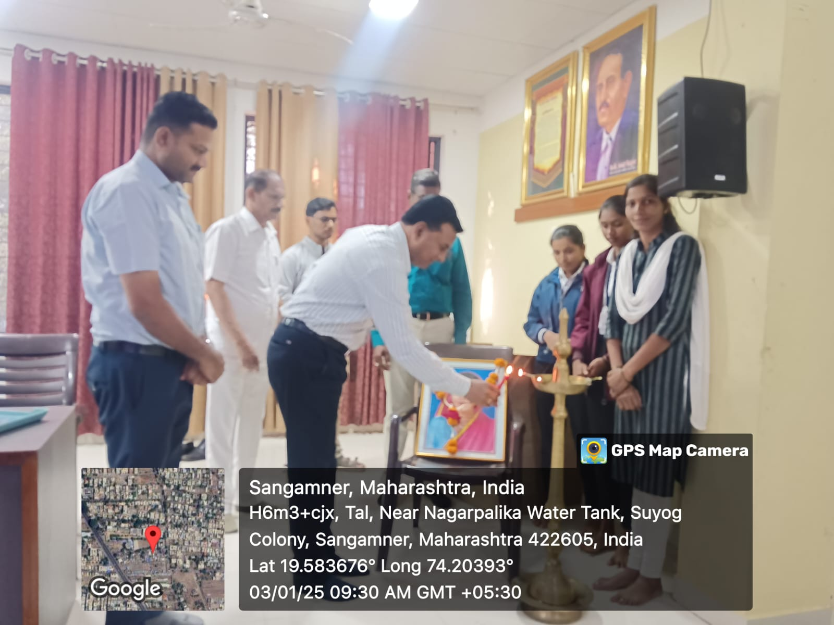

**Felicitation of Chief Guest Dr. Sachin Gunjal**

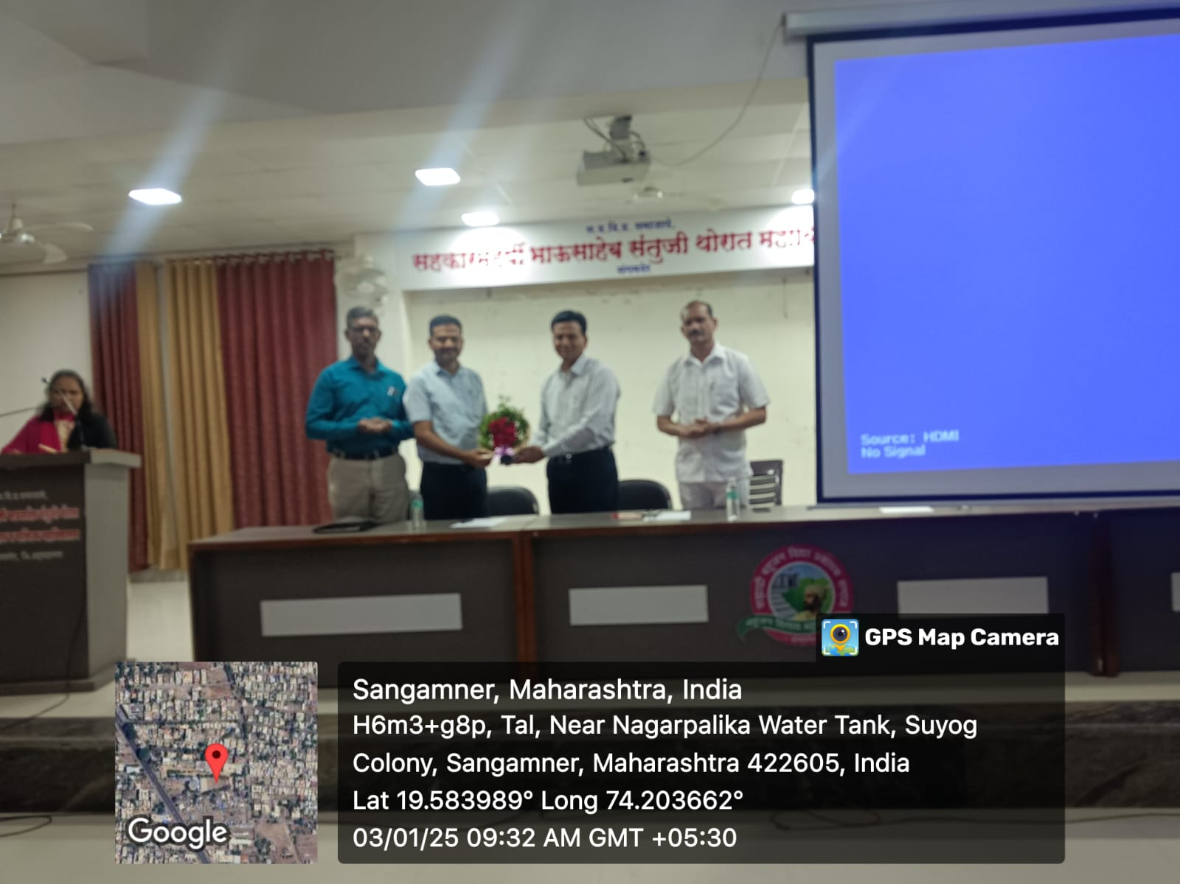

**Guidence on financial literacy by Hon. Incharge Principal Dr. B.D.wagh sir.**

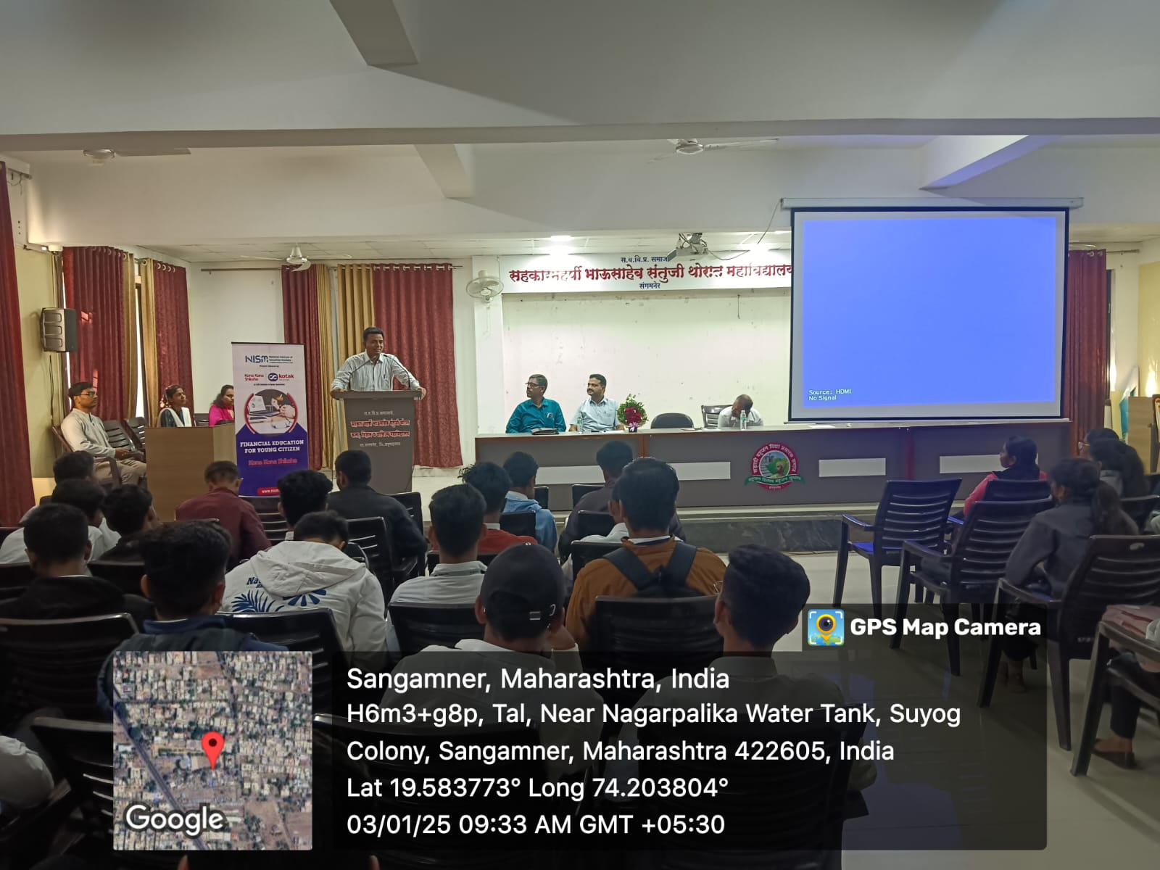

**Delivering a lecture on Financial Literacy**

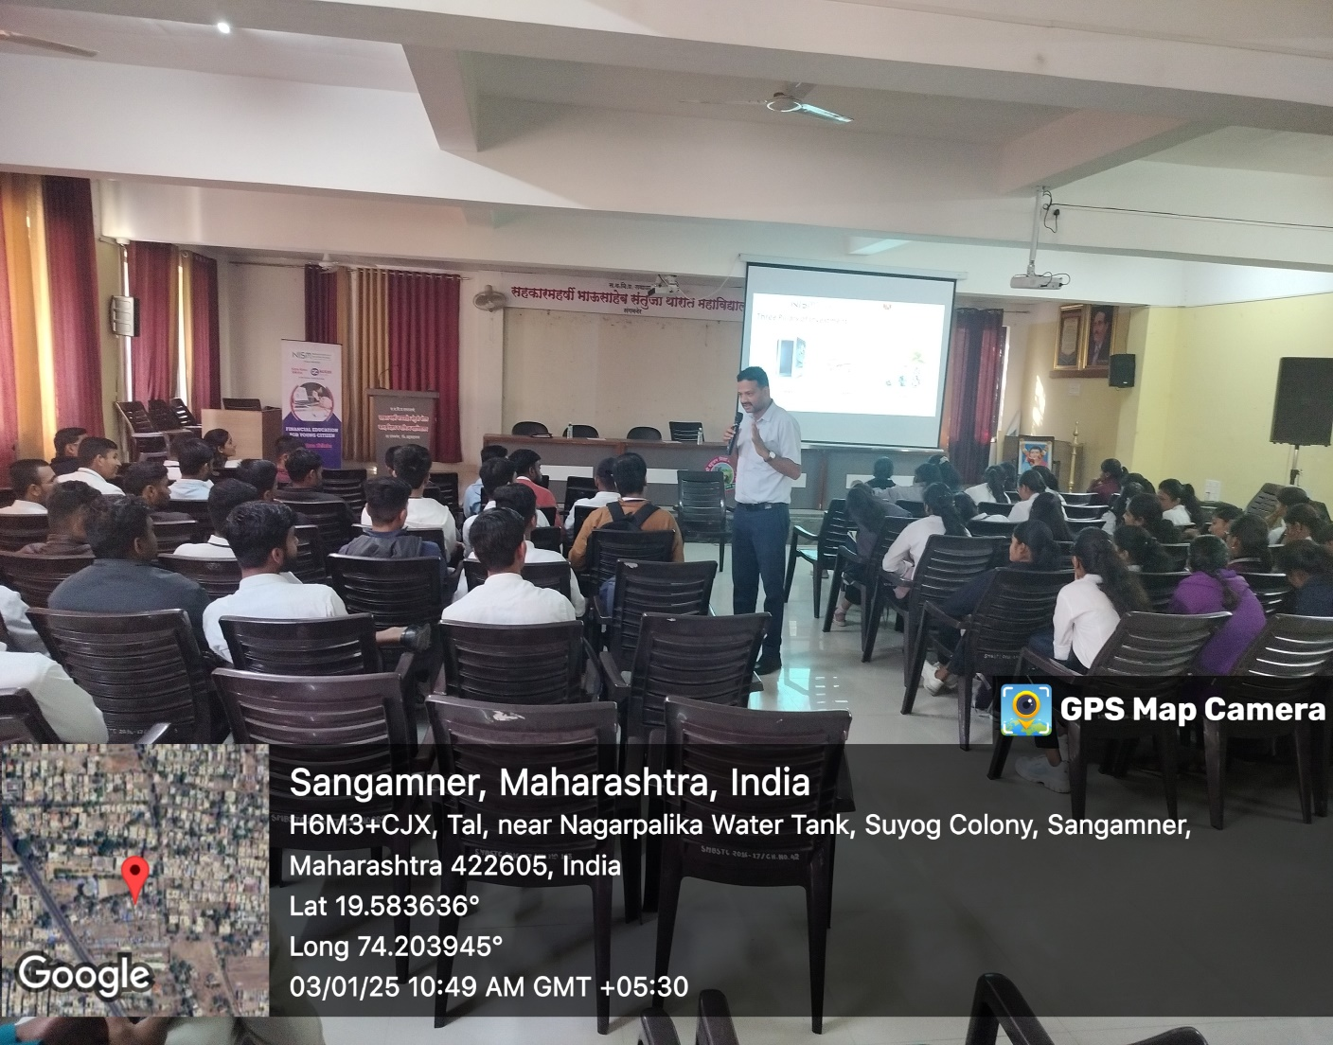

**Delivering a lecture on Financial Literacy**

