**S.B.V.P. Samaj’s,**

**S. M.B.S.T College Sangamner**

**Department of B.C.A (Science)**

**Departmental Activities**

“Ethical Activity” in our college is an activity to aware student about Security and Hacking crimes. These seminars is about and empower individual organization and Societies with knowledge skill and strategy to prevent, detect and privacy and security for evolving cybercrimes The 10th October 2024 was as a memorable day in the life of every B.C.A (Science) batch 2023-24 at S.M.B.S.T. College, Sangamner campus.

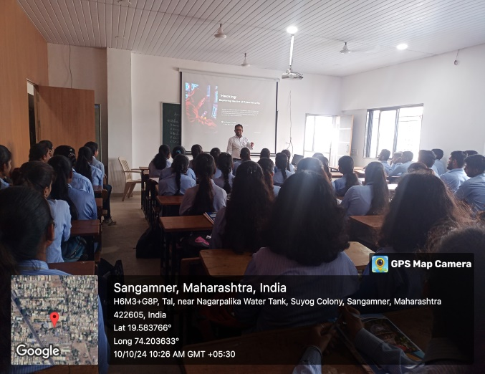 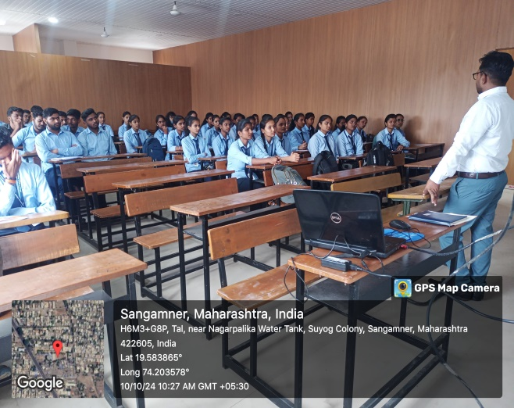

**Ethical Hacking Activity 2023-24**