Brief Introduction to the C Programming Language

# Introduction

##### The C programming language was designed by Dennis Ritchie at Bell Laboratories in the early 1970s

* Influenced by

– ALGOL 60 (1960),

* + CPL (Cambridge, 1963),
  + BCPL (Martin Richard, 1967),
  + B (Ken Thompson, 1970)

##### Traditionally used for systems programming, though this may be changing in favor of C++

* Traditional C:
  + *The C Programming Language*, by Brian Kernighan and Dennis Ritchie, 2nd Edition, Prentice Hall
  + Referred to as *K&R*

# Standard C

##### Standardized in 1989 by ANSI (American National Standards Institute) known as ANSI C

* International standard (ISO) in 1990 which was adopted by ANSI and is known as *C89*

##### As part of the normal evolution process the standard was updated in 1995 (*C95*) and 1999 (*C99*)

* C++ and C
  + C++ extends C to include support for Object Oriented Programming and other features that facilitate large software development projects
  + C is not strictly a subset of C++, but it is possible to write “*Clean C*” that conforms to both the C++ and C standards.

# Elements of a C Program

##### A C development environment includes

* + *System libraries* and *headers*: a set of standard libraries and their header files. For example see /usr/include and glibc.
  + *Application Source*: application source and header files
  + *Compiler*: converts source to object code for a specific platform
  + *Linker*: resolves external references and produces the executable module

##### User program structure

* + there must be one main function where execution begins when the program is run. This function is called main
    - int main (void) { ... },
    - int main (int argc, char *argv[]) { ... }
* UNIX Systems have a 3rd way to define main(), though it is not POSIX.1 compliant

int main (int argc, char *argv[], char *envp[])

* + additional local and external functions and variables

# A Simple C Program

* *Create* example file: try.c
* *Compile* using gcc:

gcc –o try try.c

* The standard C library *libc* is included automatically

**/* *you generally want to***

* ***include stdio.h and***
* ***stdlib.h***

***\** */**

**#include <stdio.h> #include <stdlib.h>**

**int main (void)**

**{**

**printf(“Hello World\n”); exit(0);**

**}**

* *Execute* program

./try

* Note, I always specify an absolute path
* Normal termination:

void **exit**(int status);

* + calls functions registered with

atexit()

* + flush output streams
  + close all open streams
  + return status value and control to host environment

# Source and Header files

##### Just as in C++, place related code within the same module (i.e. file).

* Header files (*.h) export interface definitions
  + function prototypes, data types, macros, inline functions and other common declarations

##### Do not place source code (i.e. definitions) in the header file with a few exceptions.

* + inline’d code
  + class definitions
  + const definitions

##### *C preprocessor* (cpp) is used to insert common definitions into source files

* There are other cool things you can do with the preprocessor

# Another Example C Program

#include directs the preprocessor to “include” the contents of the file

/usr/include/stdio.h

/* *comments* */

#ifndef _STDIO_H #define _STDIO_H

... definitions and protoypes #endif

/usr/include/stdlib.h

/* *prevents including file*

* *contents multiple*
* *times* */ #ifndef _STDLIB_H #define _STDLIB_H

... definitions and protoypes #endif

at this point in the source file. #define directs preprocessor to define macros.

example.c

**/* *this is a C-style comment***

* + ***You generally want to palce***
  + ***all file includes at start of file***

***\** */**

**#include <stdio.h> #include <stdlib.h>**

**int**

**main (int argc, char **argv)**

**{**

**// this is a C++-style comment**

**// printf prototype in stdio.h printf(“Hello, Prog name = %s\n”,**

**argv[0]);**

**exit(0);**

**}**

# Passing Command Line Arguments

* When you execute a program you can include arguments on the command line.

./try –g 2 fred

* The run time environment will create an argument vector.
  + argv is the argument vector
  + argc is the number of arguments
* Argument vector is an array of pointers to strings.

*argc* = 4,

*argv* = *<address0>*

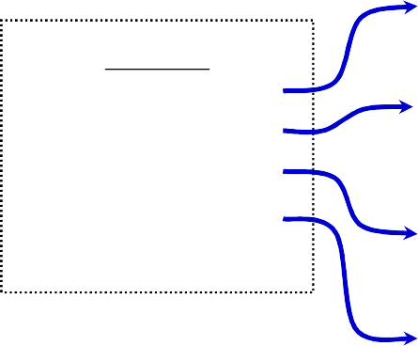‘t’‘r’‘y’‘\0’

*argv*:

* a *string* is an array of characters terminated by a binary 0 (NULL or ‘\0’).
* *argv[0]* is always the program name, so *argc* is at least 1.

1. *<addres1>*
2. *<addres2>*
3. *<addres3>*
4. *<addres4>*
5. **NULL**

‘-’‘g’‘\0’

‘2’‘\0’

‘f’‘r’‘e’‘d’‘\0’

## C Standard Header Files you may want to use

##### Standard Headers you should know about:

* + stdio.h – file and console (also a file) IO: *perror*, *printf*, *open*, *close*, *read*, *write*, *scanf*, etc.
  + stdlib.h - common utility functions: *malloc*, *calloc*, *strtol*, *atoi,* etc
  + string.h - string and byte manipulation: *strlen*, *strcpy*, *strcat*, *memcpy*, *memset*, etc.
  + ctype.h – character types: *isalnum*, *isprint*, *isupport*, *tolower*, etc.
  + errno.h – defines *errno* used for reporting system errors
  + math.h – math functions: *ceil*, *exp*, *floor*, *sqrt*, etc.
  + signal.h – signal handling facility: *raise*, *signal*, etc
  + stdint.h – standard integer: *intN_t*, *uintN_t*, etc
  + time.h – time related facility: *asctime*, *clock*, *time_t*,

etc.

# The Preprocessor

##### The C preprocessor permits you to define simple macros that are evaluated and expanded prior to compilation.

* Commands begin with a ‘#’. Abbreviated list:
  + #define : defines a macro
  + #undef : removes a macro definition
  + #include : insert text from file
  + #if : conditional based on value of expression
  + #ifdef : conditional based on whether macro defined
  + #ifndef : conditional based on whether macro is not defined
  + #else : alternative
  + #elif : conditional alternative
  + defined() : preprocessor function: 1 if name defined, else 0

#if defined( NetBSD )

# Preprocessor: Macros

##### Using macros as functions, exercise caution:

* + flawed example: #define mymult(a,b) a*b
    - Source: k = mymult(i-1, j+5);
    - Post preprocessing: k = i – 1 * j + 5;
  + better: #define mymult(a,b) (a)*(b)
    - Source: k = mymult(i-1, j+5);
    - Post preprocessing: k = (i – 1)*(j + 5);

##### Be careful of *side effects*, for example what if we did the following

* + Macro: #define mysq(a) (a)*(a)
  + flawed usage:
    - Source: k = mysq(i++)
    - Post preprocessing: k = (i++)*(i++)

##### Alternative is to use inline’ed functions

* inline int mysq(int a) {return a*a};
* mysq(i++) works as expected in this case.

Preprocessor: Conditional Compilation

##### Its generally better to use inline’ed functions

* Typically you will use the preprocessor to define constants, perform conditional code inclusion, include header files or to create shortcuts

##### #define DEFAULT_SAMPLES 100

* #ifdef linux

static inline int64_t gettime(void) {...}

##### #elif defined(sun)

static inline int64_t

gettime(void) {return (int64_t)gethrtime()}

##### #else

static inline int64_t

gettime(void) {... gettimeofday()...}

* #endif

# Another Simple C Program

int main (int *argc*, char \*\**argv*) **{**

##### int i;

printf(“There are %d arguments\n”, *argc*);

**for (i = 0; i < *argc*; i++)**

##### printf(“Arg %d = %s\n”, i, *argv*[i]);

return 0;

#### }

##### Notice that the syntax is similar to Java

* What’s new in the above simple program?
  + of course you will have to learn the new interfaces and utility functions defined by the C standard and UNIX
  + Pointers will give you the most trouble

# Arrays and Pointers

##### A variable declared as an array represents a contiguous region of memory in which the array elements are stored.

int x[5]; // an array of 5 4-byte ints.

*little endian byte ordering*

##### All arrays begin with an index of 0

*0 1 2 3*

0

1

2

3

4

memory layout for array x

##### An array identifier is equivalent to a pointer that references the first element of the array

– int x[5], *ptr;

ptr = &x[0] is equivalent to ptr = x;

##### Pointer arithmetic and arrays:

– int x[5];

x[2] is the same as *(x + 2), the compiler will assume you mean 2 objects beyond element x.

# Pointers

* For any type T, you may form a pointer type to T.
  + Pointers may reference a function or an object.
  + The value of a pointer is the address of the corresponding object or function
  + Examples: int *i; char *x; int (*myfunc)();
* Pointer operators: **\*** dereferences a pointer, *&* creates a pointer (reference to)
* int i = 3; int *j = &i;

*j = 4; printf(“i = %d\n”, i); // prints i = 4

* int myfunc (int arg);

int (*fptr)(int) = myfunc;

i = fptr(4); // same as calling myfunc(4);

* Generic pointers:
  + Traditional C used (char *)
  + Standard C uses (void *) – these can not be dereferenced or used in pointer arithmetic. So they help to reduce programming errors
* Null pointers: use ***NULL*** or ***0***. *It is a good idea to always initialize pointers to NULL.*

Step 1:

# Pointers in C (and C++)

Program Memory

|  |
| --- |
|  |
| **4** |
| **0x3dc** |
| NA  NA |
| **0** |
| **0** |
| **0**  **0** |
| **4**  **3**  **2**  **1** |
|  |

Address

int main (int argc, argv) {

|  |  |  |  |  |  |  |
| --- | --- | --- | --- | --- | --- | --- |
| **int**  **int** | **x = 4;**  **\*y = &x;** | | | | | |
| **int** | **\*z[4]** | **=** | **{*NULL*,** | ***NULL*,** | ***NULL*,** | ***NULL*};** |
| **int** | **a[4]** | **=** | **{1, 2,** | **3, 4};** |  |  |

...

Note: The compiler converts z[1] or *(z+1) to

*Value at address* (*Address of z* + *sizeof(int))*;

In C you would write the byte address as:

(char *)z + sizeof(int);

or letting the compiler do the work for you

(int *)z + 1;

*x y*

*z[3]*

*z[2]*

*z[1]*

*z[0]*

*a[3]*

*a[2]*

*a[1]*

*a[0]*

0x3dc 0x3d8 0x3d4 0x3d0 0x3cc 0x3c8 0x3c4 0x3c0 0x3bc 0x3b8 0x3b4 0x3b0

Step 1:

int main (int argc, argv) {

|  |  |  |  |  |  |  |  |  |  |  |
| --- | --- | --- | --- | --- | --- | --- | --- | --- | --- | --- |
| int  int | x  *y | = 4;  = &x; | | | | | | | | |
| int int | *z[4] = {NULL,  a[4] = {1, 2, | | | | | | NULL, NULL, 3, 4}; | | | NULL}; |
| **z[0] = a;** // same as | | | | | | | | | o array Z &a[0]; | |
| **z[1]** | **=** | **a** | **+** | **1;** | // | same | | as | &a[1]; | |
| **z[2]** | **=** | **a** | **+** | **2;** | // | same | | as | &a[2]; | |
| **z[3]** | **=** | **a** | **+** | **3;** | // | same | | as | &a[3]; | |

Step 2: Assign addresses t

*x y*

*z[3]*

*z[2]*

*z[1]*

*z[0]*

*a[3]*

*a[2]*

*a[1]*

*a[0]*

Program Memory

Address

0x3dc 0x3d8 0x3d4 0x3d0

|  |
| --- |
|  |
| 4 |
| 0x3dc |
| NA  NA |
| **0x3bc** |
| **0x3b8 0x3b4**  **0x3b0** |
| 4  3  2  1 |

0x3cc 0x3c8 0x3c4 0x3c0 0x3bc 0x3b8 0x3b4 0x3b0

Program Memory Address

|  |
| --- |
|  |
| 4 |
| 0x3dc |
| NA  NA |
| **0x3bc** |
| **0x3b8 0x3b4**  **0x3b0** |
| 4  3  2  1 |
|  |

|  |  |  |  |  |  |  |  |  |
| --- | --- | --- | --- | --- | --- | --- | --- | --- |
| Step 1:  int main (int argc, int x = 4;  int *y = &x;  int *z[4] = {NULL, | | | | | | argv)  NULL, | | {  NULL, NULL}; |
| int a[4] = Step 2: | | | | {1, | 2, | 3, | 4}; | |
| z[0]  z[1] | =  = | a; a + | | 1; | | | | |
| z[2] | = | a | + | 2; | | | | |
| z[3] | = | a | + | 3; | | | | |
| Step 3:  **z[0] =** | | No change in z’s values  **(int *)((char *)a);** | | | | | | |
| **z[1]** | **=** | **(int** | | **\*)((char *)a** | | | | |

**+ sizeof(int)); z[2] = (int *)((char *)a**

**+ 2 * sizeof(int)); z[3] = (int *)((char *)a**

**+ 3 * sizeof(int));**

*x y*

*z[3]*

*z[2]*

*z[1]*

*z[0]*

*a[3]*

*a[2]*

*a[1]*

*a[0]*

0x3dc 0x3d8 0x3d4 0x3d0 0x3cc 0x3c8 0x3c4 0x3c0 0x3bc 0x3b8 0x3b4 0x3b0

\

|  |  |  |  |  |
| --- | --- | --- | --- | --- |
| **#define QNODE(type) \ struct { \**  **struct type *next; \ struct type **prev; \**  **}** |  | #define **QINSERT_BEFORE**(loc, node, do {  *(loc)->field.prev = (node); (node)->field.prev =  (loc)->field.prev; | field)  \  \  \ | \ |
| #define **QNODE_INIT**(node, field) do {  (node)->field.next = (node); (node)->field.prev =  &(node)->field.next; | \  \  \  \  \ | (loc)->field.prev =  &((node)->field.next); (node)->field.next = (loc);  } while (/* */0) | \  \ |  |
| } while ( /* */ 0 ); |  |  |  |  |

\

#define **QFIRST**(head, field) \ ((head)->field.next)

#define **QNEXT**(node, field) \ ((node)->field.next)

#define **QEMPTY**(head, field) \

((head)->field.next == (head))

#define **QFOREACH**(head, var, field) \ for ((var) = (head)->field.next; \ (var) != (head); \

(var) = (var)->field.next)

#define **QINSERT_AFTER**(loc, node, field) \ do { \

((loc)->field.next)->field.prev = \ &(node)->field.next; \

(node)->field.next = (loc)->field.next; \ (loc)->field.next = (node); \

(node)->field.prev = &(loc)->field.next; \

} while ( /* */ 0)

#define **QREMOVE**(node, field) \ do { \

*((node)->field.prev) = (node)->field.next; \ ((node)->field.next)->field.prev = \ (node)->field.prev; \

(node)->field.next = (node); \ (node)->field.prev = &((node)->field.next); \

} while ( /* */ 0)

typedef struct wth_t

{

int state; QNODE(wth_t) alist;

} wth_t;

} wth_t;

#define QNODE(type) \

**CPP**

typedef struct wth_t { int state;

struct {

struct wth_t *next; struct wth_t **prev;

} alist;

#define QNODE_INIT(node, field) \ do { \

(node)->field.next = (node); \ (node)->field.prev = &(node)->field.next;\

struct { \

struct type *next; \ **memory layout**

struct type **prev; \

} while ( /* */ 0 );

**after GCC**

}***head***: instance of wth_t

3 words in memory

0x100

0x104

0x108

0

0x00100

0x00104

**QNODE_INIT(head, alist)**

<*integer*> state

<*address*> next

<*address*> prev

**0x100**

0x104

0x108

***head***

### before

**0x1a0** 0x1a4 0x1a8

0

0x100

0x104

***node0***

#define QINSERT_BEFORE(**head**, **node**, **alist**)\ do { \

*(**head**)->**alist**.prev = (**node**); \ (**node**)->**alist**.prev = (**head**)->**alist**.prev; \ (**head**)->**alist**.prev = &(**node**)->**alist.**next;\ (**node**)->**alist**.next = (**head**); \

0

0x1a0 0x1a4

} while (/* */0)

QINSERT_BEFORE(head, node0, alist);

**?**

**0x100**

0x104

0x108

***head***

### before

**0x1a0** 0x1a4 0x1a8

0

0x100

0x104

***node0***

#define QINSERT_BEFORE(**head**, **node**, **alist**)\ do { \

*(**head**)->**alist**.prev = (**node**); \ (node)->alist.prev = (head)->alist.prev; \ (head)->alist.prev = &(node)->alist.next;\ (node)->alist.next = (head); \

0

0x1a0 0x1a4

} while (/* */0)

QINSERT_BEFORE(head, node0, alist);

0

0x1a0 0x1a4

0x100

0x104

0x108

***head***

0x1a0 0x1a4 0x1a8

0

**0x1a0**

0x104

***node0***

**0x100**

0x104

0x108

***head***

### before

**0x1a0** 0x1a4 0x1a8

0

0x100

0x104

***node0***

#define QINSERT_BEFORE(**head**, **node**, **alist**)\ do { \

*(**head**)->**alist**.prev = (**node**); \ (**node**)->**alist**.prev = (**head**)->**alist**.prev; \ (**head**)->**alist**.prev = &(**node**)->**alist.**next;\ (**node**)->**alist**.next = (**head**); \

0

0x1a0 0x1a4

} while (/* */0)

QINSERT_BEFORE(head, node0, alist);

0

0x1a0 0x104

0

0x1a0

**0x104**

***head***

***node0***

0x100 0x1a0

0x104 0x1a4

0x108 0x1a8

**0x100**

0x104

0x108

***head***

### before

**0x1a0** 0x1a4 0x1a8

0

0x100

0x104

***node0***

#define QINSERT_BEFORE(**head**, **node**, **alist**)\ do { \

*(**head**)->**alist**.prev = (**node**); \ (**node**)->**alist**.prev = (**head**)->**alist**.prev; \ (**head**)->**alist**.prev = &(**node**)->**alist.**next;\ (**node**)->**alist**.next = (**head**); \

0

0x1a0 0x1a4

} while (/* */0)

QINSERT_BEFORE(head, node0, alist);

0

0x1a0

**0x1a4**

***head***

0x100

0x104

0x108

***node0***

0x1a0 0 0x1a4 0x1a0 0x1a8 0x104

**0x100**

0x104

0x108

***head***

### before

**0x1a0** 0x1a4 0x1a8

0

0x100

0x104

***node0***

#define QINSERT_BEFORE(**head**, **node**, **alist**)\ do { \

*(**head**)->**alist**.prev = (**node**); \ (**node**)->**alist**.prev = (**head**)->**alist**.prev; \ (**head**)->**alist**.prev = &(**node**)->**alist.**next;\ (**node**)->**alist**.next = (**head**); \

0

0x1a0 0x1a4

} while (/* */0)

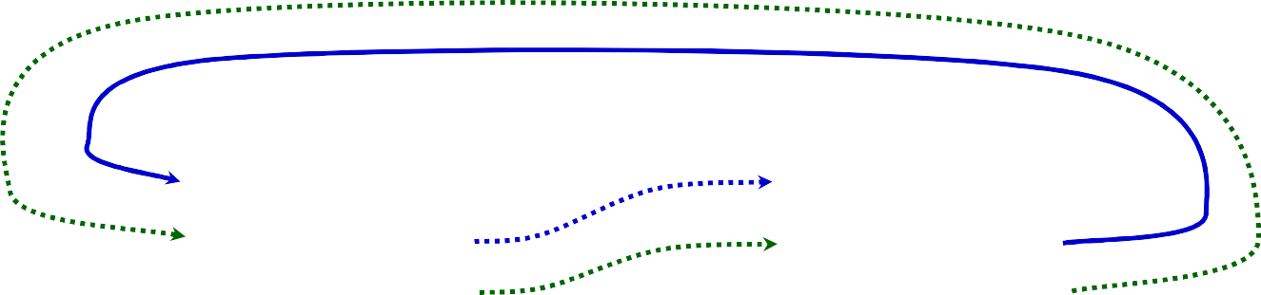QINSERT_BEFORE(head, node0, alist);

0

0x1a0 0x1a4

0

**0x100**

0x104

***head***

***node0***

0x100 0x1a0

0x104 0x1a4

0x108 0x1a8

**0x100**

0x104

0x108

***head***

### before

**0x1a0** 0x1a4 0x1a8

0

0x100

0x104

***node0***

#define QINSERT_BEFORE(**head**, **node**, **alist**)\ do { \

*(**head**)->**alist**.prev = (**node**); \ (**node**)->**alist**.prev = (**head**)->**alist**.prev; \ (**head**)->**alist**.prev = &(**node**)->**alist.**next;\ (**node**)->**alist**.next = (**head**); \

0

0x1a0 0x1a4

} while (/* */0)

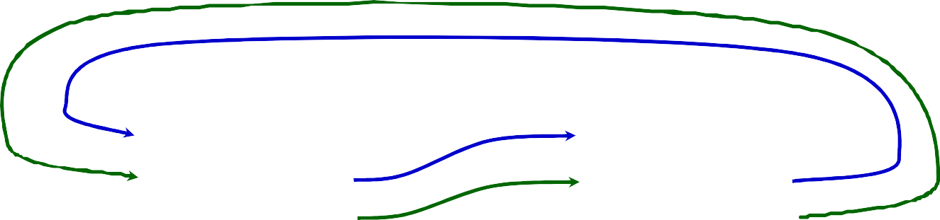QINSERT_BEFORE(head, node0, alist);

0

**0x1a0 0x1a4**

0

**0x100**

**0x104**

***head***

***node0***

**0x100 0x1a0**

**0x104 0x1a4**

0x108 0x1a8

**0x100**

0x104

0x108

***head***

0

0x1a0 0x1a4

**0x200**

0x204

0x208

**0x1a0** 0x1a4 0x1a8

***node1***

0

0x100

0x104

0

0x200

0x204

***node0***

#define QINSERT_BEFORE(**head**, **node**, **alist**)\

do { \

*(**head**)->**alist**.prev = (**node**); \ (**node**)->**alist**.prev = (**head**)->**alist**.prev; \ (**head**)->**alist**.prev = &(**node**)->**alist.**next; \ (**node**)->**alist**.next = (**head**); \

} while (/* */0)

QINSERT_BEFORE(head, node1, alist);

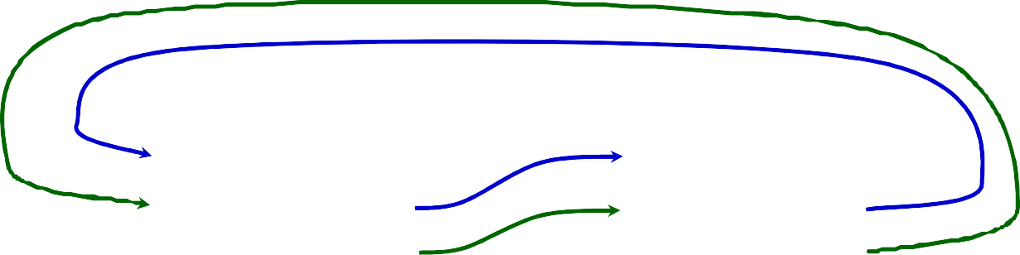*node1*

0

0x200

0x204

0

0x1a0 0x1a4

0

0x100

0x104

*head*

*node0*

0x100 0x1a0

0x104 0x1a4

0x108 0x1a8

0x200

0x204

0x208

**0x100**

***head***

**0x1a0**

0

0x1a0 0x1a4

***node0***

#define QINSERT_BEFORE(**head**, **node1**, **alist**)\

do { \

0x104

0x108

0x1a4 0x1a8

***node1***

0

0x100

0x104

(1)

*(**head**)->**alist**.prev = (**node1**); \

(**node1**)->**alist**.prev = (**head**)->**alist**.prev; \ (**head**)->**alist**.prev = &(**node1**)->**alist.**next; \ (**node1**)->**alist**.next = (**head**); \

**0x200**

0x204

0x208

} while (/* */0)

QINSERT_BEFORE(head, node1, alist);

0

0x200

0x204

**0x200**

*head*

0x100 0 0x104 0x1a0 0x108 0x1a4

0x1a0

0x1a4 0x1a8

*node0*

0

**0x200**

0x104

(1)

0

0x200

0x204

0x204

0x208

*node1*

**0x100**

0x104

***head***

**0x1a0**

0

0x1a0 0x1a4

0x1a4

***node0***

#define QINSERT_BEFORE(**head**, **node1**, **alist**)\

do { \

*(**head**)->**alist**.prev = (**node1**); \

0x108

0x1a8

***node1***

0

0x100

0x104

(2)

(**node1**)->**alist**.prev = (**head**)->**alist**.prev; \ (**head**)->**alist**.prev = &(**node1**)->**alist.**next; \

(**node1**)->**alist**.next = (**head**); \

**0x200**

0x204

0x208

} while (/* */0)

QINSERT_BEFORE(head, node1, alist);

0

0x200

0x204

*node1*

0x100

0x104

0x108

*head*

0

0x1a0 0x1a4

0x1a0

*node0*

0

(1)

0

0x200

**0x1a4**

0x200

0x1a4 0x200

0x1a8 0x104

0x204

0x208

(2)

**0x100**

***head***

**0x1a0**

0

0x1a0 0x1a4

***node0***

#define QINSERT_BEFORE(**head**, **node1**, **alist**)\

do { \

0x104

0x108

0x1a4 0x1a8

***node1***

0

0x100

0x104

(1)

(2)

(3)

*(**head**)->**alist**.prev = (**node1**); \

(**node1**)->**alist**.prev = (**head**)->**alist**.prev; \ (**head**)->**alist**.prev = &(**node1**)->**alist.**next; \ (**node1**)->**alist**.next = (**head**); \

**0x200**

0x204

0x208

} while (/* */0)

QINSERT_BEFORE(head, node1, alist);

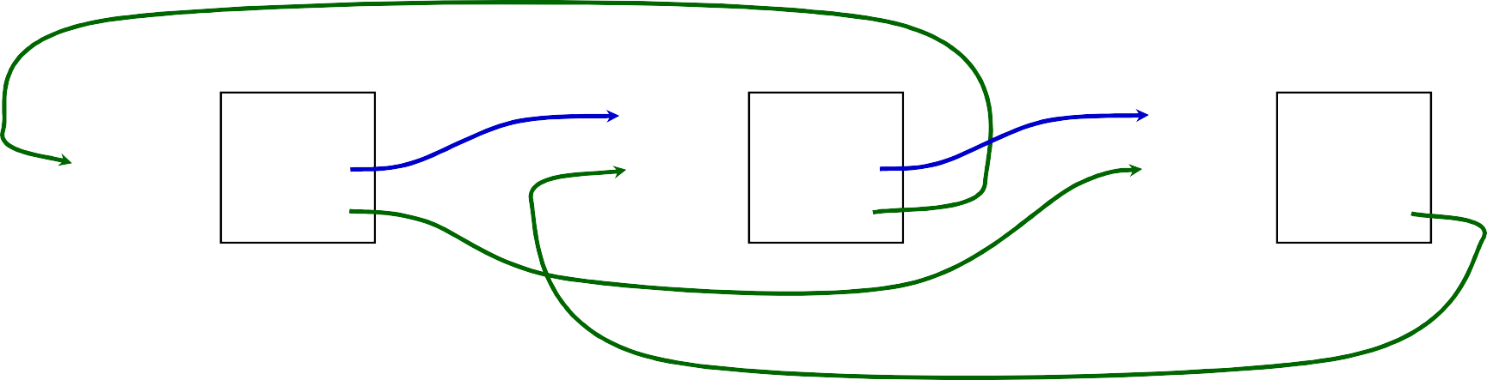

*head*

*node0*

*node1*

0

0x200

0x204

|  |  |  |  |  |  |
| --- | --- | --- | --- | --- | --- |
| 0x100 | 0 | 0x1a0 | 0 | (1) 0x200 | 0 |
| 0x104 | 0x1a0 | 0x1a4 | 0x200 | 0x204 | 0x200 |
| 0x108 | **0x204** | 0x1a8 | 0x104 | 0x208 | 0x1a4 |
|  |  |  | (3) |  |  |
|  |  |  |  | (2) |  |

**0x100**

***head***

**0x1a0**

0

0x1a0 0x1a4

***node0***

#define QINSERT_BEFORE(**head**, **node1**, **alist**)\

do { \

0x104

0x108

0x1a4 0x1a8

***node1***

0

0x100

0x104

(1)

(2)

(3)

(4)

*(**head**)->**alist**.prev = (**node1**); \

(**node1**)->**alist**.prev = (**head**)->**alist**.prev; \ (**head**)->**alist**.prev = &(**node1**)->**alist.**next; \ (**node1**)->**alist**.next = (**head**); \

**0x200**

0x204

0x208

} while (/* */0)

QINSERT_BEFORE(head, node1, alist);

0

0x200

0x204

(4)

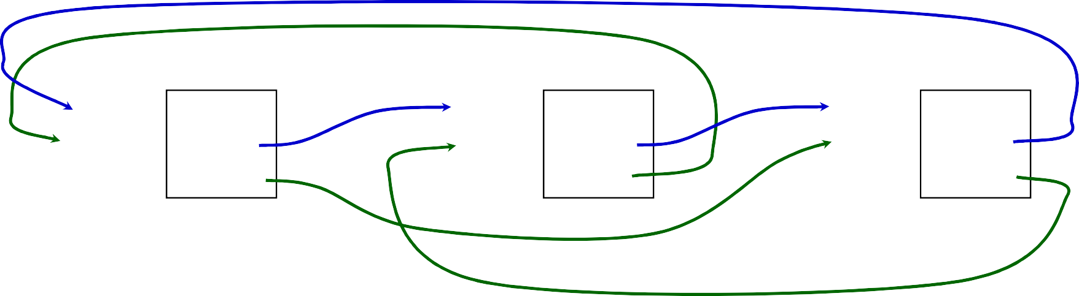

*head*

*node0*

*node1*

|  |  |  |  |  |  |
| --- | --- | --- | --- | --- | --- |
| 0x100  0x104 | 0  0x1a0 | 0x1a0  0x1a4 | 0  0x200 | (1) 0x200  0x204 | 0  **0x100** |
| 0x108 | 0x204 | 0x1a8 | 0x104 | 0x208 | 0x1a4 |
|  |  |  | (3) |  |  |
|  |  |  |  | (2) |  |

**0x100**

0x104

0x108

***head***

0

0x1a0 0x204

**0x200**

0x204

0x208

**0x1a0** 0x1a4 0x1a8

***node1***

0

0x100

0x1a4

***node0***

#define QREMOVE(**node**, **alist**) \

do { \

0

0x200

0x104

1. *((**node**)->**alist**.prev) = (**node**)->**alist**.next; \
2. ((**node**)->**alist**.next)->**alist**.prev = (**node**)->**alist**.prev;\
3. (**node**)->**alist**.next = (**node**); \
4. (**node**)->**alist**.prev = &((**node**)->**alist**.next); \

} while ( /* */ 0)

QREMOVE(node0, alist);

0

**??**

**??**

0

**??**

**??**

**0x100**

0

**??**

**??**

**0x104**

0x108

***head***

**0x1a0 0x1a4** 0x1a8

***node0***

**0x200**

**0x204**

0x208

***node1***

**0x100**

0x104

0x108

***head***

0

0x1a0 0x204

**0x200**

0x204

0x208

**0x1a0** 0x1a4 0x1a8

***node1***

0

0x100

0x1a4

***node0***

#define QREMOVE(**node**, **alist**) \

do { \

0

0x200

0x104

*((**node**)->**alist**.prev) = (**node**)->**alist**.next; \ ((**node**)->**alist**.next)->**alist**.prev = (**node**)->**alist**.prev;\ (**node**)->**alist**.next = (**node**); \ (**node**)->**alist**.prev = &((**node**)->**alist**.next); \

} while ( /* */ 0)

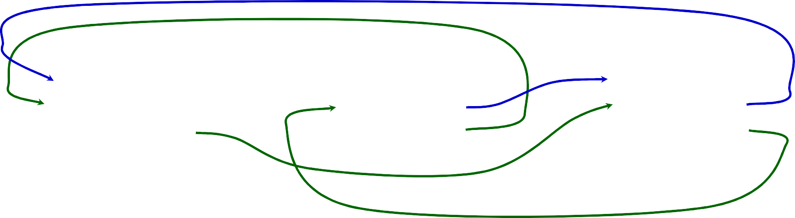QREMOVE(node0, alist);

0

0x1a0 0x204

0

0x200

0x104

0

**0x100**

0x1a4

*head*

*node0*

*node1*

0x100 0x1a0 0x200

0x104 0x1a4 0x204

0x108 0x1a8 0x208

**0x100**

0x104

0x108

***head***

0

0x1a0 0x204

**0x200**

0x204

0x208

**0x1a0** 0x1a4 0x1a8

***node1***

0

0x100

0x1a4

***node0***

#define QREMOVE(**node0**, **alist**) \

do { \

0

0x200

0x104

1. **\*((node0)->alist.prev) = (node0)->alist.next; \** ((node0)->alist.next)->alist.prev = (node0)->alist.prev;\ (node0)->alist.next = (node0); \

(node0)->alist.prev = &((node0)->alist.next); \

} while ( /* */ 0)

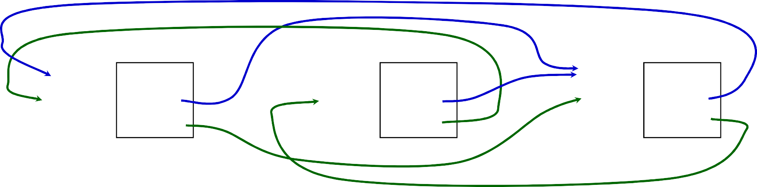QREMOVE(node0, alist);

|  |  |  |  |  |  |  |
| --- | --- | --- | --- | --- | --- | --- |
|  | *head* |  |  | *node0* |  | *node1* |
| 0x100 | 0 | **(1)** | 0x1a0 | 0 | 0x200 | 0 |
| 0x104 | **0x200** |  | 0x1a4 | 0x200 | 0x204 | 0x100 |
| 0x108 | 0x204 |  | 0x1a8 | 0x104 | 0x208 | 0x1a4 |

**0x100**

0x104

0x108

***head***

**0x1a0** 0x1a4 0x1a8

0

0x1a0 0x204

***node1***

***node0***

#define QREMOVE(**node0**, **alist**) \

do { \

0

0x200

0x104

**\*((node0)->alist.prev) = (node0)->alist.next; \**

1. ((node0)->alist.next)->alist.prev = (node0)->alist.prev;\ (node0)->alist.next = (node0); \

(node0)->alist.prev = &((node0)->alist.next); \

**0x200**

0x204

0x208

0

0x100

0x1a4

} while ( /* */ 0)

QREMOVE(node0, alist);

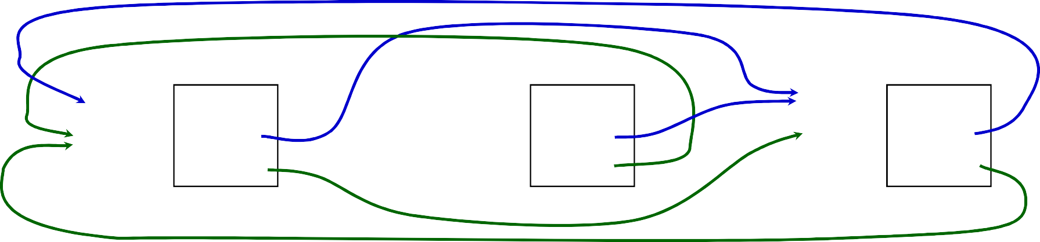

|  |  |  |  |  |  |  |
| --- | --- | --- | --- | --- | --- | --- |
|  | *head* |  | *node0* |  |  | *node1* |
| 0x100 | 0 | 0x1a0 | 0 |  | 0x200 | 0 |
| 0x104 | 0x200 | 0x1a4 | 0x200 |  | 0x204 | 0x100 |
| 0x108 | 0x204 | 0x1a8 | 0x104 |  | 0x208 | **0x104** |
|  |  |  |  | **(2)** |  |  |

**0x100**

0x104

0x108

***head***

**0x1a0** 0x1a4 0x1a8

0

0x1a0 0x204

***node1***

***node0***

#define QREMOVE(**node0**, **alist**) \

do { \

0

0x200

0x104

**\*((node0)->alist.prev) = (node0)->alist.next; \**

((node0)->alist.next)->alist.prev = (node0)->alist.prev;\

1. (node0)->alist.next = (node0); \ (node0)->alist.prev = &((node0)->alist.next); \

**0x200**

0x204

0x208

0

0x100

0x1a4

} while ( /* */ 0)

QREMOVE(node0, alist);

*node1*

0x100

0x104

0x108

*head*

0

0x200

0x204

**(3)**

*node0*

0x1a0 0 0x1a4 **0x1a0** 0x1a8 0x104

0x200 0

0x204

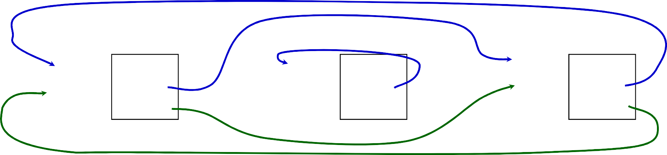

0x208

0x100

0x104

**0x100**

0x104

0x108

***head***

**0x1a0** 0x1a4 0x1a8

0

0x1a0 0x204

***node1***

***node0***

#define QREMOVE(**node0**, **alist**) \

do { \

0

0x200

0x104

**\*((node0)->alist.prev) = (node0)->alist.next; \** ((node0)->alist.next)->alist.prev = (node0)->alist.prev;\ (node0)->alist.next = (node0); \

1. (node0)->alist.prev = &((node0)->alist.next); \

**0x200** 0

} while ( /* */ 0)

0x204

0x208

0x100

0x1a4

QREMOVE(node0, alist);

*head*

0x100 0

*node0*

0x1a0 0

*node1*

0x200 0

0x104

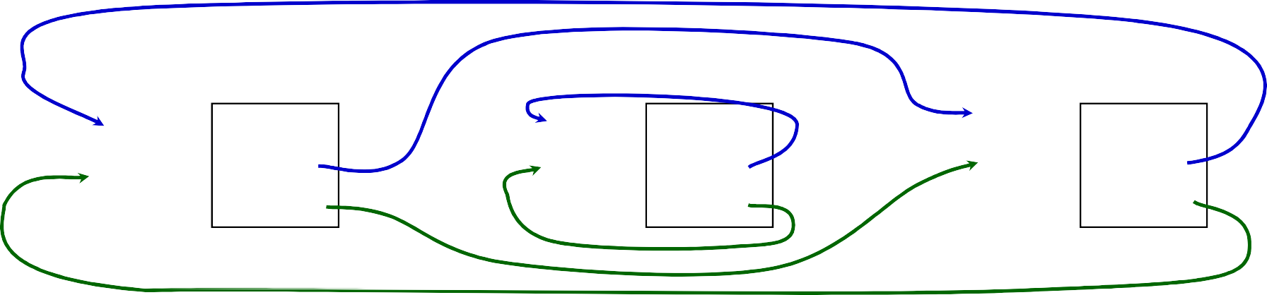

0x108

**0x200**

0x204

**(4)**

0x1a4 0x1a8

0x1a0

**0x1a4**

0x204

0x208

0x100

0x104

# Solution to Removing a Node

**0x100**

0x104

0x108

***head***

0

0x1a0 0x204

**0x200**

0x204

0x208

**0x1a0** 0x1a4 0x1a8

***node1***

0

0x100

0x1a4

***node0***

#define QREMOVE(**node**, **alist**) \

do { \

0

0x200

0x104

1. *((**node**)->**alist**.prev) = (**node**)->**alist**.next; \
2. ((**node**)->**alist**.next)->**alist**.prev = (**node**)->**alist**.prev;\
3. (**node**)->**alist**.next = (**node**); \
4. (**node**)->**alist**.prev = &((**node**)->**alist**.next); \

} while ( /* */ 0)

QREMOVE(node0, alist);

0

**0x200**

**0x204**

0

**0x1a0 0x1a4**

0

**0x100**

**0x104**

***head***

***node0***

***node1***

**0x100 0x1a0 0x200**

**0x104 0x1a4 0x204**

0x108 0x1a8 0x208

# Functions

* Always use function prototypes

int myfunc (char *, int, struct MyStruct *); int myfunc_noargs (void);

void myfunc_noreturn (int i);

* C and C++ are *call by value*, copy of parameter passed to function
  + C++ permits you to specify pass by reference
  + if you want to alter the parameter then pass a pointer to it (or use references in C++)
* If performance is an issue then use inline functions, generally better and safer than using a macro. Common convention
  + define prototype and function in header or *name*.i file
* static inline int myinfunc (int i, int j);
* static inline int myinfunc (int i, int j) { ... }

# Basic Types and Operators

* Basic data types
  + Types: *char, int, float and double*
  + Qualifiers: *short, long, unsigned, signed, const*
* Constant: 0x1234, 12, “Some string”
* Enumeration:
  + Names in different enumerations must be distinct

– enum WeekDay_t {Mon, Tue, Wed, Thur, Fri}; enum WeekendDay_t {Sat = 0, Sun = 4};

* Arithmetic: +, -, *, /, %
  + prefix ++i or --i ; increment/decrement before value is used
  + postfix i++, i--; increment/decrement after value is used
* Relational and logical: <, >, <=, >=, ==, !=, &&, ||
* Bitwise: &, |, ^ (xor), <<, >>, ~(ones complement)

Operator Precedence (from “C a Reference Manual”, 5th Edition)

|  |  |  |  |  |
| --- | --- | --- | --- | --- |
| **Tokens** | **Operator** | **Class** | **Precedence** | **Associates** |
| ***names, literals*** | simple tokens | primary | **16** | n/a    left-to-right left-to-right  left-to-right |
| ***a*[k]** | subscripting | postfix |
| ***f*(...)** | function call | postfix |
| **.** | direct selection | postfix |
| **->** | indirect selection | postfix |  | left to right left-to-right  left-to-right |
| **++ --** | increment, decrement | **postfix** |
| **(*type*){*init*}** | compound literal | postfix |
| **++ --** | increment, decrement | **prefix** | **15** | right-to-left right-to-left right-to-left right-to-left right-to-left right-to-left  right-to-left |
| **sizeof** | size | unary |
| **~** | bitwise not | unary |
| **!** | logical not | unary |
| **- +** | negation, plus | unary |
| **&** | address of | unary |
| **\*** | indirection  (*dereference*) | unary |

|  |  |  |  |  |  |  |  |
| --- | --- | --- | --- | --- | --- | --- | --- |
| **Tokens** | | | | **Operator** | **Class** | **Precedence** | **Associates** |
| **(*type*)** | | | | casts | unary | **14** | right-to-left |
| **\* / %** | | | | multiplicative | binary | **13** | left-to-right |
|  | **+** | **-** |  | additive | binary | **12** | left-to-right |
|  | **<<** | **>>** |  | left, right shift | binary | **11** | left-to-right |
| **<** | **<=** | **>** | **>=** | relational | binary | **10** | left-to-right |
|  | **==** | **!=** |  | equality/ineq. | binary | **9** | left-to-right |
| **&** | | | | bitwise and | binary | **8** | left-to-right |
| **^** | | | | bitwise xor | binary | **7** | left-to-right |
| **|** | | | | bitwise or | binary | **6** | left-to-right |
| **&&** | | | | logical and | binary | **5** | left-to-right |
| **||** | | | | logical or | binary | **4** | left-to-right |
| **?:** | | | | conditional | ternary | **3** | right-to-left |
| **= += -=** | | | |  |  |  |  |
| **\*= /= %=**  **&= ^= |=** | | | | assignment | binary | **2** | right-to-left |
| **<<= >>=** | | | |  |  |  |  |
| **,** | | | | sequential eval. | binary | **1** | left-to-right |

* structures

# Structs and Unions

* + struct MyPoint {int x, int y};
  + typedef struct MyPoint MyPoint_t;
  + MyPoint_t point, *ptr;
  + point.x = 0;point.y = 10;
  + ptr = &point; ptr->x = 12; ptr->y = 40;

##### unions

* + union MyUnion {int x; MyPoint_t pt; struct {int 3; char c[4]} S;};
  + union MyUnion x;

– Can only use one of the elements. Memory will be allocated for the largest element

**if** (a < 10)

printf(“a is less than 10\n”);

**else if** (a == 10) printf(“a is 10\n”);

**else**

printf(“a is greater than 10\n”);

* If you have compound statements then use brackets (blocks)

– **if** (a < 4 && b > 10) { c = a * b; b = 0;

printf(“a = %d, a\’s address = 0x%08x\n”, a, (uint32_t)&a);

} **else** {

c = a + b; b = a;

}

* These two statements are equivalent:

|  |  |  |
| --- | --- | --- |
| – **if** (a) x = 3; | **else** | **if** (b) x = 2; **else** x = 0; |
| – **if** (a) x = 3;   * Is this correct? | **else** | {**if** (b) x = 2; **else** x = 0;} |
| – **if** (a) x = 3; | **else** | **if** (b) x = 2; |

**else** (z) x = 0; **else** x = -2;

int c = 10;

**switch** (c) {

**case** 0:

printf(“c is 0\n”);

###### break;

...

###### default:

printf(“Unknown value of c\n”);

###### break;

}

* What if we leave the break statement out?
* Do we need the final break statement on the default case?

**for** (i = 0; i < MAXVALUE; i++) {

dowork();

}

**while** (c != 12) {

dowork();

}

**do** { dowork();

} **while** (c < 12);

* flow control
  + **break** – exit innermost loop
  + **continue** – perform next iteration of loop
* Note, all these forms permit one statement to be executed. By enclosing in brackets we create a block of statements.

##### For all labs and programming assignments:

* + you must supply a make file
  + you must supply a README file that describes the assignment and results. This must be a text file, no MS word.
  + of course the source code and any other libraries or utility code you used
  + you may submit plots, they must be postscript or pdf
* Why use make?
  + convenience of only entering compile directives once
  + make is smart enough (with your help) to only compile and link modules that have changed or which depend on files that have changed
  + allows you to hide platform dependencies
  + promotes uniformity
  + simplifies my (and hopefully your) life when testing and verifying your code
* A makefile contains a set of rules for building a program

target ... : prerequisites ... command

...

* Static pattern rules.
  + each target is matched against target-pattern to derive stem which is used to determine prereqs (see example)

targets ... : target-pattern : prereq-patterns ... command

...

##### Defining variables MyOPS := -DWTH MyDIR ?= /home/fred MyVar = $(SHELL)

* Using variables

##### MyFLAGS := $(MyOPS)

* Built-in Variables
  + $@ = filename of target
  + $< = name of the first prerequisites

##### Patterns

* + use % character to determine stem
  + foo.o matches the pattern %.o with foo as the stem.
  + foo.o moo.o : %.o : %.c # says that foo.o depends on foo.c and moo.o depends on moo.c

# Makefile.inc

Makefile.inc Makefile

# Project specific

# Contains common definitions

MyOS := $(shell uname -s)

MyID := $(shell whoami)

MyHost := $(shell hostname)

WARNSTRICT := -W \

-Wstrict-prototypes

\

-Wmissing-prototypes

WARNLIGHT := -Wall

WARN := ${WARNLIGHT}

ALLFLGS := -D_GNU_SOURCE \

-D_REENTRANT \

-D_THREAD_SAFE

APPCFLGS = $(ALLFLGS) \

$(WARN)

WUCC := gcc

WUCFLAGS := -DMyOS=$(MyOS) \

$(OSFLAGS) \

$(ALLFLGS) $(WARN)

WUINCLUDES :=

WULIBS := -lm

ifeq (${MyOS), SunOS)

OSLIBS+= -lrt

endif

include ../Makefile.inc INCLUDES = ${WUINCLUDES} –I.

LIBS = ${WILIBS} ${OSLIBS} CFLAGS = ${WUCLFAGS} –DWUDEBUG CC = ${WUCC}

HDRS := util.h

CSRCS := testapp1.c testapp2.c SRCS := util.c callout.c

COBJS = $(addprefix ${OBJDIR}/, \

$(patsubst %.c,%.o,$(CSRCS)))

OBJS = $(addprefix ${OBJDIR}/, \

$(patsubst %.c,%.o,$(SRCS))) CMDS = $(addprefix ${OBJDIR}/, $(basename $(CSRCS)))

all : $(OBJDIR) $(CMDS)

install : all

$(OBJDIR) :

mkdir $(OBJDIR)

$(OBJS) $(COBJS) : ${OBJDIR}/%.o : %.c $(HDRS)

${CC} ${CFLAGS} ${INCLUDES} –o $@ -c $<

$(CMDS) : ${OBJDIR}/% : ${OBJDIR}/%.o $(OBJS)

${CC} ${CFLAGS} -o $@ $@.o ${LIBS} chmod 0755 $@

clean :

/bin/rm -f $(CMDS) $(OBJS)

* README file structure
  + ***Section A***: *Introduction*

describe the project, paraphrase the requirements and state your understanding of the assignments value.

* + ***Section B***: *Design and Implementation*

List all files turned in with a brief description for each. Explain your design and provide simple psuedo-code for your project. Provide a simple flow chart of you code and note any constraints, invariants, assumptions or sources for reused code or ideas.

* + ***Section C***: *Results*

For each project you will be given a list of questions to answer, this is where you do it. If you are not satisfied with your results explain why here.

* + ***Section D***: *Conclusions*

What did you learn, or not learn during this assignment. What would you do differently or what did you do well.

# Attacking a Project

* *Requirements and scope*: Identify specific requirements and or goals. Also note any design and/or implementation environment requirements.
  + knowing when you are done, or not done
  + estimating effort or areas which require more research
  + programming language, platform and other development environment issues
* *Approach*: How do you plan to solve the problem identified in the first step. Develop a prototype design and document. Next figure out how you will verify that you did satisfy the requirements/goals. Designing the tests will help you to better understand the problem domain and your proposed solution
* *Iterative development*: It is good practice to build your project in small pieces. Testing and learning as you go.
* *Final Touches*: Put it all together and run the tests identified in the approach phase. Verify you met requirements. Polish you code and documentation.
* *Turn it in*: