**S.B.V.P. Samaj’s,**

**S.M.B.S.T. College Sangamner.**

**Department of BCA(Science)**

**Departmental Activities**

“**Brain Power Development**” in our college is an activity which inspire student regarding how to improve our sharp Memory Techniques . It is an ability to perform large-scale analysis, get more objective and accurate analysis, Student Satisfaction Regarding Study. The 9th of July 2023 was as a memorable day in the life of every fresher of B.C.A (Science) batch 2023-24 at S.M.B.S.T. College, Sangamner campus.

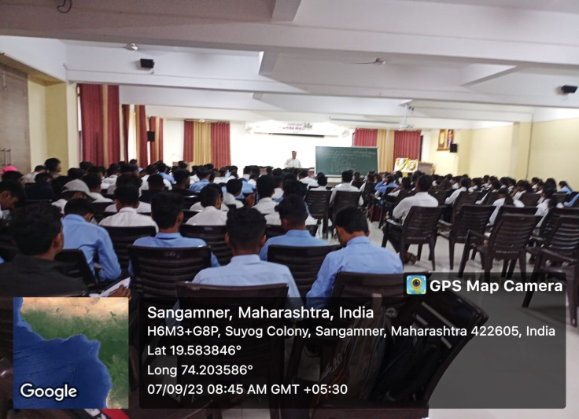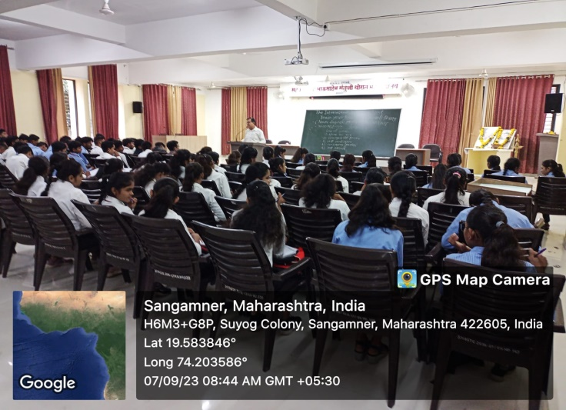

**Brain Development Program**

