**Field Visit Report**

**Date:** 14th September 2024  
**Organized by:** Zoology Department, SMBST College, Sangamner  
**Participants:** 13 Students, 7 Teachers  
**Departure Time:** 9:00 AM  
**Return Time:** 8:00 PM

**Itinerary and Observations:**

1. **Departure from College:**
   * We left SMBST College at 9:00 AM by a private bus. Everyone was excited and ready for a day of adventure and learning.
2. **Randha Falls:**

Randha Falls is a stunning waterfall located near Bhandardara in the Ahmednagar district of Maharashtra, India. Cascading from a height of 170 feet, it is the third-highest waterfall in Maharashtra. The falls are formed over the Pravara River and are especially breathtaking during the monsoon season when the water flow is at its peak.

The surrounding area is a popular tourist destination, offering picturesque views and opportunities for activities like trekking and boating. There is also a temple on the banks of the river and a viewpoint above the falls that provides a great vantage point to admire the cascading water1. The rocky sides of the gorge are home to bee colonies, adding to the natural beauty of the location

* + **Observation:** At Randha Falls, we observed the lotic ecosystem. The fast-flowing water was fascinating, and we saw how it influenced the plants and animals living there.
  + **Learning:** It was interesting to see how different organisms adapt to the fast-moving water. We could see the practical side of what we learned in class.

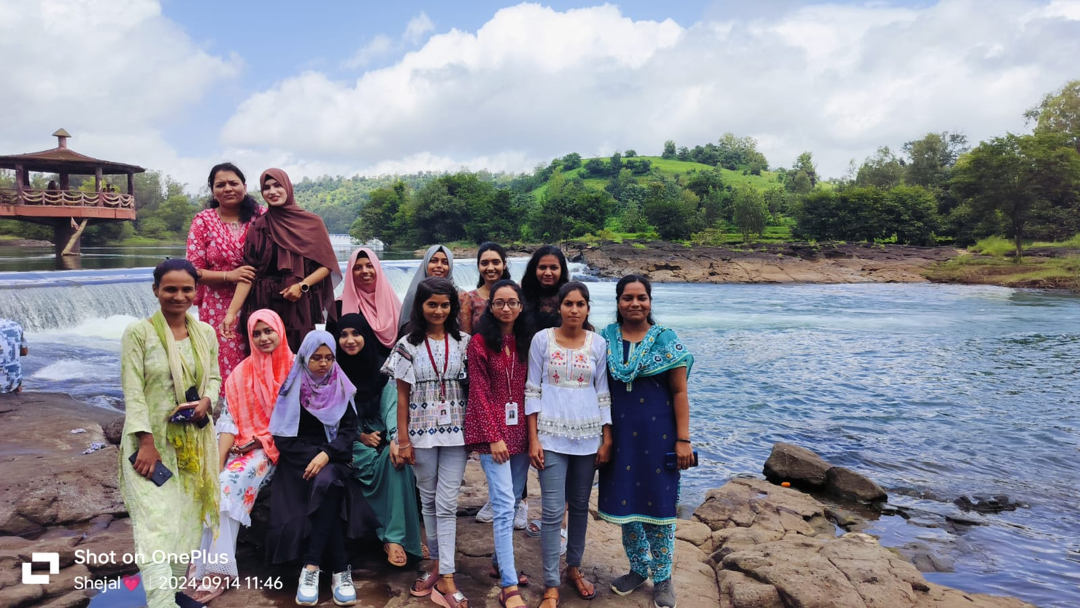

**At Randhafall : Chasing Waterfall**

1. **Bhandardara Dam:**

**Construction and Capacity**

* **Construction Start**: The construction of Bhandardara Dam began in **1910** and was completed in **1926**.
* **Capacity**: The dam has a gross storage capacity of **11 TMC (Thousand Million Cubic feet)**.

**Biodiversity**

Bhandardara is located in the scenic Western Ghats of Maharashtra and is known for its rich biodiversity. The area around the dam is home to a variety of flora and fauna, including:

* **Forests**: The region is covered with lush green forests, which are home to many species of trees, shrubs, and herbs.
* **Wildlife**: The area is inhabited by various wildlife species such as deer, monkeys, and a variety of birds.
* **Water Bodies**: The dam creates Arthur Lake, which supports aquatic life and provides a habitat for fish and other aquatic organisms.
* **Trekking and Nature Trails**: The surrounding area offers numerous trekking trails and nature walks, allowing visitors to explore the diverse ecosystem.
* **Observation:** Next, we visited Bhandardara Dam and studied the lentic water ecosystem. The still water was a stark contrast to the rushing waters of Randha Falls.
* **Learning:** Comparing the two ecosystems helped us understand the differences between lotic and lentic environments and how organisms adapt to each.

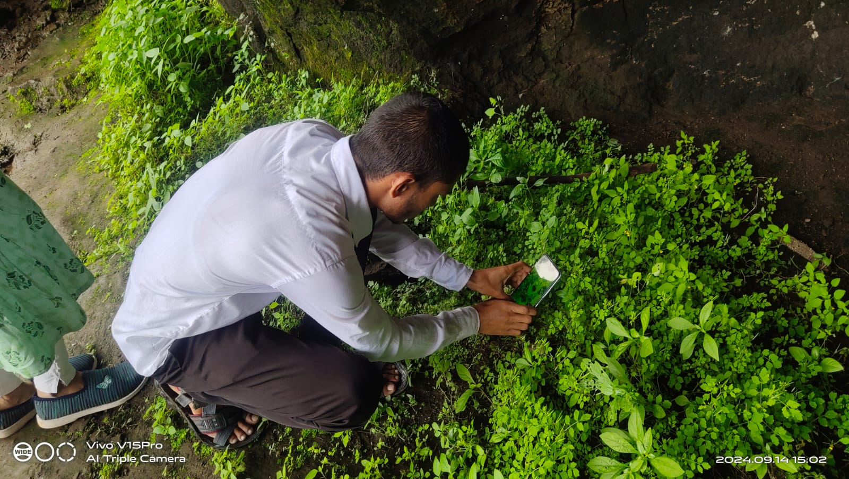

**Observing The Spider diversity at nhani fall**

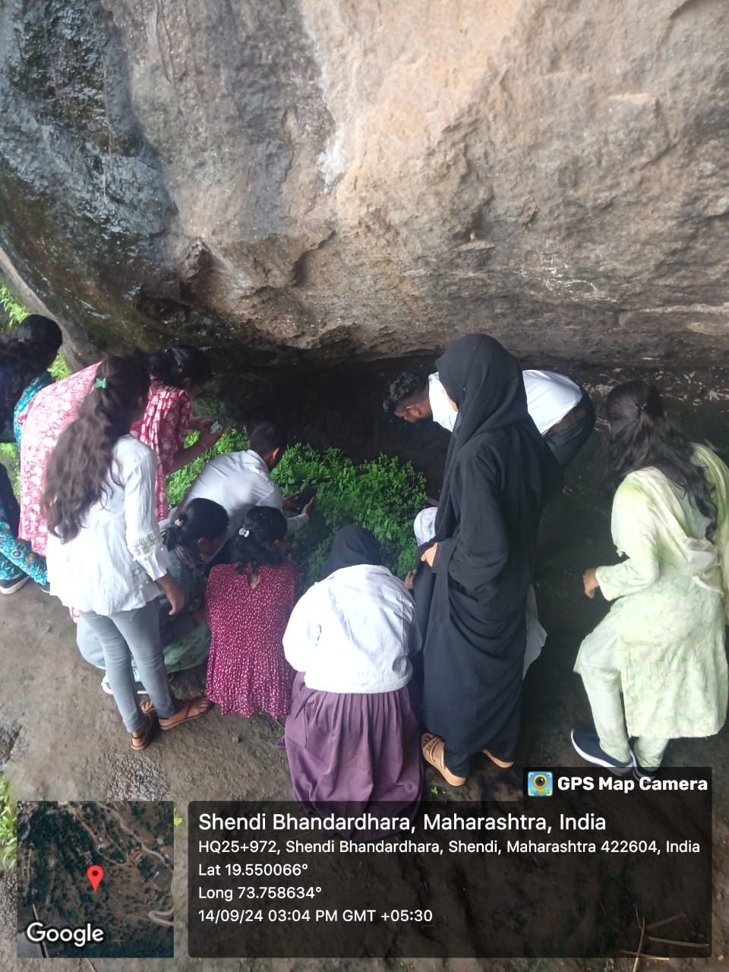

1. **Nani Waterfall:**
   * **Observation:** The scenery at Nani Waterfall was breathtaking. We also observed a variety of spiders in their natural habitat.
   * **Learning:** Seeing the diversity of spiders and their webs was amazing. It gave us a better understanding of arachnid diversity and their ecological roles.
2. **Necklace Falls:**
   * **Observation:** At Necklace Falls, we visited the Harishchandragad and Kalsubai Wildlife Sanctuary. We saw various species in a protected environment.
   * **Learning:** The sanctuary visit highlighted the importance of wildlife conservation and the role of such habitats in preserving biodiversity.
3. **Amruteshwar Temple:**
   * **Lunch Break:** We had our lunch at the historic Amruteshwar Temple. It was a nice break and a chance to relax.
   * **Cultural Insight:** Visiting the temple added a cultural aspect to our trip, making it more enriching.
4. **Ghatghar:**
   * **Observation:** The mist and fog at Ghatghar created a magical landscape. It was a perfect end to our trip.
   * **Learning:** This stop helped us appreciate the climatic conditions and their effects on the local ecosystem.

**Conclusion:**

We returned to the college at 8:00 PM, tired but happy. The field visit was a great way to see our lessons come to life. It gave us practical insights into different ecosystems and biodiversity, making our studies more interesting and meaningful.

**Student’s Note:** The trip was not only educational but also a lot of fun. We learned so much about different ecosystems and saw things we had only read about in textbooks. The teachers were very supportive and answered all our questions. This field visit was a compulsory part of our syllabus, and it truly enhanced our understanding of the subject.

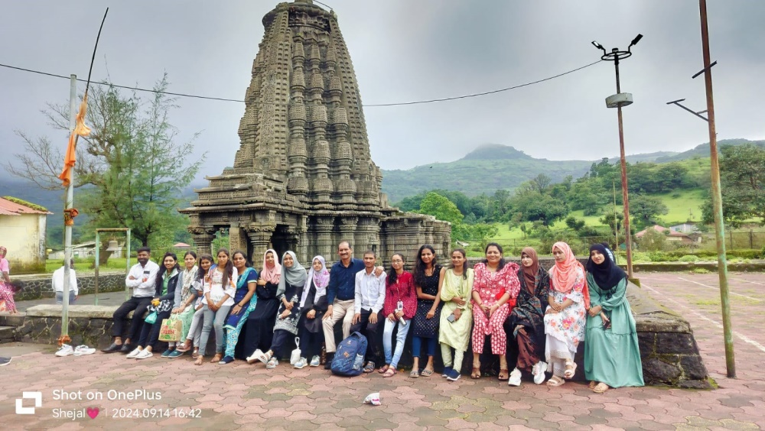

**At Amruteshwar Temple**

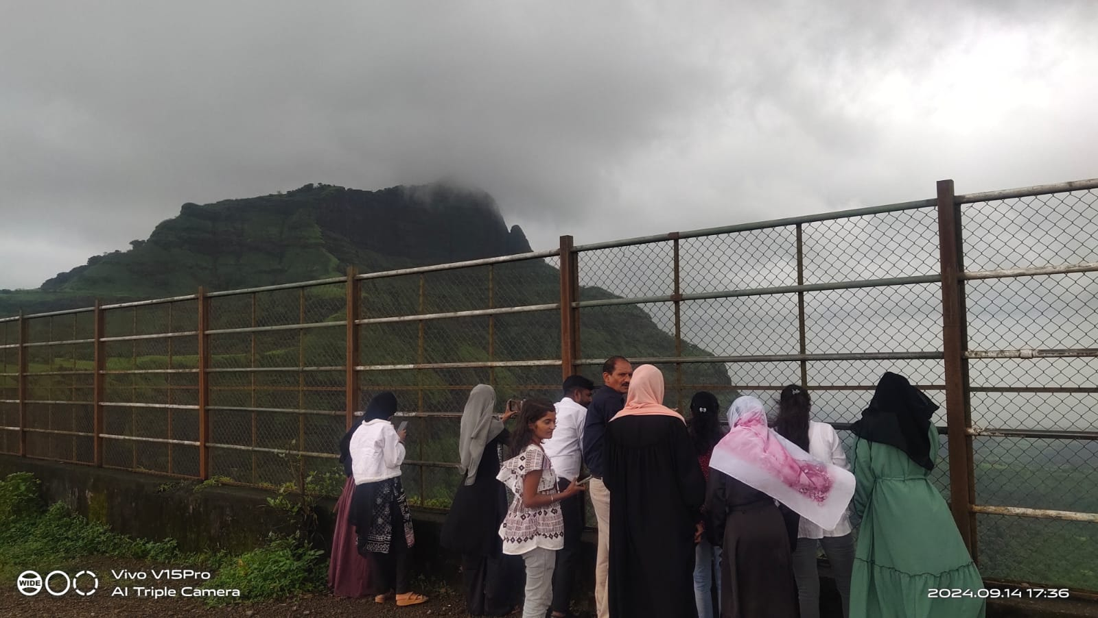

**At ghatghar : Embrace the misty fog**