NIRBHAY KANYA ABHIYAN
BOARD

Objectives
- To train girls students for personal safety
- To enable girls students to fight against operations and injustice
- To enable girls students to participate in the programs fearlessly.
- To make girls students mentally self-reliant
- To enable girls students to participate in extra co-curricular activities
Grants for the Nirbhay Kanya Abhiyan

- University has given Rs.15000 for those colleges who agri get this Abhiyan.
Implementation of the Abhiyan

- This Abhiyan is agreement by 5 colleges collectively under Student Welfare Council.
- 20 students were selected first year student were preferred.
- For the training of the girl students expert were invited
- Attendance of the girl students was maintained.

2022-23
Date |  | Resource Persons | Topic | Participated  Students | Sanction Amount
15/2/2023 |  | Dr.SandhyaKhedkar | PresonalityDevelopment,Karate Training | 145 | 15,000/-
16/2/2023 |  | Dr.JayshreeTai Thorat | SelfConfidence&Woman’s Health | 162
28/2/2023 |  | Mrs SonaliGiri | Women Empowerment | 189
2021-22
Nov 2021 | Mr.MilindAuti |  | Given KarateTrainging | 165 |  | 15,000/-
Nov 2021 | Dr.SandhyaKhedkar |  | Presonality Development | 183
Nov 2021 | Dr.HemlataRathod |  | Women Empowerment | 177

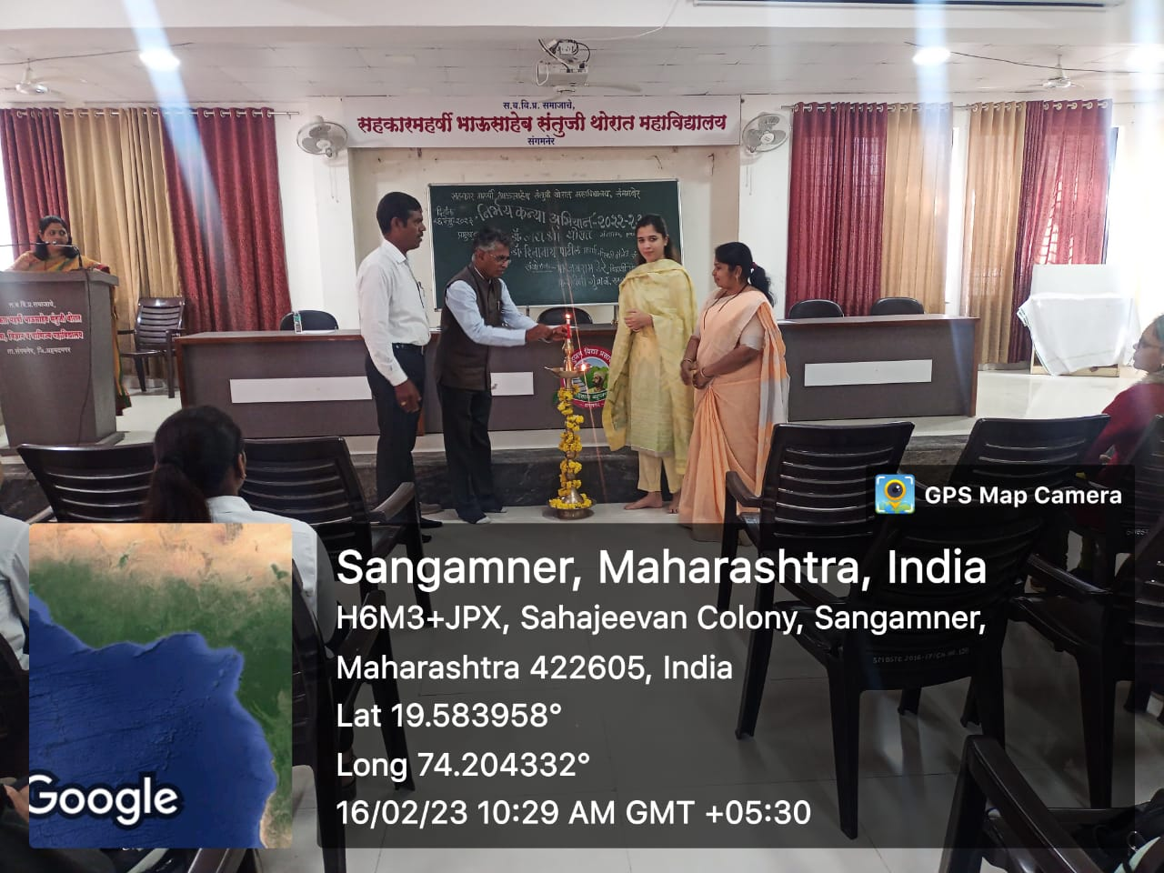
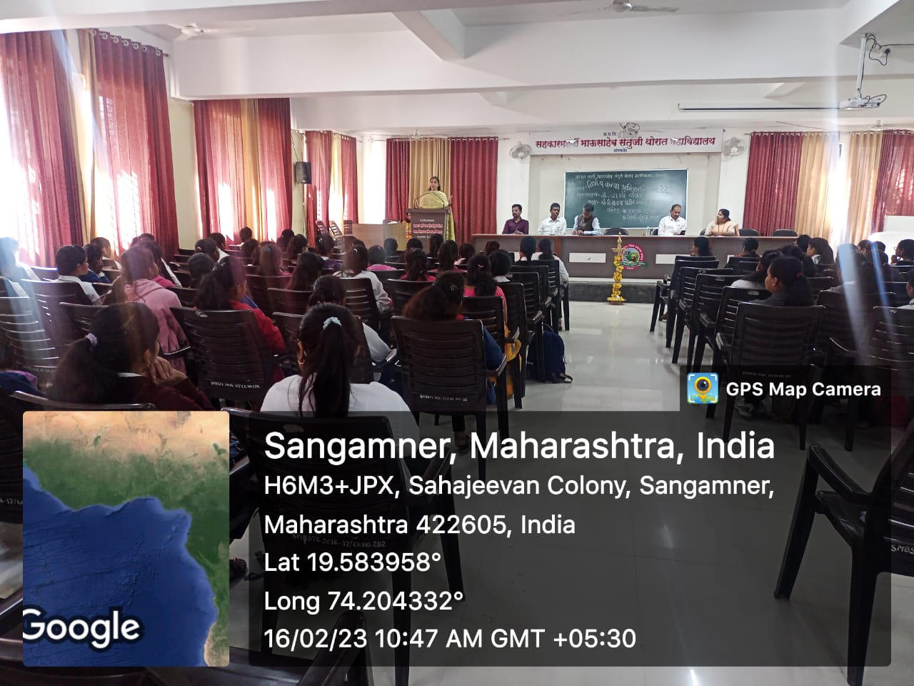

Dr. Jayashri Tai Thorat guide Leady students about Health .

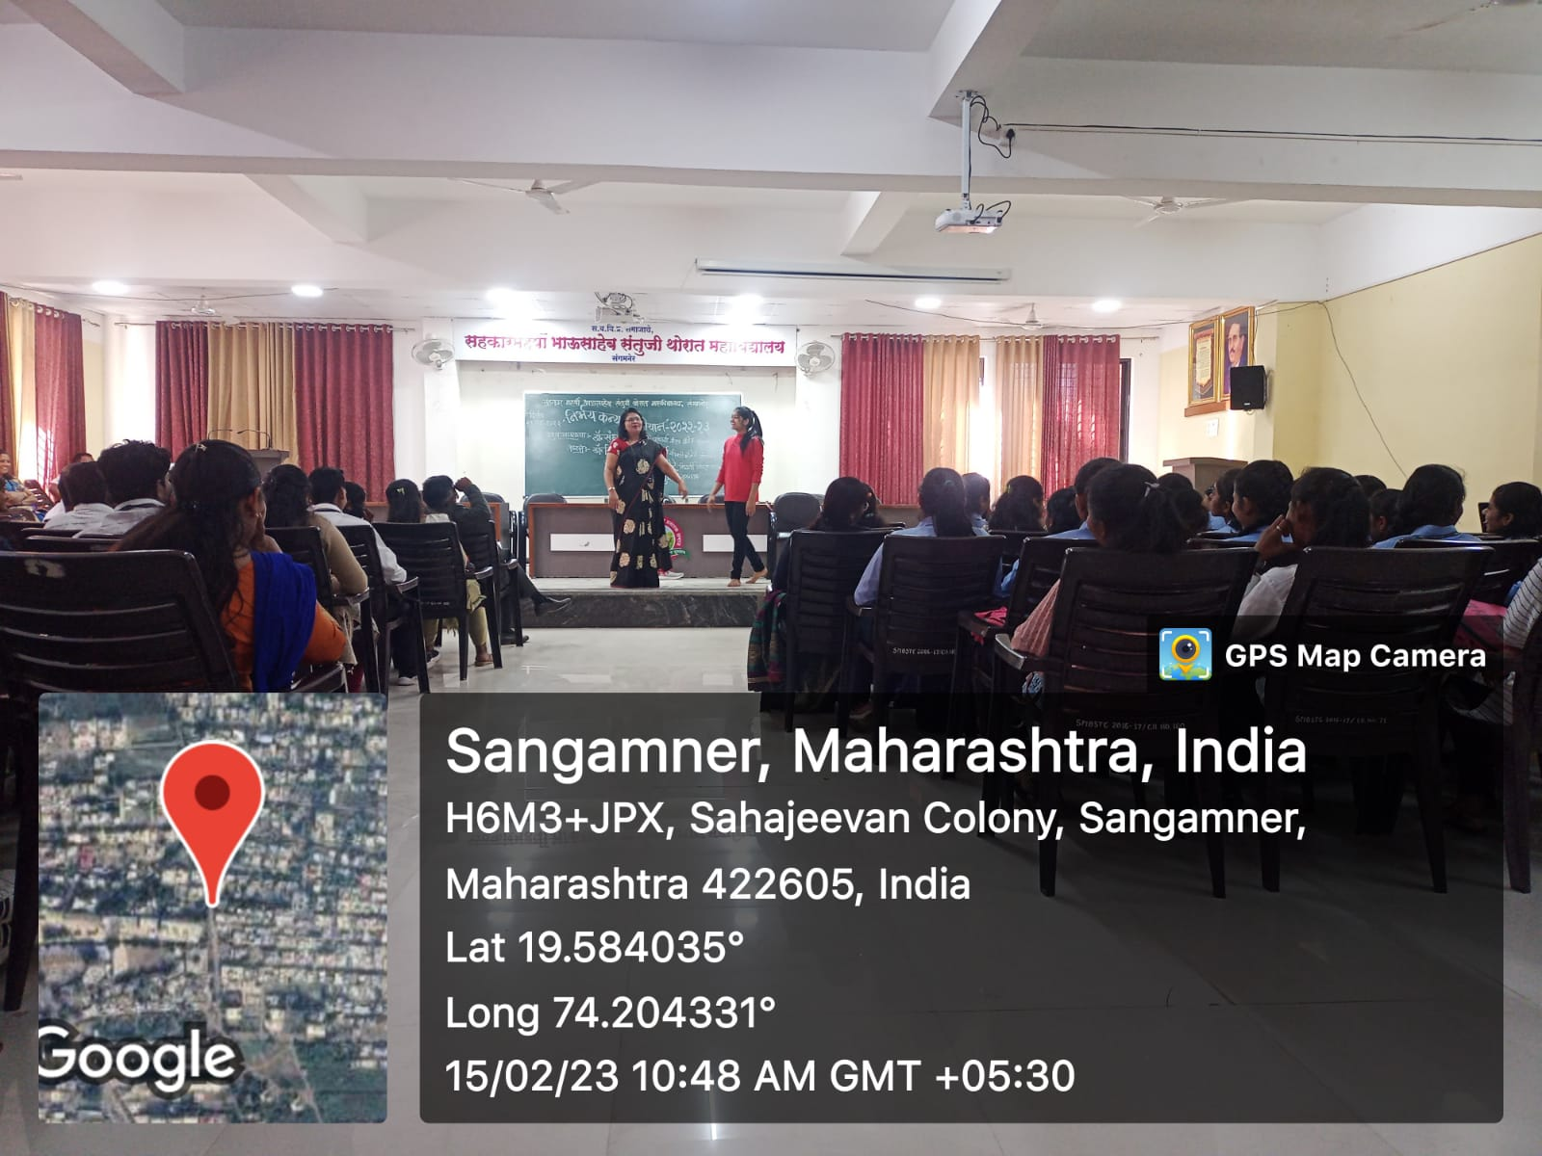

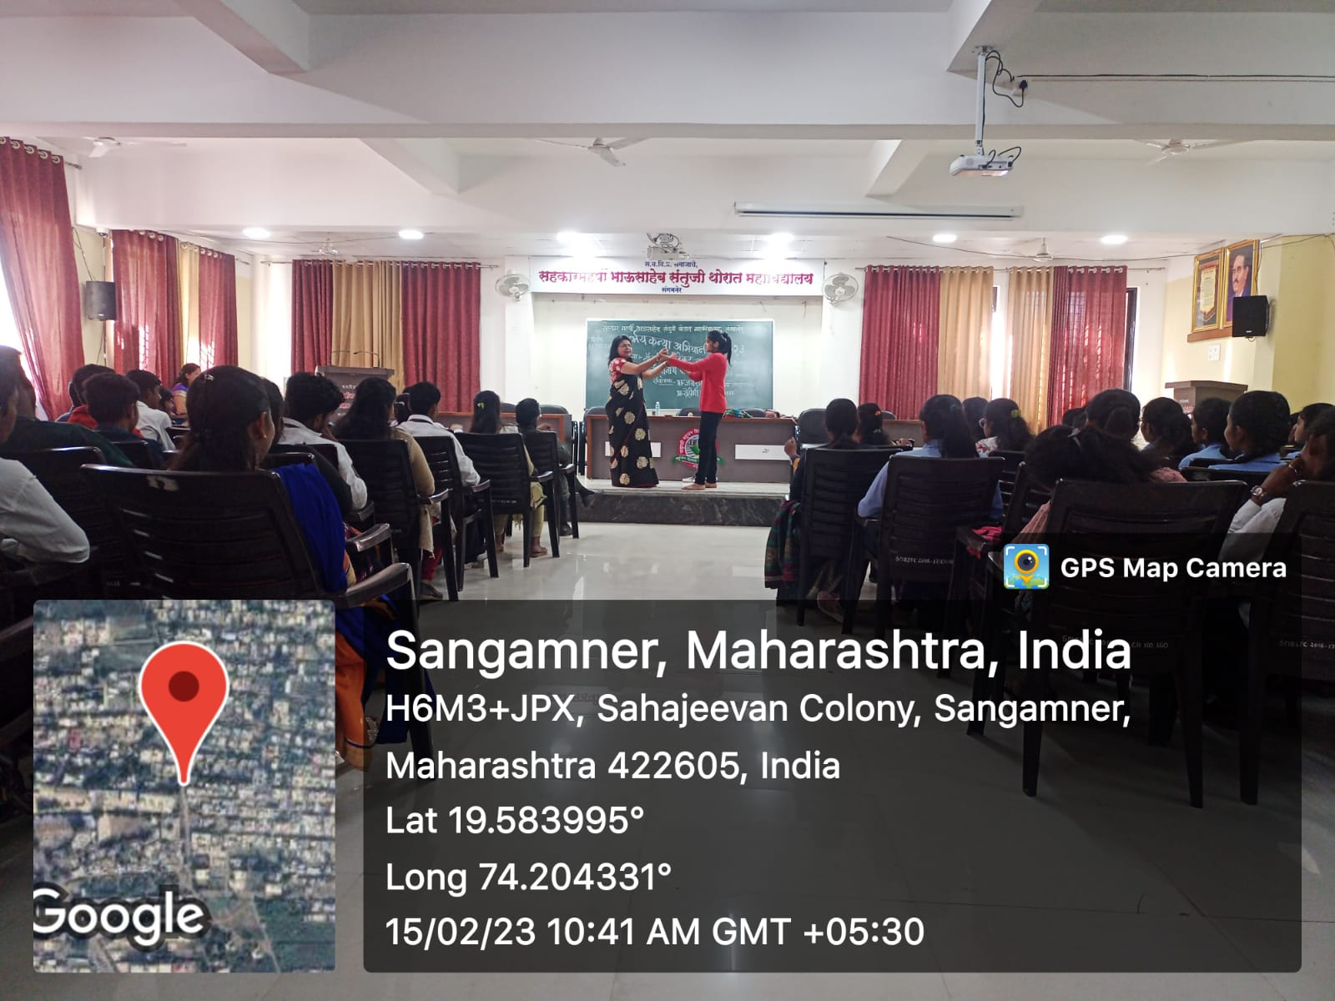
Dr.Sandhya Khedkar gives training on Karate

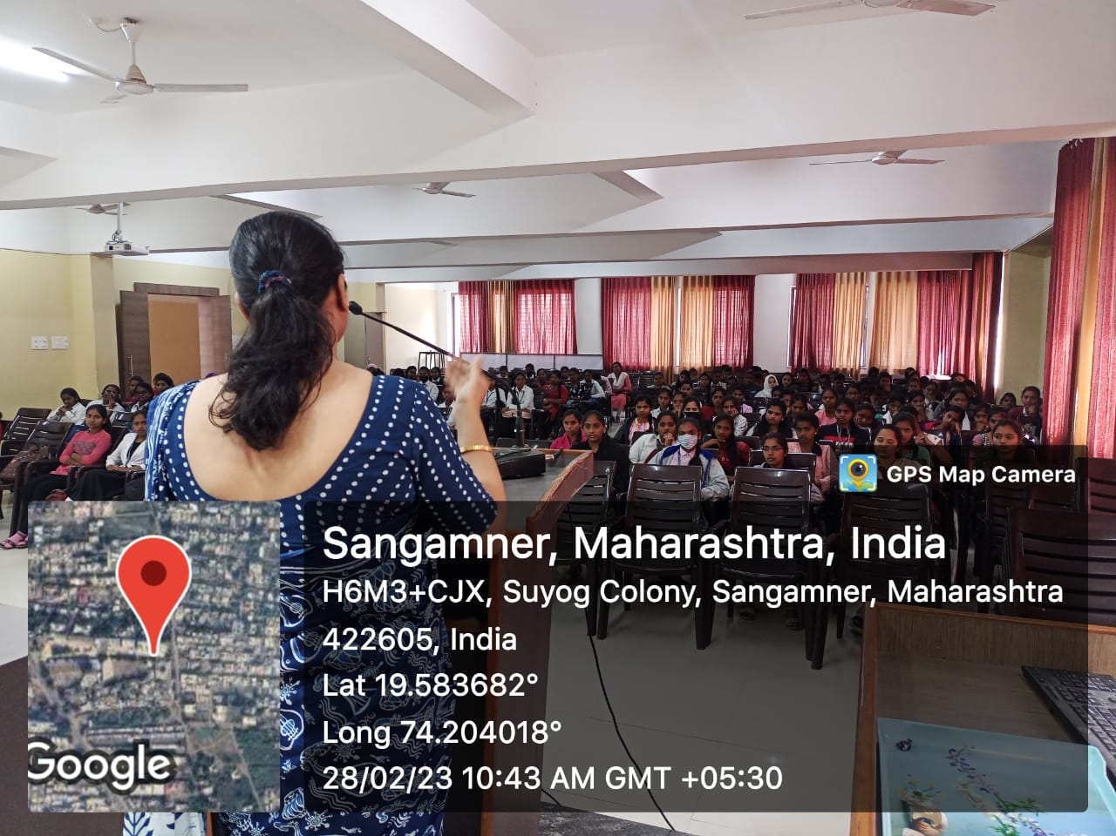

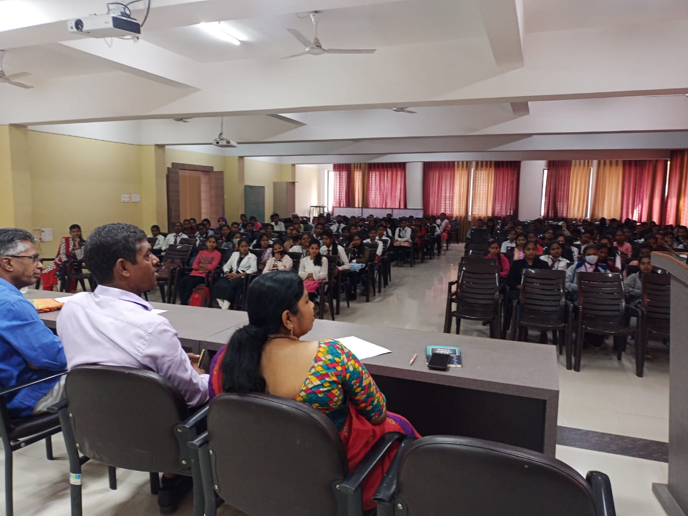
Mrs.Sonali Giri Guide to Students

