KARMVIR BHAURAO PATIL EARN AND
LEARN SCHEME

Objective of the scheme
- Giving Economics help to those who are needy and economically backward
- To gave priority to human labour
- To make a knowledge servant
- To inspire students for self-employment
- To make students aware of work culture
Eligibility of the scheme
- Only those candidates are incorporated in the scheme whose parents have their annual income below
- Rs. 500,000/-
Grants for the scheme
- Candidate from SC, ST, VJNT, SBC are given 100% grand’s by the University.
- Physically challenged candidates are given 100% grant by the University. They are given works as per their capability.
Work to be done under Earn and Learn scheme
- Producing material useful for the college and university like pad, file, notebook etc.
- To help hostel administration, library, office and various departments.
- To gives work as an assistant in a Laboratory,Library.
- To give work of typing and printing.
Procedure of the regulations
- Candidates are given 45 rupees per hour considering their work. From the year 2017-18.
- Remuneration is given per month.
- Remuneration is deposited in their respective bank accounts.

FUNDS SANCTIONED IN BENEFICIARIES
Academic Year | No. of Students | University  Share  (in Lakhs) | College Share  (in Lakhs) | Total Expenses  (in Lakhs)
2019-2020 | 72 | 493857 | 54855 | 548730
2021-2022 | 35 | 31387 | 3488 | 34875
2022-2023 | 75 | 450000 | 66125 | 514125

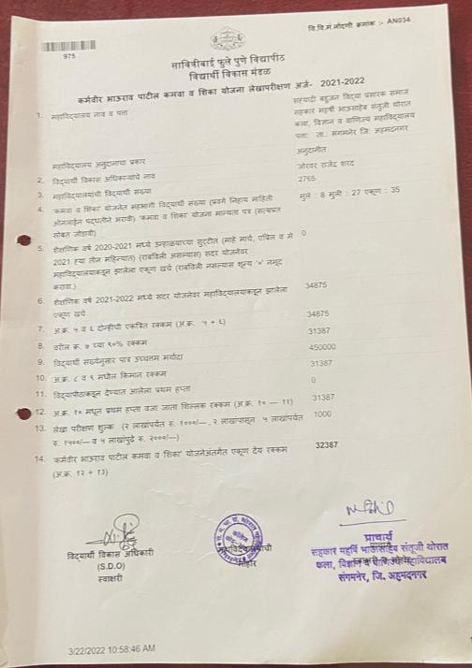

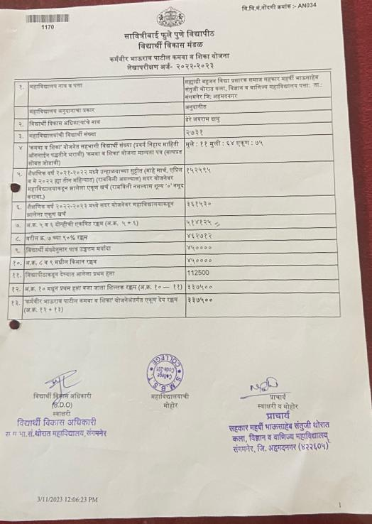

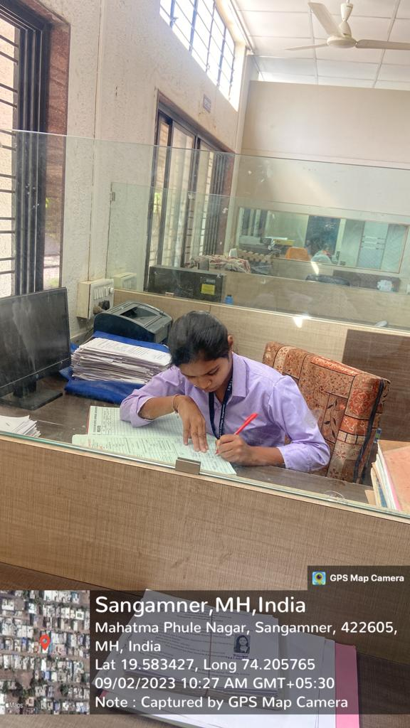
Student Works In Admission Department under the Earn and Learn Scheme

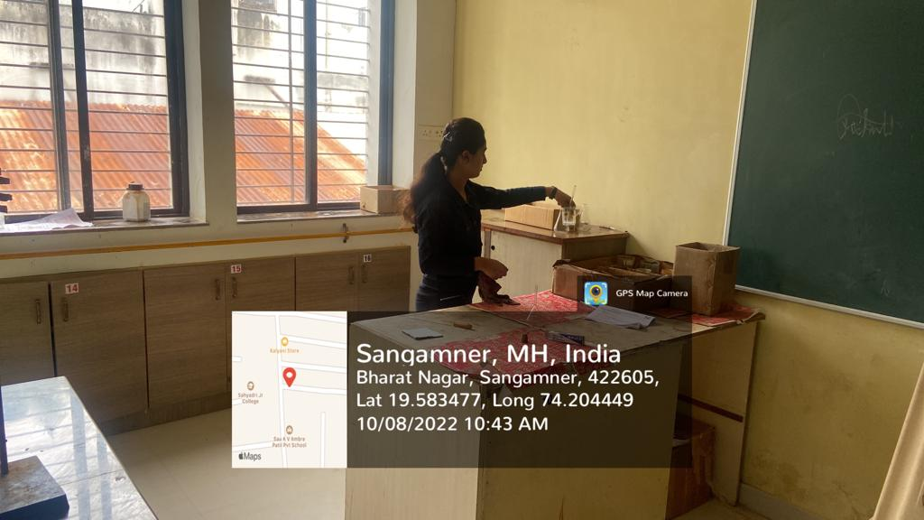

Student Works in Chemistry Department under the Earn and Learn Scheme

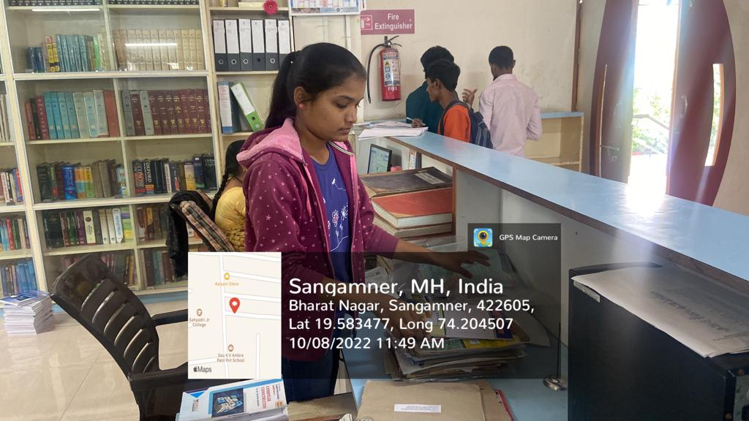
Student Works in Library Department under the Earn and Learn Scheme

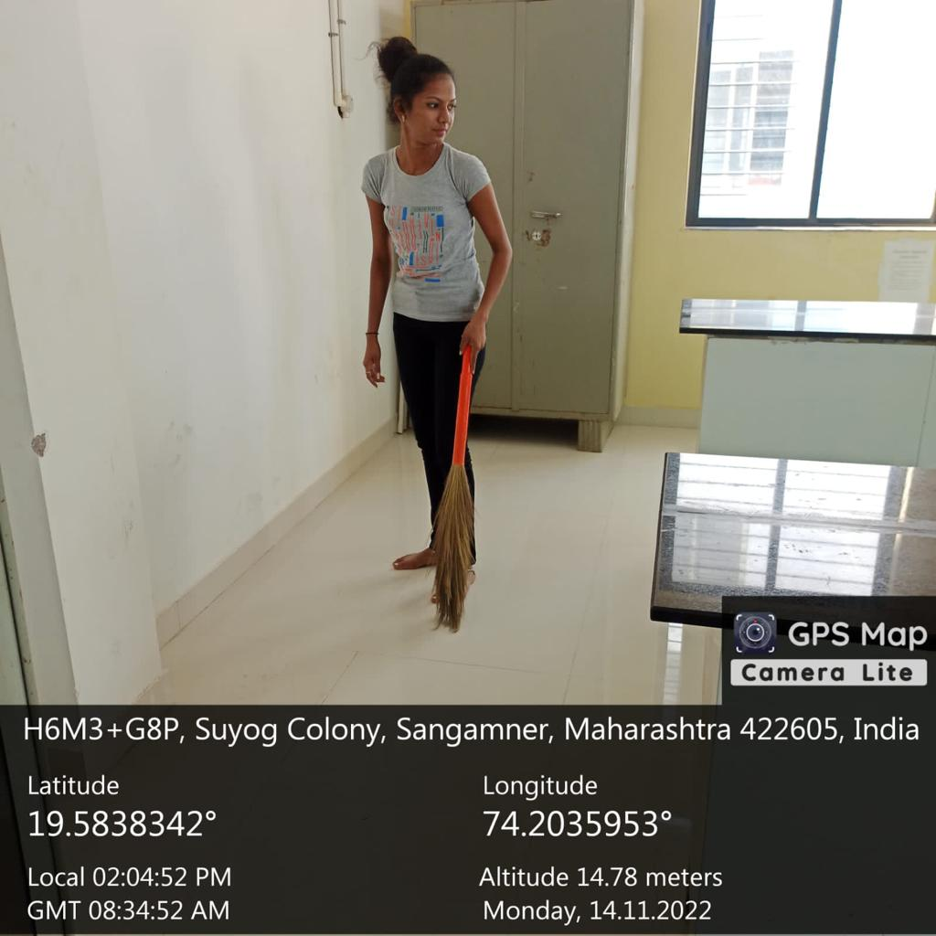
Student Works in Zoology Department under the Earn and Learn Scheme

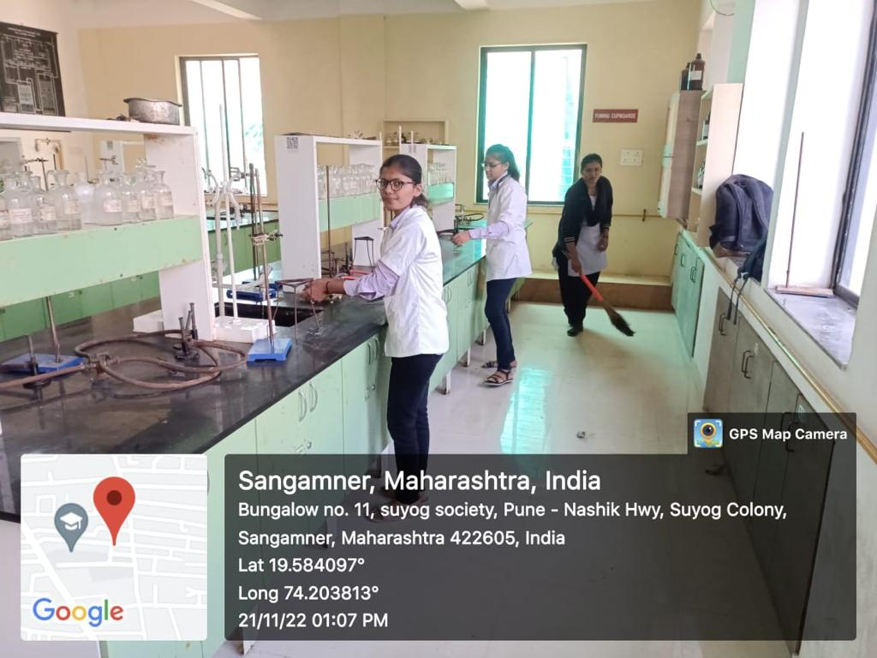
Student Works in Chemistry Department under the Earn and Learn Scheme

Student Works in English Department under the Earn and Learn Scheme

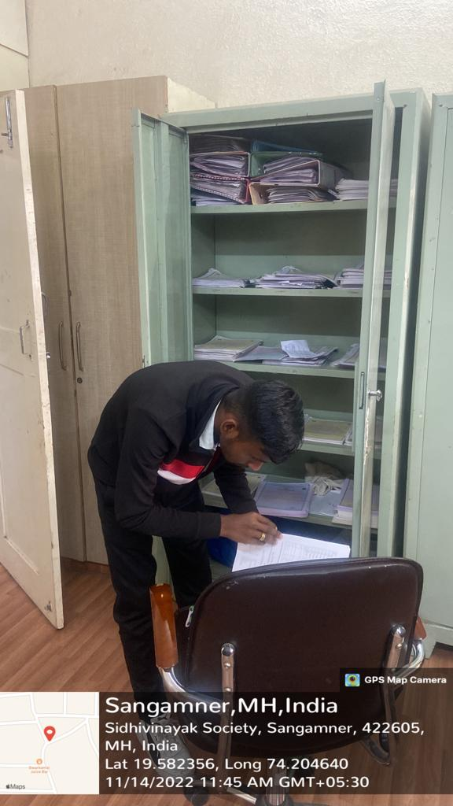
Student Works in Examination Department under the Earn and Learn Scheme

